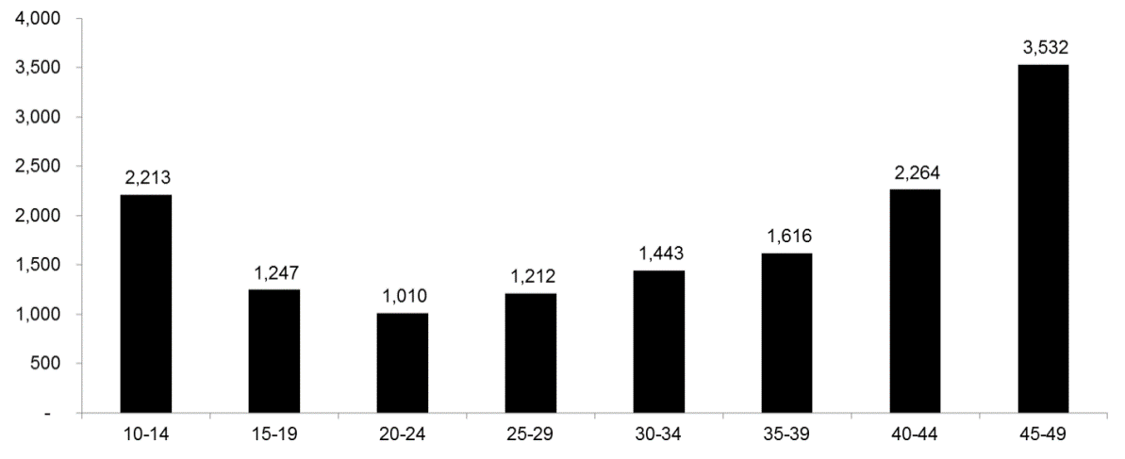
Cost-effectiveness ($/HIA)
HIA: HIV infection averted
Fig. S7. Cost of voluntary medical male circumcision (VMMC) per HIV infection averted by 2025 (cost-effectiveness) assuming a fixed age-specific unit cost*
*Unit cost of USD$95

