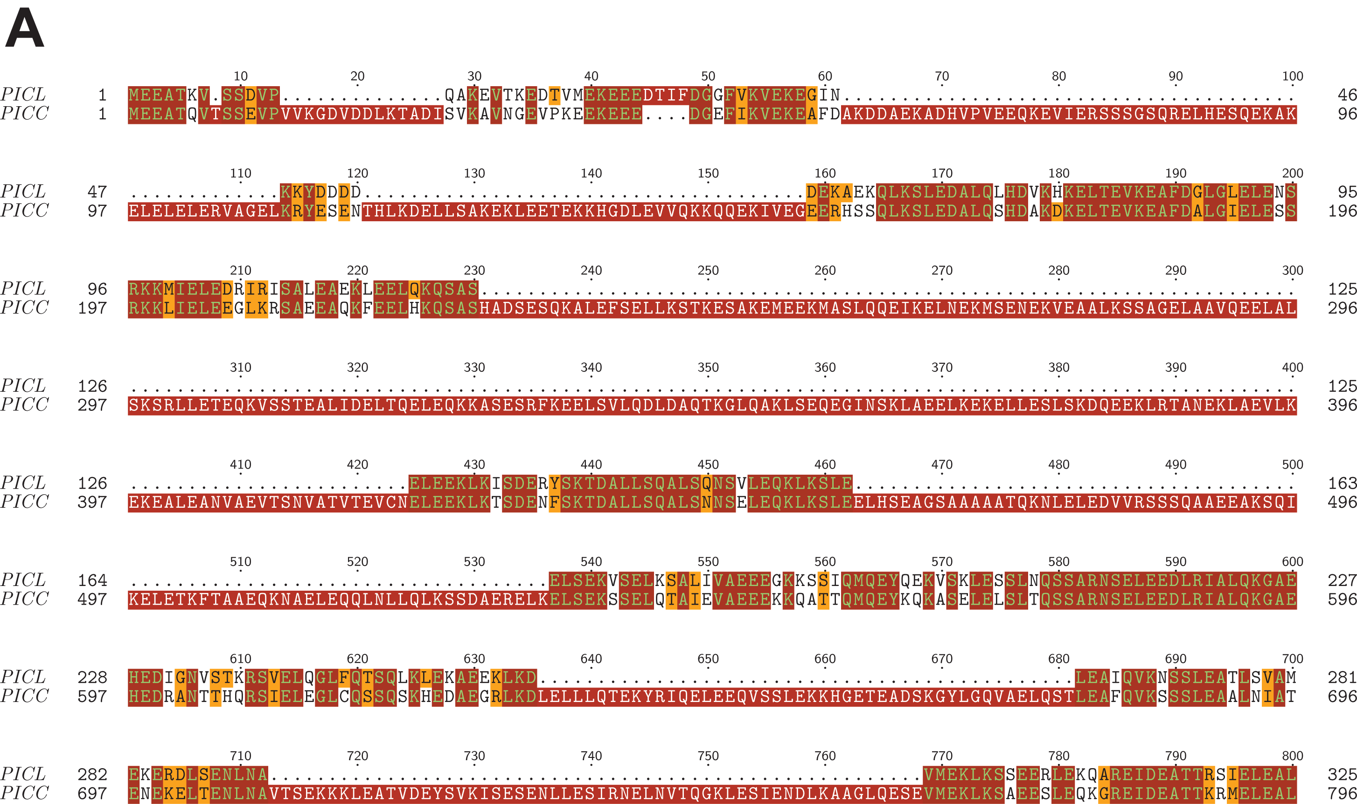
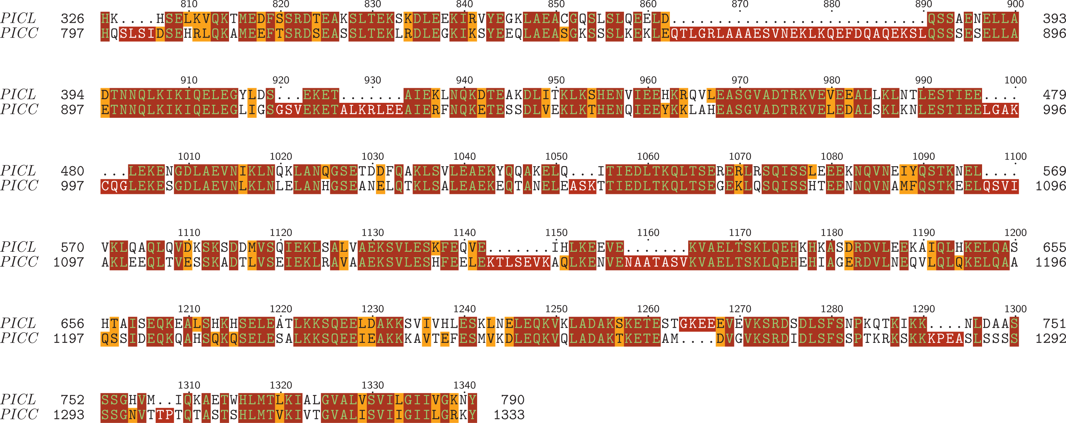

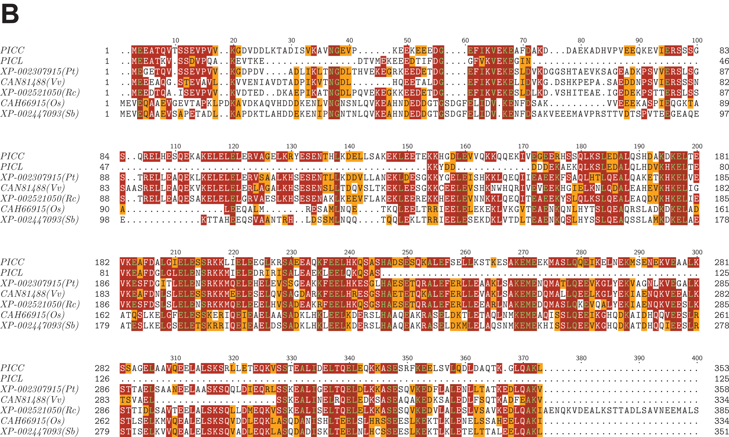

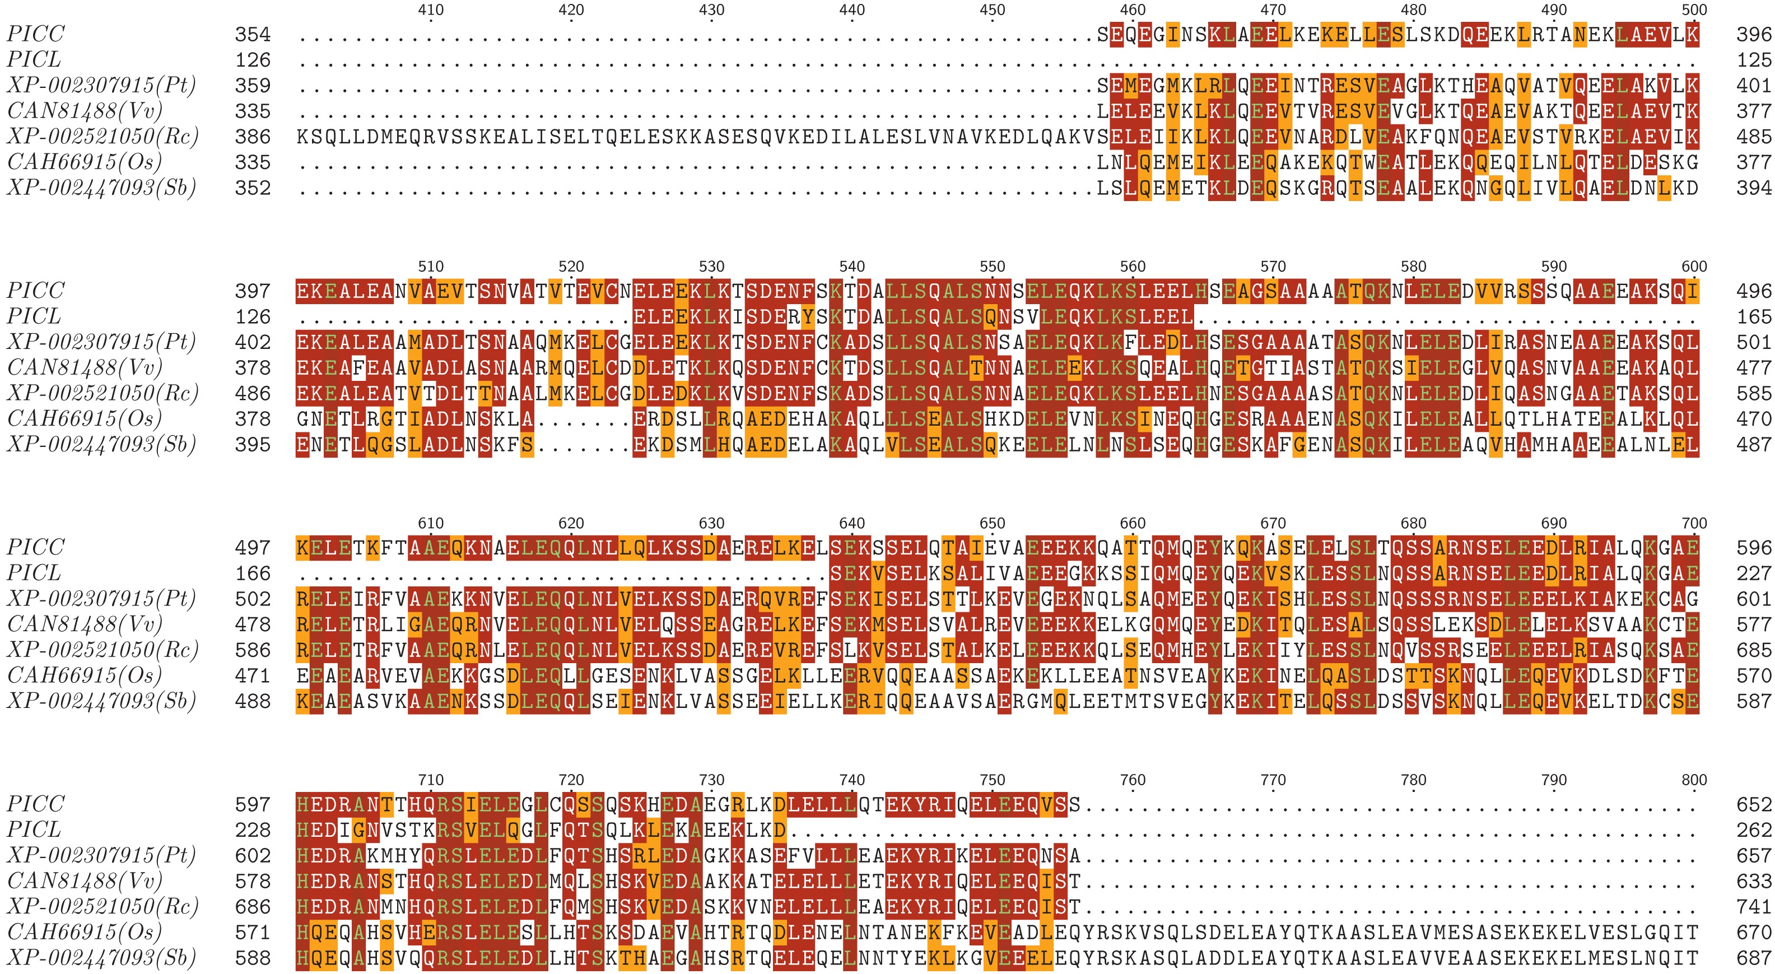
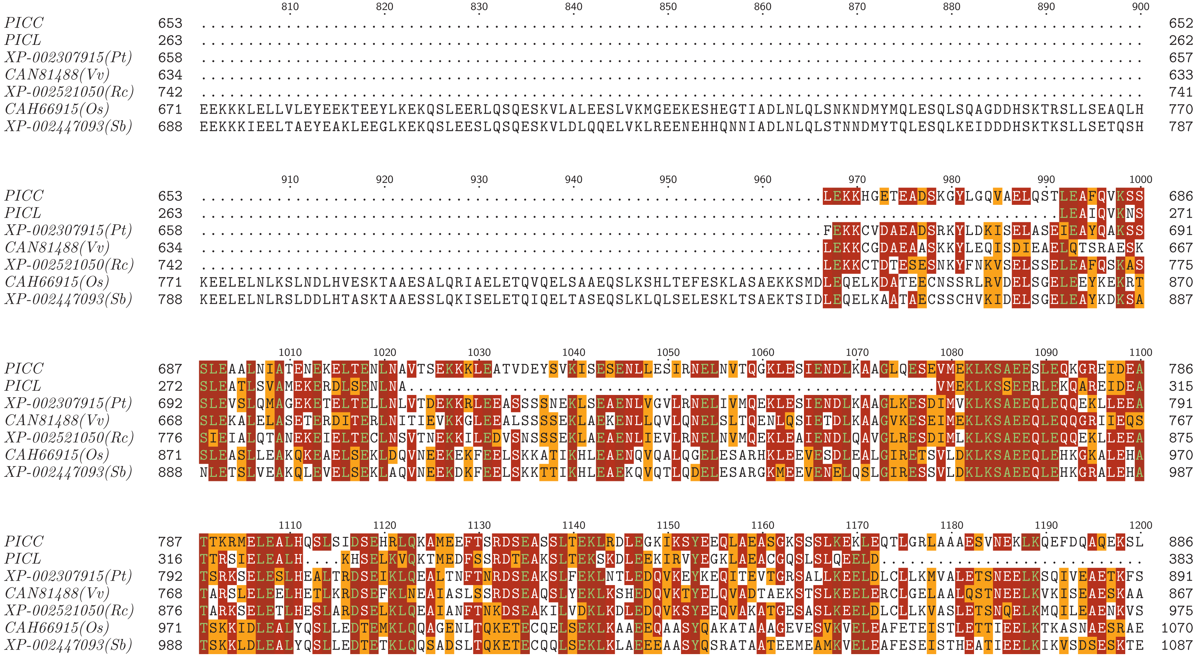
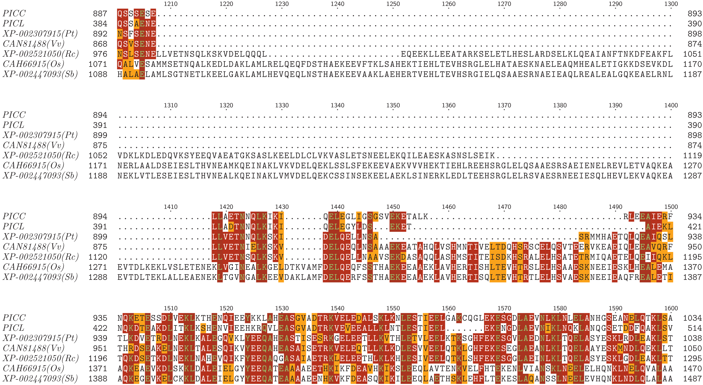
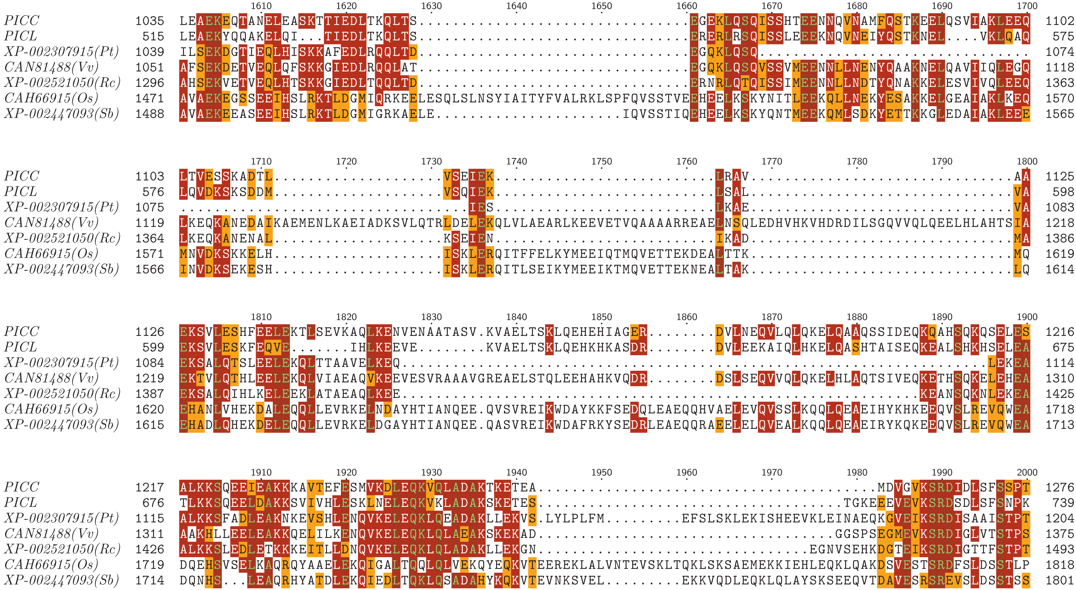
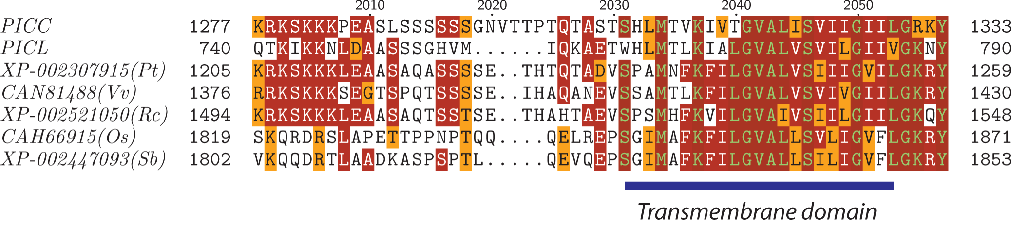
Figure S1. (A) Sequence alignment of PICC and PICL. (B) Multiple sequence alignment of PICC, PICL and their orthologs in vascular plants. Blue bar below the alignment indicates the predicted transmembrane domain. Os, Oryza sativa; Pt, Populus trichocarpa; Rc, Ricinus communis; Sb, Sorghum bicolor; Vv, Vitis vinifera.

