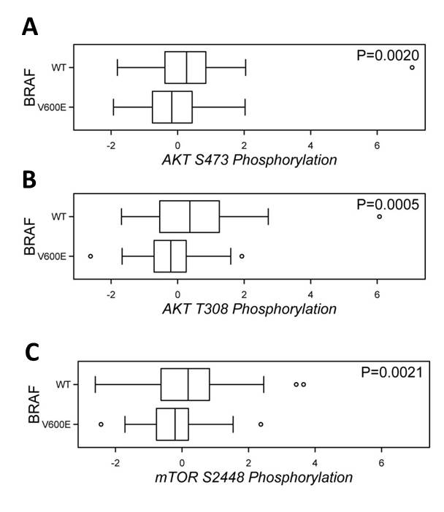
S8 File. BRAF V600E correlates to Inactivation of the PI3K/AKT Pathway in Papillary Thyroid Cancer. Box plots showing a significantly decreased phosphorylation of both AKT (T308 and S473) and mTOR (S2448) in PTC specimens carrying a BRAF V600E mutation as compared to those with BRF WT. Data of PTC patient samples (n=197) were downloaded from the TCGA portal and analyzed using the cBioPortal for Cancer Genomics. The phosphorylation z-scores (displayed at the x-axis) were used for statistical calculation by the means of Mann-Whitney-Wilcoxon testing.

