S1 Fig. Association between body mass index and all-cause mortality according to DM, CVD, and cancer status.
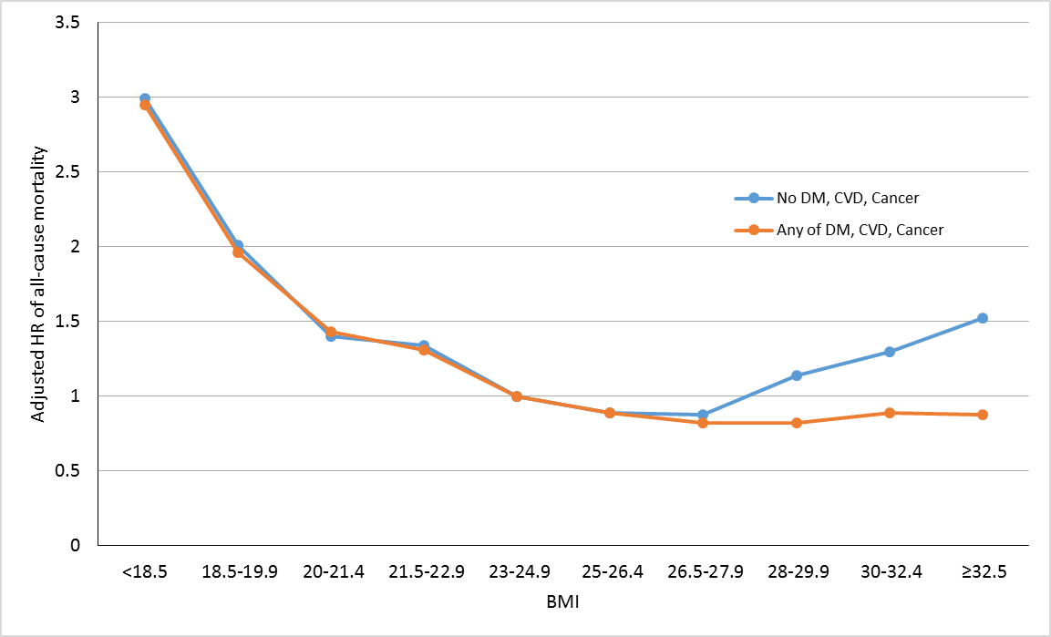
Analyses were adjusted for age, sex, smoking status, alcohol intake, physical activity, socioeconomic status, and body weight change.

