Supporting information

Figure S1: Time-dependent effect of the L. variegata aqueous extract on the viability of Hela cells. A time series of the effect of the L. variegata aqueous extract on viability of Hela cells was determined by a colorimetric XTT assay. Hela cells were treated with a fixed concentration of 400 µg/ml of the extract for time periods of one day up to 7 days. Data are given relative to untreated cells measured at the same time point (100%).

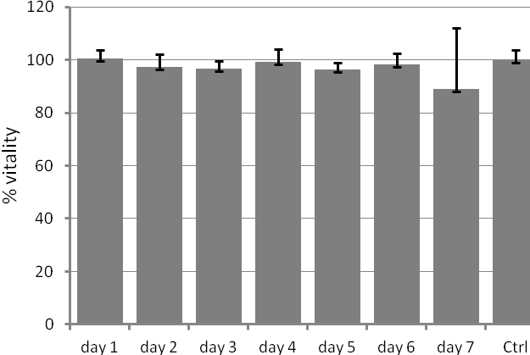

Supplemental experimental procedures
Hela cells were seeded into a 96-well plate (µCLEAR-Plate Black; Greiner Bio-One, Kremsmuenster, Germany) at a density of 2000 cells per well at 24 h prior to treatment. L. variegata aqueous extract was tested at a fixed concentration of 400 µg/ml in triplicates. Cells were incubated for up to 7 days after extract addition under standard conditions at 37 °C in 5% CO₂. Cell culture medium was carefully replaced every second day with pre-warmed medium including fresh L. variegata aqueous extract. Viability of Hela cells was determined by a standard XTT test (TACS® XTT Cell Proliferation Assay, Trevigen, USA) at various time points after extract addition (from one day up to 7 days). Cells were incubated with 0.3 mg/ml XTT working solution in 100 µl of culture medium for 2 h under standard culture conditions. XTT formazan concentrations was determined by an ELISA plate reader (SpectraMax M2 Multi-Mode Microplate Reader, Molecular Devices, USA) at a test wavelength of 490 nm and a reference wavelength of 630 nm. Values for treated cultures were related to those of untreated cultures in the same plate and the same length of incubation.

