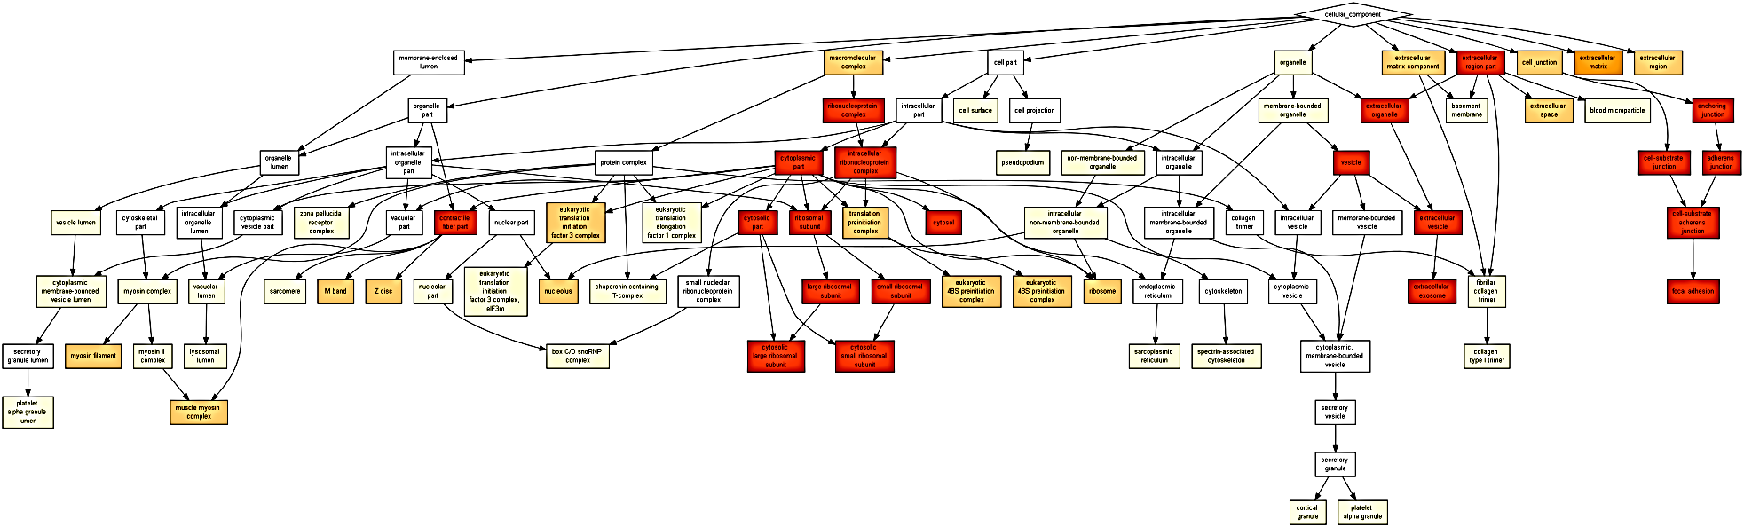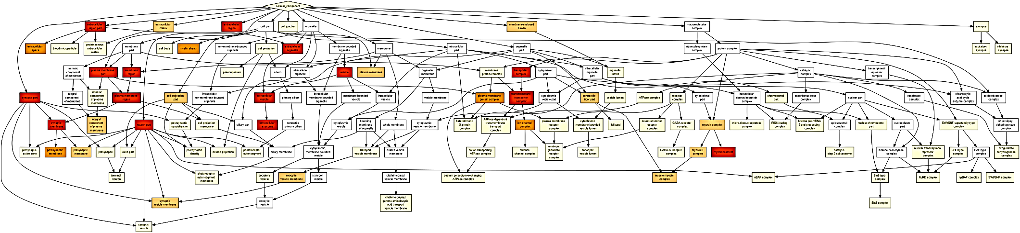
A
B
S3 Fig. Cellular components enriched during transtion 1 (a) and transition 2 (b).

