**Supplemental Figure 1.** Immunohistochemical labeling of renal tissue for tyrosine hydroxylase (TH) in CON rats (first row) and CKD rats (second row) to detect sympathetic nerves (green, white arrows).

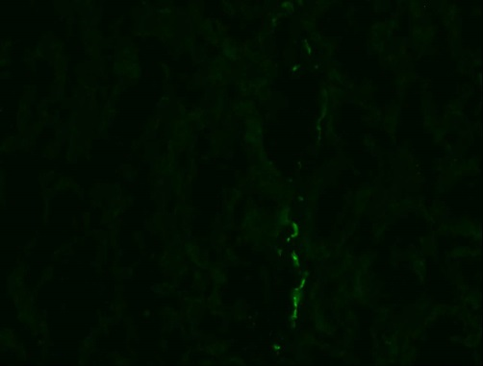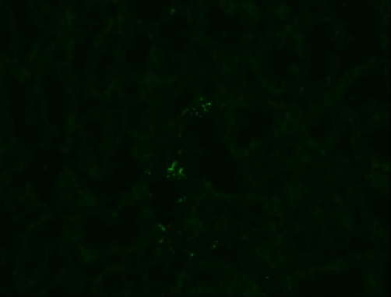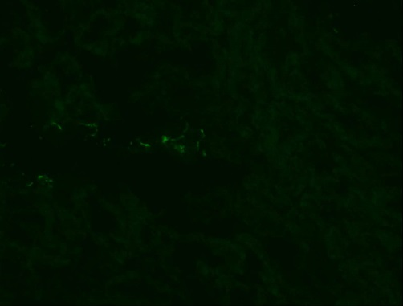

CON, Tempol

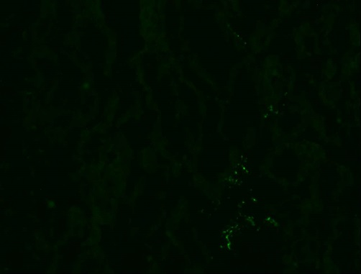

CON, PEG-catalase

CON, vehicle

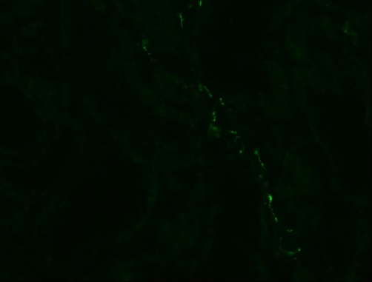

CKD, Tempol

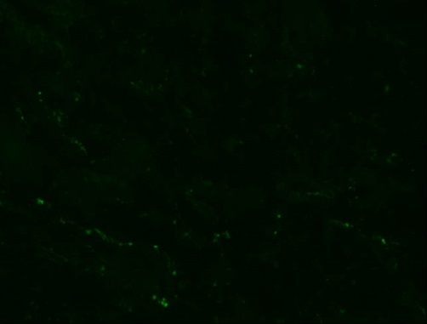

CKD, PEG-catalase

CKD, vehicle