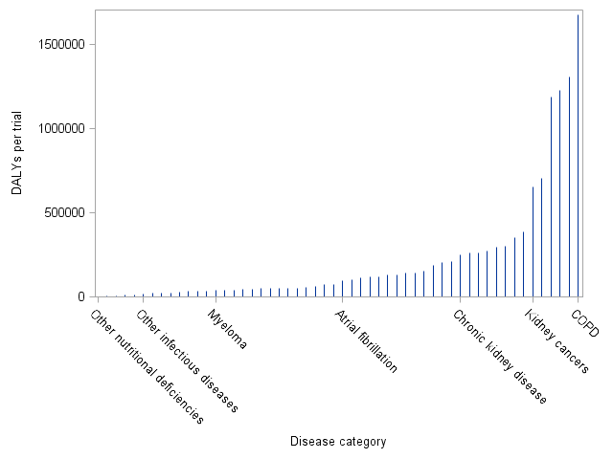

**S1 Fig.** DALYs per trial among trials enrolling exclusively elderly persons. Disease labels included for minimum and maximum as well as 10th, 25th, 50th, 75th, and 90th percentile of values.