Supplementary figures
S1 Fig A. Frequency distribution of right atrium volume indexed in patients with and without study outcome.
S1 Fig B. Mortality Risk per Adjusted Right Atrium Volume Indexed.

S1 Fig A. Frequency distribution of right atrium volume indexed in patients with and without study outcome.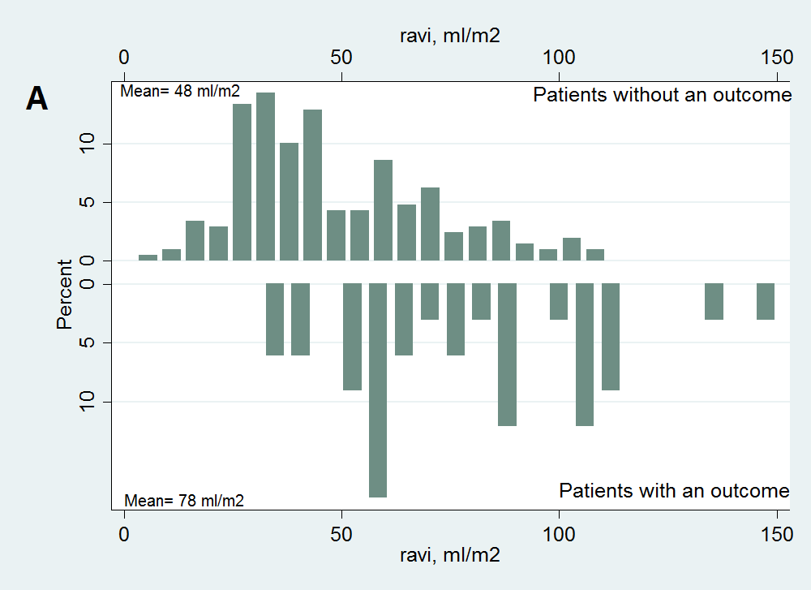

S1 Fig B. Mortality Risk per Adjusted Right Atrium Volume Indexed.
