**Core _NS5B**

Genetic distance



Percentage of sequence clustering and average cluster size



Phylogenetic tree

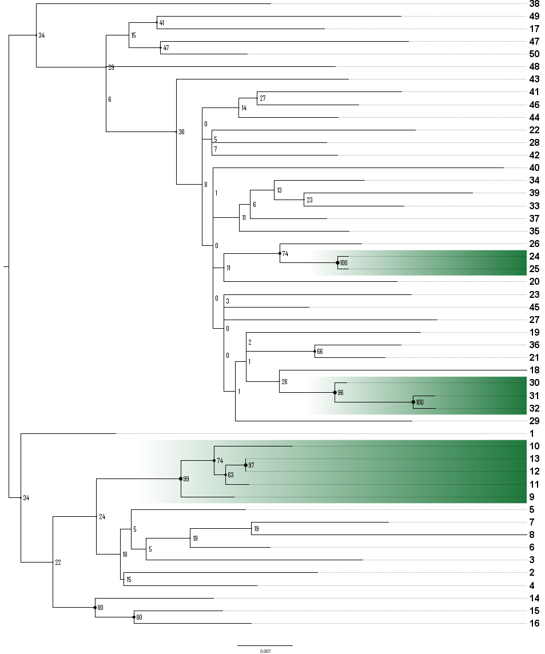

**S5 Figure: Clustering results among 50 GT1a ATAHC sequences with genetic distance, percentage of sequences, tree, patristic distance and bootstrap values.**