**S3 Fig. Propylgallate Azide**

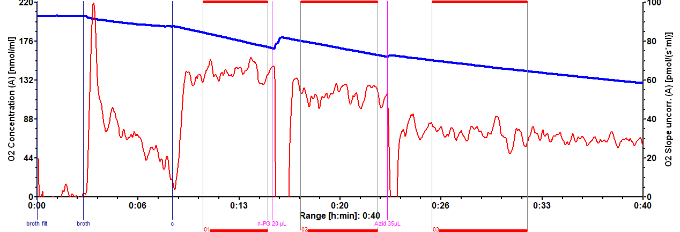



S3 Fig. Propylgallate Azide. Simultaneously measurement of mycelium from a steady state sample, chamber A (upper panel) and chamber B (lower panel). Chamber A: n-PG followed by azide, Chamber B: *vice versa* sequence of inhibitors.