Figure S3: Lipoprotein lipase treatment does not significantly alter TLR-2 signalling of B.pseudomallei-LPS.

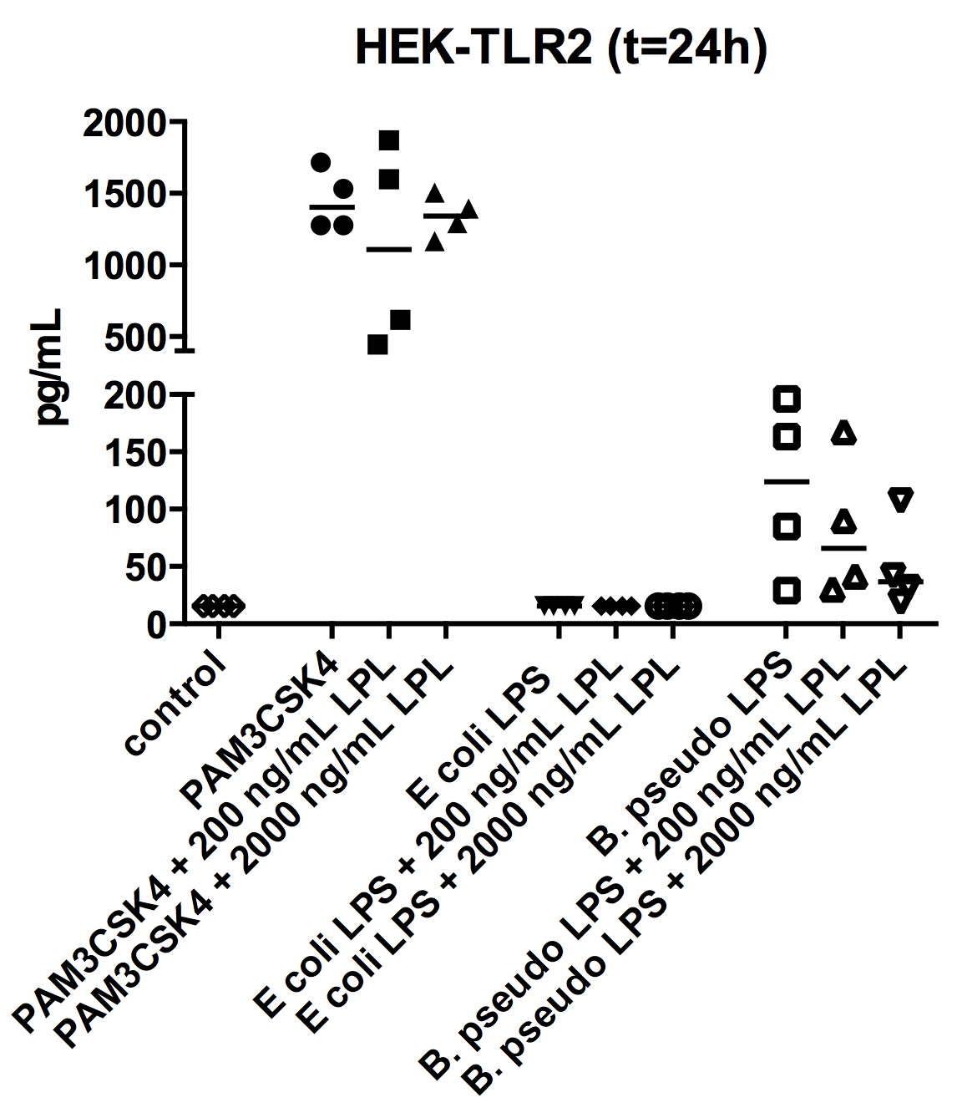
A

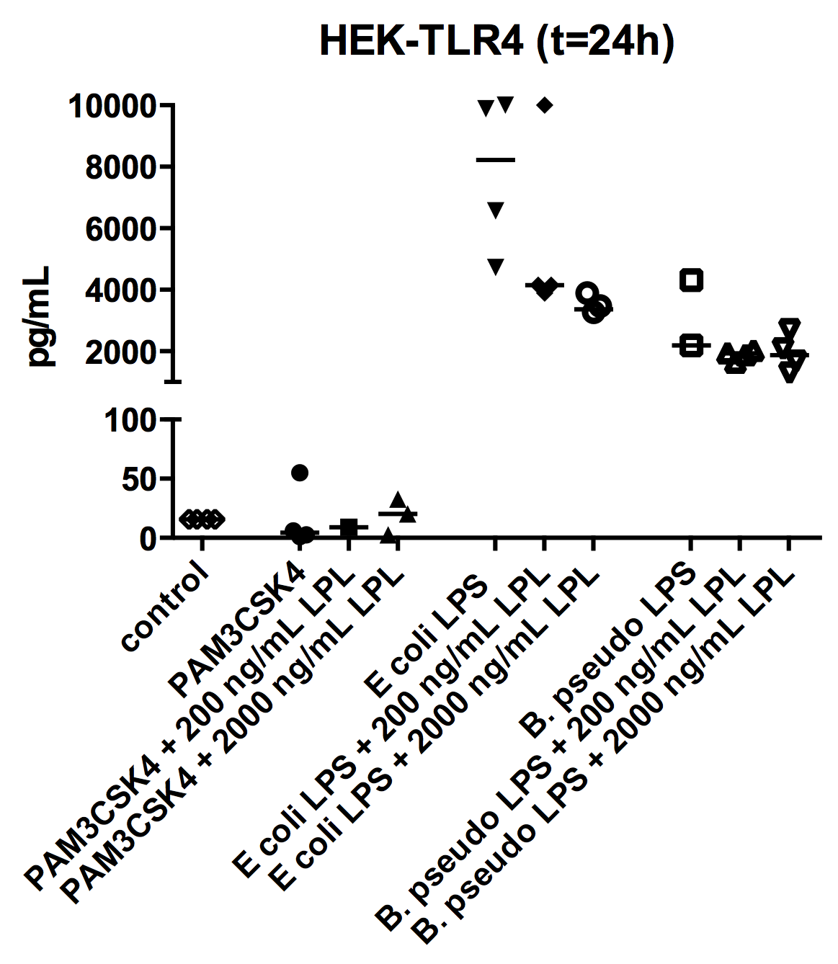
B

Human Embryonic Kidney (HEK)-293 cells, stably transfected with either CD14-TLR2 or CD14-TLR4/MD2 were stimulated with purified LPS of B.pseudomallei 1026b (100 ng/ml), LPS of E. coli 0111:B4 (100 ng/ml), PAM3CSK4 (100 ng/ml) or DMEM+ 10% FCS. Subsequently, lipoprotein lipase (200 or 2000 ng/ml) was added to the culture.
24h post-stimulation supernatant was collected and interleukin (IL)-8 was measured by ELISA (n=4). Data are presented as means ± SEM and were analysed by Kruskall- Wallis analysis followed by Mann-Whitney- U tests. *P< 0.05 compared to control.

