1. **β-actin**

**A B**

**M 1 2 3**

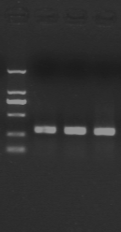 **M:\TUPIAN\ACTIN.emf**

1. **TCRβ**

**A B**

**M 1 2 3**

 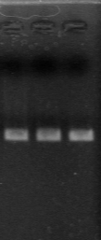 M:\TUPIAN\TCR-B.emf

**(3) STAT3**

**A B**

**M 1 2 3**

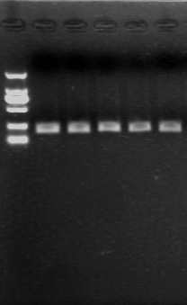 **M:\TUPIAN\STAT3.emf**

**(4) IL-12**

**A B**

**1 2 M**

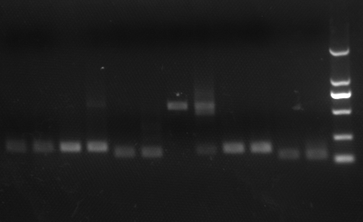 M:\IL-12.emf

**(5) MDA5**

**A B**

**M 1 2 3**

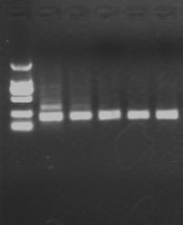 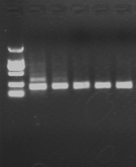 **M:\MDA5.emf**

**Figure S1. The agarose gel electrophoresis and melt curve analysis of amplification products of partial genes.**

A: The agarose gel electrophoresis analysis. M: marker, 2000 bp, 1000 bp, 750 bp, 500 bp, 250 bp, 100 bp; 1: control; 2: Expression analysis of genes in spleen at 12 h after induction with poly (I: C); 3: Expression analysis of genes in spleen at 24 h after induction with poly (I: C). B: Melt curve analysis