**S3 Fig.** 1H NMR spectra (500 MHz, CDCl3) of *C. magnifica* crude extracts containing 1,4-dimethoxybenzene (DMB) as an internal standard.

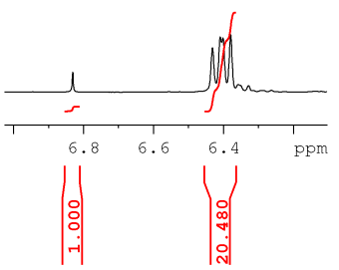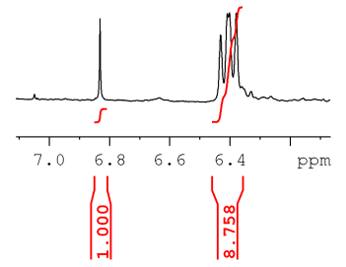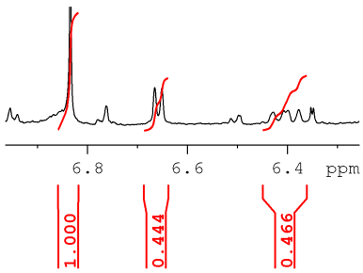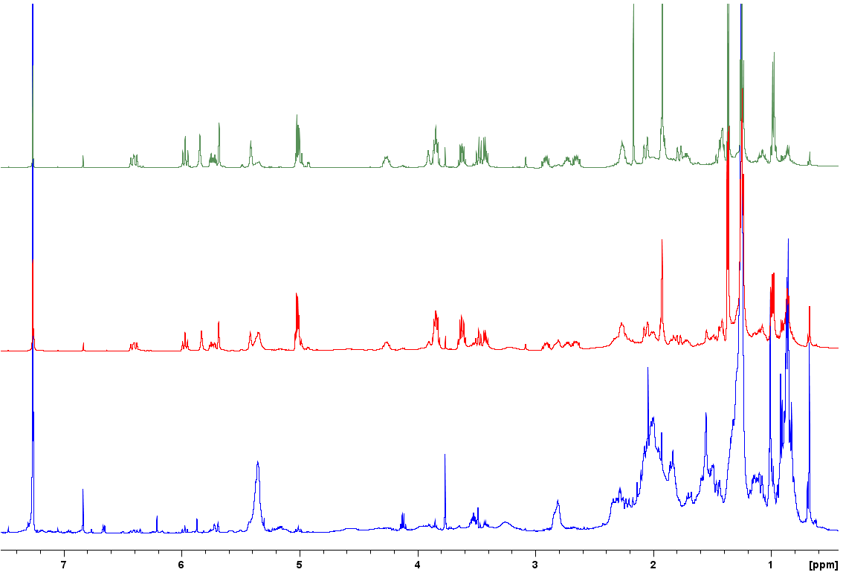



**H7**

**Viscera**



**H15’**

**DMB**

**H7**

**DMB**

**Mantle**

**Mantle rim**