Supplementary Figures
S1 Fig. Trial Schematic.
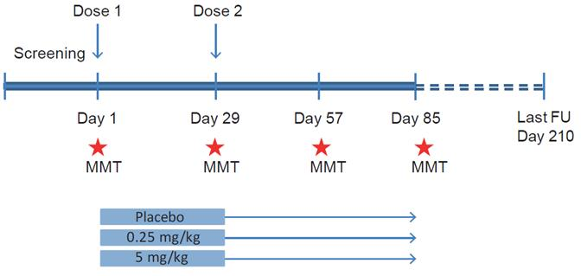

FU, follow-up; MMT, mixed meal test

