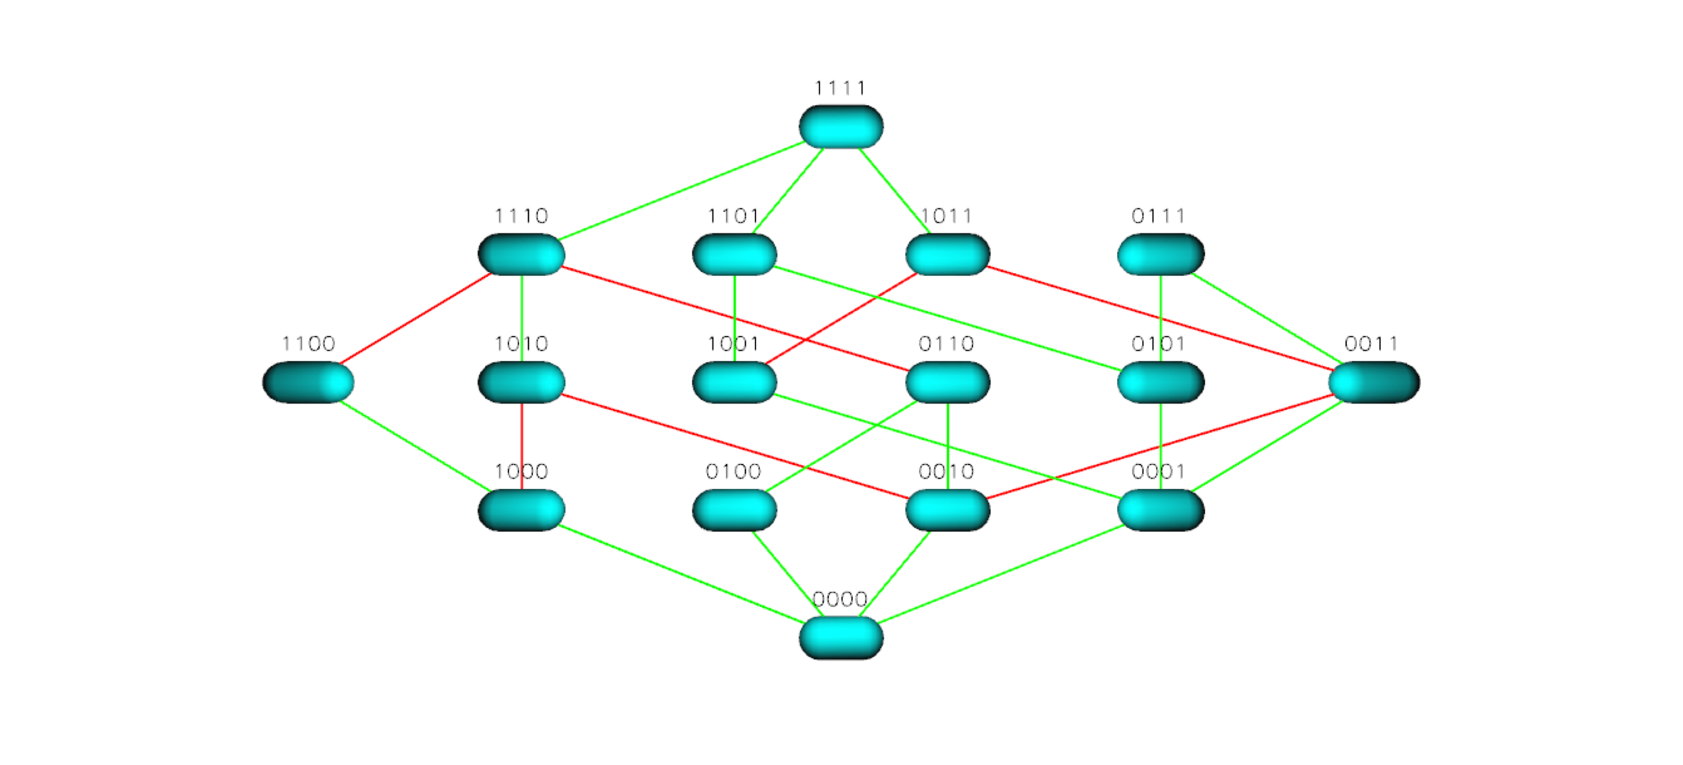

Figure S17 TEM 85 Landscape for Ceftazidime