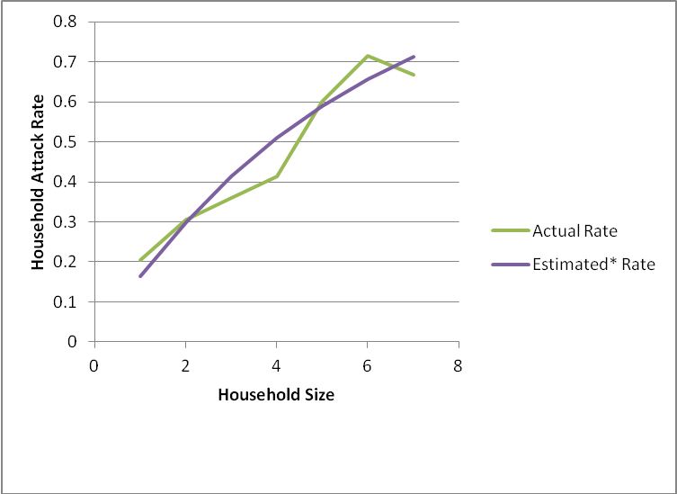

*We calculated the individual attack rate by minimizing the square difference between the actual household illness rate and the estimated rate based on the binomial distribution, assuming that cases of illness were independent of one another within households. The estimated rates did not differ significantly from the observed rates (p=0.993).

Fig. S1: Actual and estimated physical illness rates by household size

