S1.Fig.A
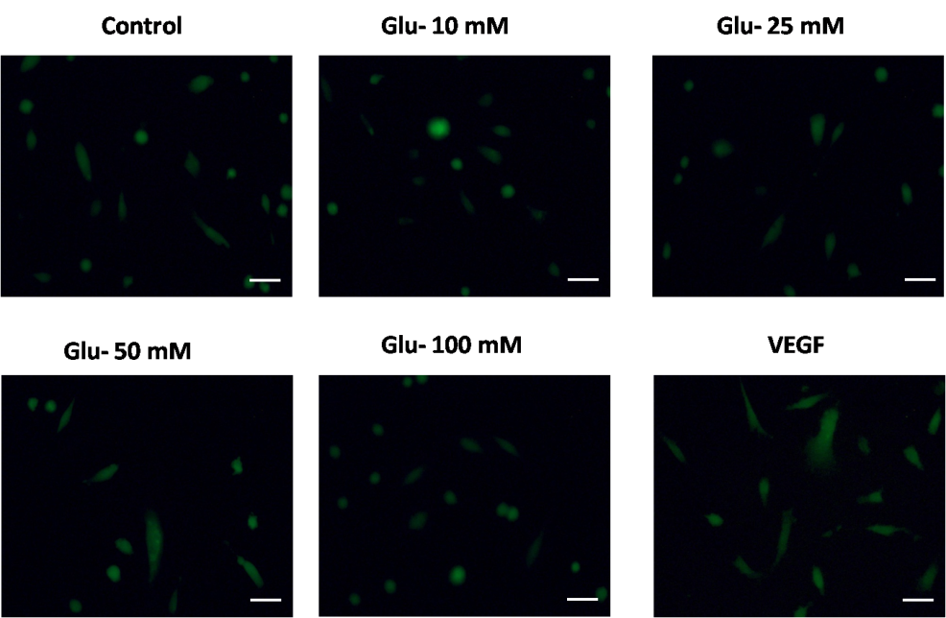
S1.Fig.B

S1.Fig: A] NO detection by fluorescent dye DAF 2 DA in HUVEC cells after treated with D-Glucose (10, 25, 50, 100mM) for 4 hrs. Scale bar=50µm. B] NO levels produced from HUVEC cells after 4hrs treatment of D-Glucose (10, 25, 50,100mM). Data were represented as ± SEM. * p<0.05, ** p<0.01,*** p<0.001 vs Control (CT).

