SUPPORTING INFORMATION: PEST AND BENEFICIAL ARTHROPOD ABUNDANCE ACROSS TIME FOR EACH SAMPLING TECHNIQUE
NSW site
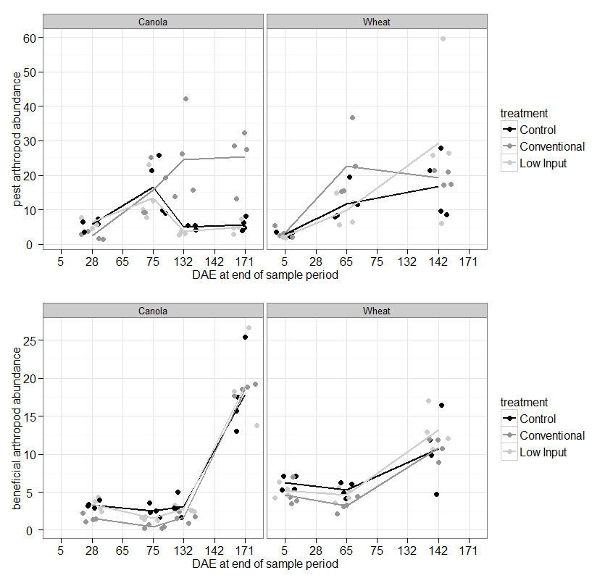
Figure A.

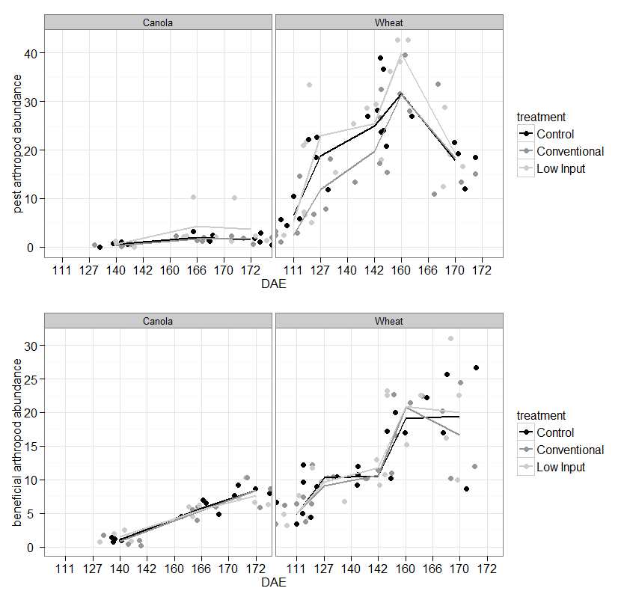
Figure B.

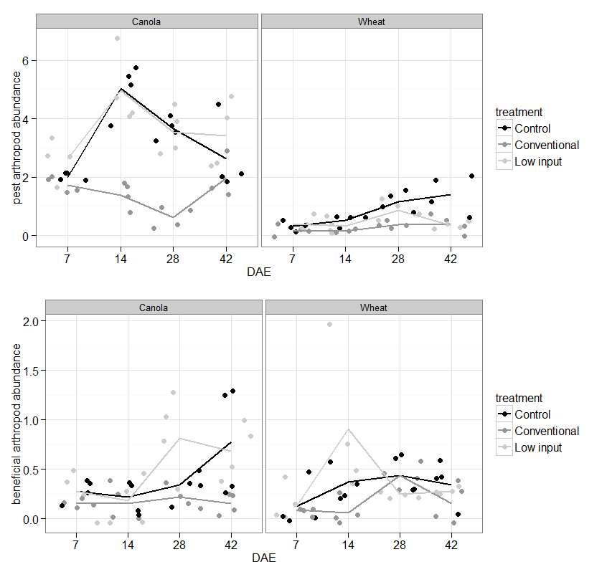
Figure C.

