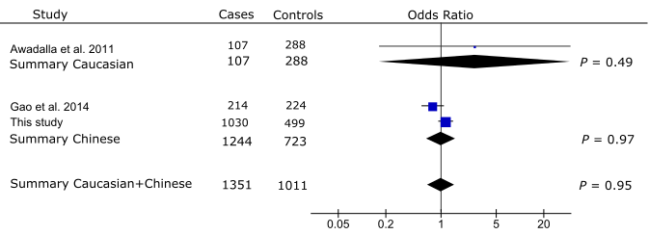
S1 Fig. Meta-analysis with prior studies of the association between rs3918254 and PAC/PACG. Odds ratio was calculated per each increase in minor allele A. The summary odds ratio was 2.68 (95% CI: 0.17-43.00) for the Caucasian population, 0.99 (95% CI: 0.65-1.52) for the Chinese populations, and 1.01 (95%CI: 0.68-1.50) for the combined Caucasian + Chinese populations, respectively. The odds ratios between the Caucasian and Chinese datasets were not significantly heterogeneous (Q = 0.49, I² = 0%). The Bonferroni corrected significance level was set as 0.01 (0.05/5).

