Appendix A. Formulas for calculation of incidence and cumulative diabetes risk.

Equation 1. Calculation of age and stratum-specific incidence rate

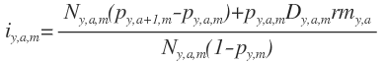

Equation 2. Calculation of standardized incidence rate (standardized against the population in 2010)
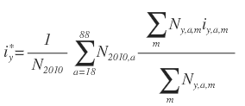
Equation 3. Calculation of cumulative risk of diabetes 18-88 years.

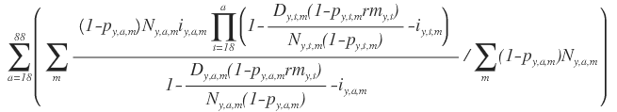

a=Age
D=No of deaths during the year
M=Municipality
N=population size at the beginning of the year
P=Prevalence of diabetes
rm=Relative mortality
y=Year

