Figure S3. Forest plots showing differences in absolute second trimester measurements between individuals whose mothers smoked and did not smoke
- Biparietal Diameter
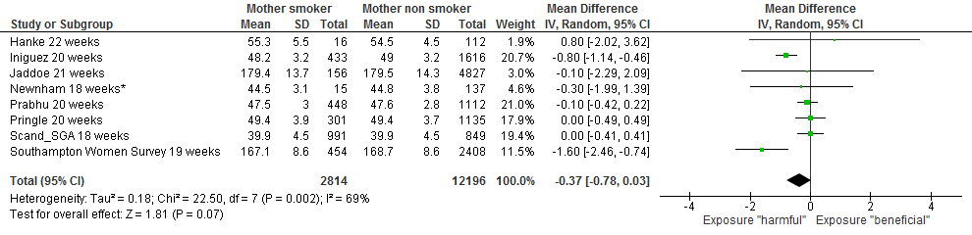
- Femur Length
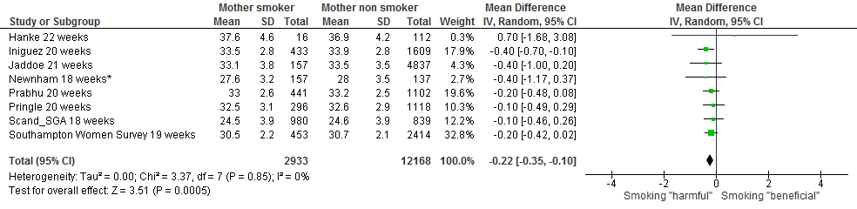
- Abdominal Circumference
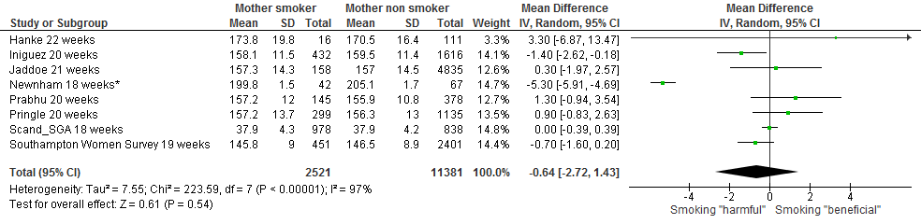
- Estimated Fetal Weight
