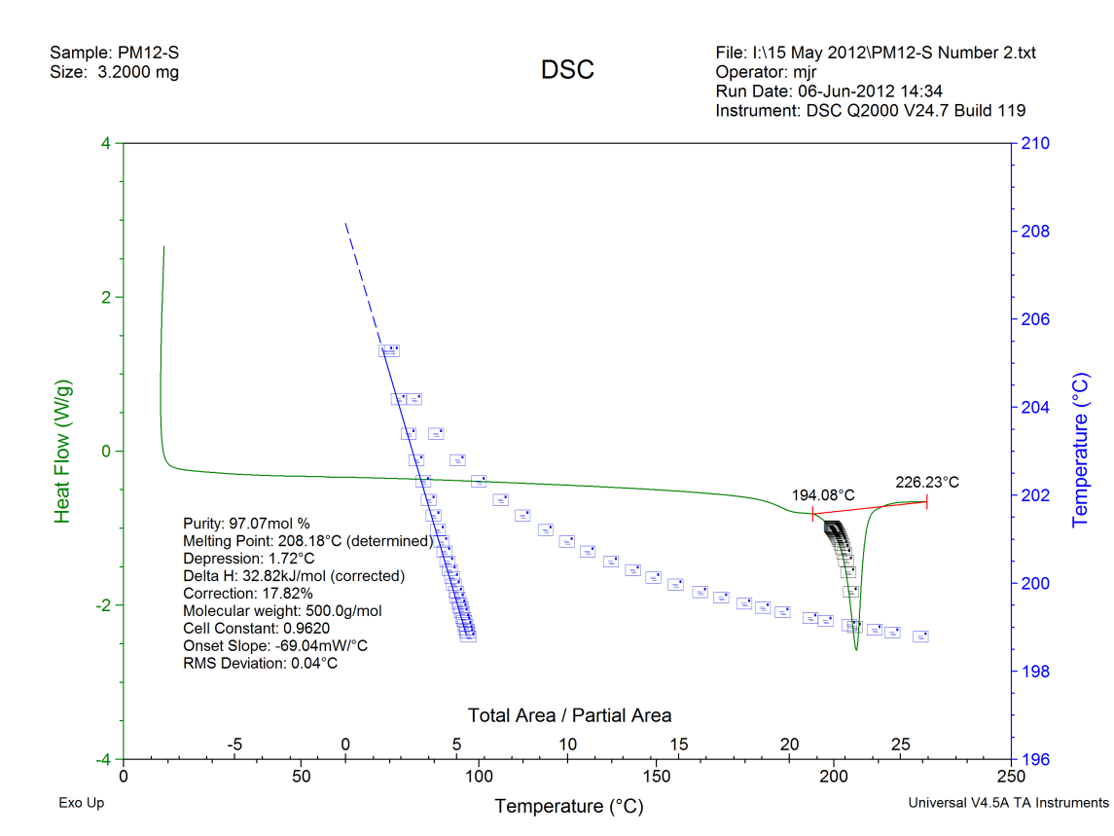

S1 Fig. DSC scan and purity analysis for the synthetic DkPES (heating rate = 1.0 ºC/min, sample weight = 3.20 mg).

