Supplementary material for:
MotifHound: fast and accurate discovery of protein linear motifs
Abdellali Kelil⁺, Benjamin Dubreuil⁺, Emmanuel D. Levy* and Stephen W. Michnick*

Table S1. Parameters used for the benchmark with the different programs tested
Methods | Motif Discovery parameters
Fire-pro | -expfile=SeqExp -species=yeast -exptype=discrete -kmers=3-S -gaps=0-(S-C)
MotifHound | -Setfile=SeqFasta -Proteome=SeqBack -Size=S-S
MEME | SeqFasta -mod=zoops -protein -bfile=MarkBack.ord2  -nmotifs=1 -minsites=3 -maxsites=30 -maxiter=100 -w=S -nomatrim
SLiMFinder | -seqin=SeqFasta -aafreq=MarkBack.ord0 -minwild=0 -maxwild=min(S-C,4) -slimlen=C -eFilter=F  -minocc=3 -walltime=3.0 -termini=F -extras=F -savespace=2 -preamb=F
TEIRESIAS | -l=C -w=S -c=0 -n=0 -q=100 -k=3 -v -u -p -s
Nested MICA | -alphabet protein -maxLength S -minLength S -seqs SeqFasta  -backgroundModel MarkBack.ord2 -numMotifs 1
S = Length of the motif,
C = Number of non-wildcard positions,
SeqExp = Expression profile for 100 randomly selected protein sequences,
SeqFasta = Sequence file containing 100 randomly selected protein sequences in FASTA format,
MarkBack.ordX = Markov Background of order X

Below we outline general as well as method-specific parameters used in this study:
Table S2. Parameters that are method specific
Methods | Parameter | Description
FIRE-pro | -expfile | Input expression profile ( all proteins are listed and associated to a value)
 | -species | Name of the organism where the sequences should be extracted from
 | -exptype | Type of value in the expression profile ( in that case, a binary value, 0 for no expression and 1 for expression)
 | -kmers | Lower and Upper bound for the length of kmers in the k-mer exploration step
 | -gaps | Lower and Upper bound for the number of gaps (wildcard inserted in the middle of the k-mer seed)
MotifHound | -Setfile | Query set containing the protein sequences of interest
 | -Proteome | Background set
 | -Size | Lower and Upper bound for the length of motif in the search step
MEME | Standard input | Set of sequences in which motifs are searched for
 | -mod | Model of motifs distribution (zoops = zero or one per protein sequence)
 | -protein | Sequences use protein alphabet
 | -bfile | Background file in the form of nth-order Markov chain
 | -nmotifs | Maximum number of motifs to find
 | -w | Width of motifs
 | -minsites | Minimum number of sites for each motif
 | -maxsites | Maximum number of sites for each motif
 | -maxiter | Maximum Expectation-Maximization iterations to run
 | -nomatrim | Do not adjust motif width using multiple alignments
SLiMFinder | -seqin | Sequence file to search
 | -aafreq | Use a model to replace individual sequence Amino Acid Frequencies (here a Markov chain of order 0)
 | -minwild | Minimum number of consecutive wildcard positions to allow
 | -maxwild | Maximum number of consecutive wildcard positions to allow
 | -slimlen | Maximum length of motifs to return (Number of non-wildcard positions)
 | -minocc | Minimum number of unrelated occurrences for returned motifs. (Proportion of UP if < 1)
 | -efilter* | Whether to use evolutionary filtering
 | -termini* | Whether to add termini characters (^ & $) to search sequences
 | -walltime* | Time in hours before program will abort search and exit
 | -preamb* | Whether to search for ambiguous motifs during motif discovery
 | -extras* | Whether to generate additional output files (alignments etc.)
 | -savespace* | Delete "unnecessary" files following run (best used with tar.gz):  0 = Delete no files,  1 = Delete all bar *.upc and *.pickle files,  2 = Delete all dataset-specific files (*.upc and *.pickle and not *.tar.gz)
TEIRESIAS | -l | Number of non-dot characters in the pattern
 | -w | The maximum extent of an elementary pattern (Length of a motif)
 | -c | Number of overlapping in the convolved pattern
 | -n | Number of maximum brackets allowed in a pattern
 | -k | Minimum allowed support (occurrences) for a pattern
 | -q | Maximum allowed support (occurrences) for a pattern
 | -v | If given, then -k is the minimum number of sequences in which a pattern should appear
 | -u | Consider only the uppercase characters during pattern discovery
 | -p | Output the list of positions (offset list) for each discovered pattern
 | -s | Do scanning and output the sample list only (elementary patterns
NestedMICA | -seqs | Sequence file to search
 | -backgroundModel | Background file in the form of nth-order Markov chain (here, order 2 with 5 classes)
 | -alphabet | Sequences use protein alphabet
 | -minLength | Minimum length of motif
 | -maxLength | Maximum length of motif
 | -numMotifs | Maximum number of motifs to find
*Those following parameters have been disabled in order to reduce the running times without affecting the accuracy.

Table S3. List of regions known to bind FUS1 SH3 domain that were used in the case study. Note that amino acids that are part of overlapping regions were only counted once in our analysis.

ORF | Gene ID | Binding Region |  | Reference
 |  | START | END
YIL159W | BNR1 | 639 | 653 | [1]
YNL042W | BOP3 | 291 | 305 | [1]
YGL116W | CDC20 | 43 | 57 | [1]
YPR023C | EAF3 | 194 | 208 | [1]
YDR206W | EBS1 | 627 | 641 | [1]
YLR056W | ERG3 | 80 | 94 | [1]
YGR098C | ESP1 | 1127 | 1141 | [1]
YKR049C | FMP46 | 6 | 20 | [1]
YCL039W | GID7 | 107 | 121 | [1]
YAL031C | GIP4 | 527 | 541 | [1]
YPR008W | HAA1 | 497 | 511 | [1]
YPL224C | MMT2 | 26 | 40 | [1]
YPL070W | MUK1 | 176 | 190 | [1]
YCL052C | PBN1 | 40 | 54 | [1]
YNL267W | PIK1 | 370 | 384 | [1]
YPL156C | PRM4 | 133 | 147 | [1]
YMR308C | PSE1 | 276 | 290 | [1]
YJL047C | RTT101 | 745 | 759 | [1]
YMR140W | SIP5 | 41 | 55 | [1]
YBR172C | SMY2 | 75 | 89 | [1]
YER090W | TRP2 | 254 | 268 | [1]
YIL159W | BNR1 | 639 | 650 | [2]
YIL159W | BNR1 | 640 | 654 | [2]
YDR103W | STE5 | 111 | 122 | [2]
YDR103W | STE5 | 112 | 126 | [2]

Table S4. Usage of the algorithms tested on the 22 proteins binding partners of FUS1 SH3 domain
Methods | Usage | Motif Discovery parameters
MotifHound | Local | -Proteome=S. cerevisiae proteome -Size=3 to 10
SLiMFinder | Webserver | http://bioware.ucd.ie/~compass/biowareweb/Server_pages/slimfinder.php  Mask out ordered residues=OFF Mask out unconserved residues=OFF  Mask out the N-terminal=M Minimum disordered length for inclusion=0  Mask out low complexity regions=[5,8] Mask out position specific residues=2:A  Min. #. consecutive wildcards=0 Max. #. consecutive wildcards=2  Max. # wildcards=5 Min. # unrelated seqs with motif=3  Blast expectation (E) value=0.0001 Find ambiguity=OFF  Allow variable length wildcards=OFF  Significance cut off for returning results=0.99  Probabilities based on residue frequencies after masking=OFF  Only return max. this no. of motifs=100 Min. information content of motifs=2.1
TEIRESIAS | Local | -l=3 -w=10 -c=0 -n=0 -q=100 -k=3 -v -u -p –s
NestedMICA | Local | -alphabet protein -minLength 3 -maxLength 10 -numMotifs 100  -backgroundModel MarkBack.ord2
MEME1  MEME2 | Webserver | http://meme.nbcr.net/meme/cgi-bin/meme.cgi  minimum width=3 maximum width=10  maximum number of motifs to find=100  any number of repetitions=checked  proteins tested negatively for binding to FUS1 SH3 domain are use as negative controls with MEME2
FIRE-PRO | Webserver | https://iget.c2b2.columbia.edu  Species=Saccharomyces cerevisiae Distribution type=continuous
DILIMOT | Webserver | http://dilimot.russelllab.org  Remove=Smart domains, Pfam domains, Homology  Your species=Saccharomyces cerevisiae  Fixed positions=3 Maximum motif length=10  Minimal number of motifs in your=100
ANCHOR | Webserver | http://anchor.enzim.hu  (no parameters)
SLIMPRED | Webserver | http://bioware.ucd.ie/~compass/biowareweb  (no parameters)
qPMS7 | Webserver | http://pms.engr.uconn.edu  The percentage of protein sequences containing motifs=75%  Single-box=Any Full Search=checked
D-STAR | Local | -l 3 to 10 -d 2 -L 6 -R 6 -I 8 -N 100
phylo-HMM | Webserver  Predictions | http://www.moseslab.csb.utoronto.ca/phylo_HMM/  (no parameters)

LENGTH 4
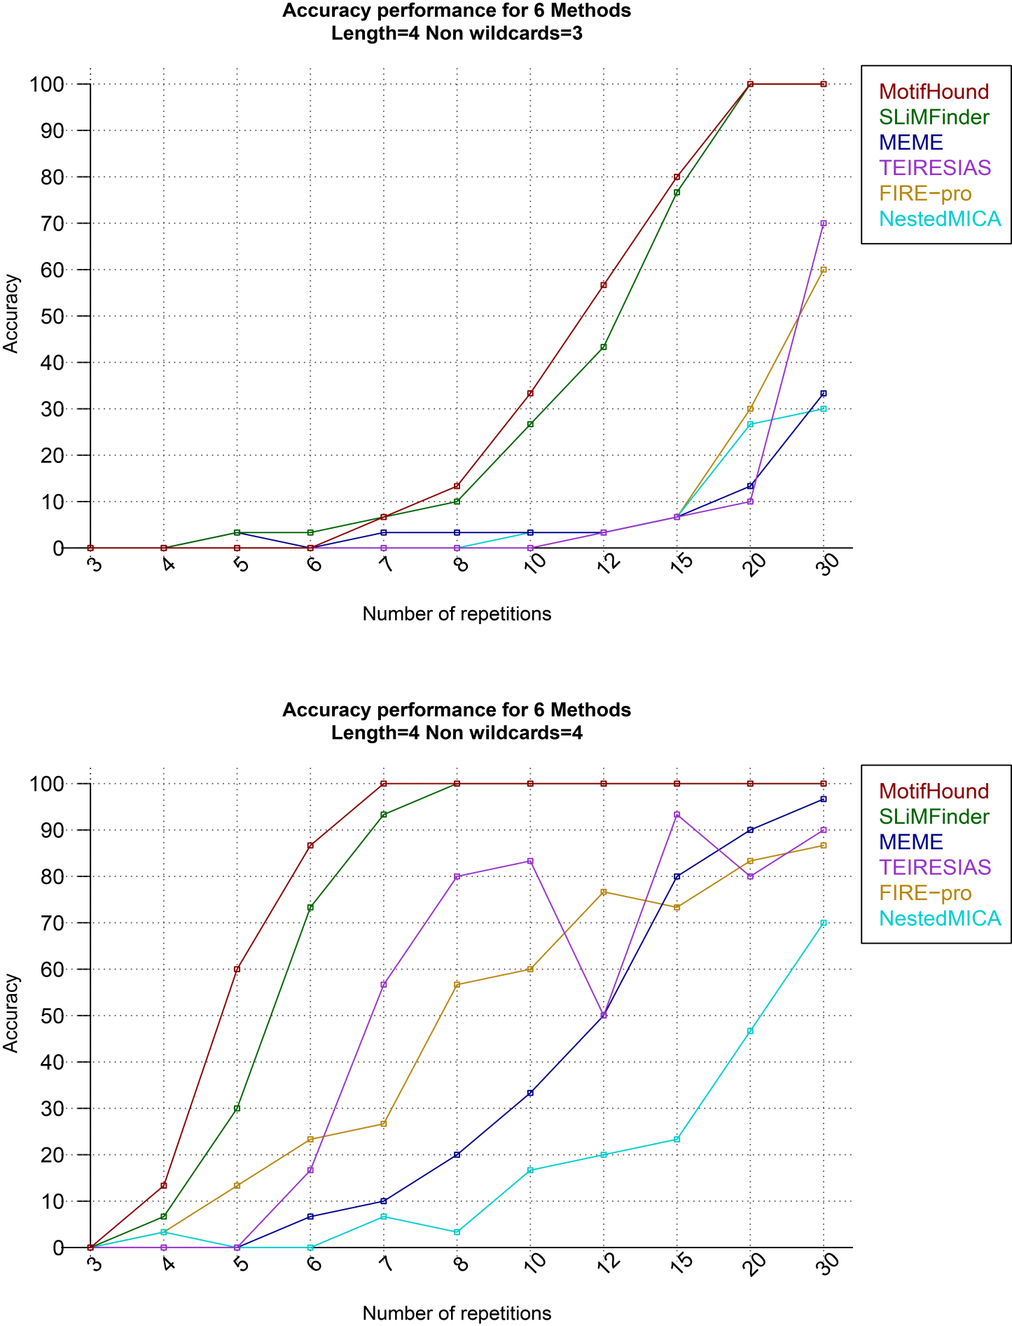
LENGTH 10

Figure S1. Results of the benchmark for motifs of length 4 or 10, with 3 and 4 defined positions respectively.

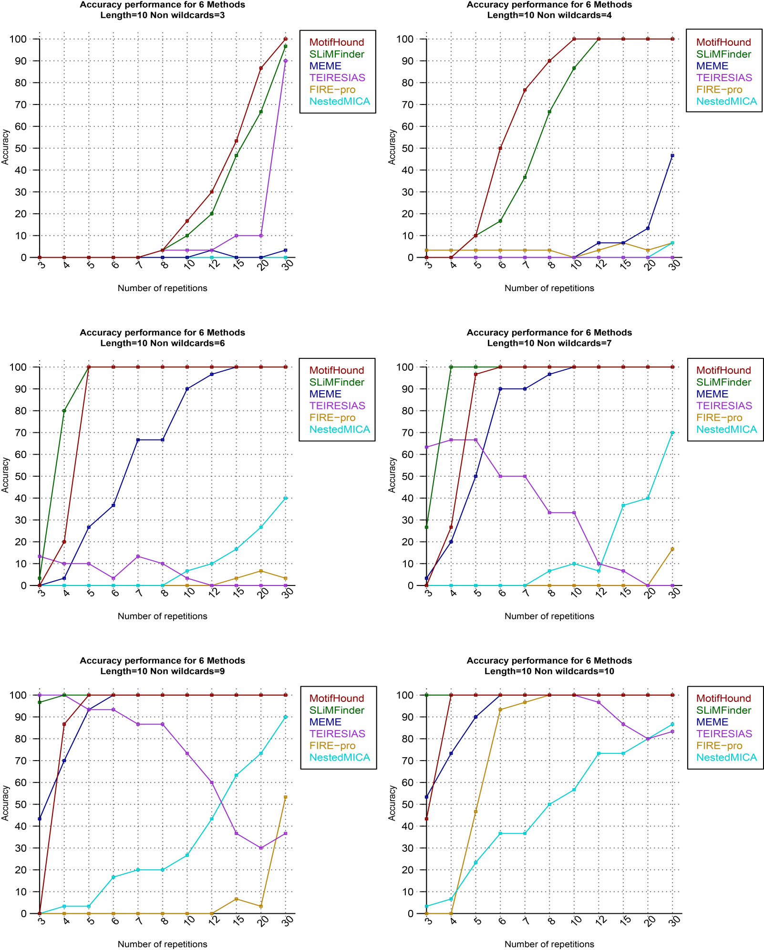
Figure S2. Results of the benchmark for motifs of length 10, with 3 or 4 (top), 6 or 7 (middle) and 9 or 10 defined positions.

1. Tonikian R, Xin X, Toret CP, Gfeller D, Landgraf C, et al. (2009) Bayesian modeling of the yeast SH3 domain interactome predicts spatiotemporal dynamics of endocytosis proteins. PLoS Biol 7: e1000218.
2. Kim J, Lee CD, Rath A, Davidson AR (2008) Recognition of non-canonical peptides by the yeast Fus1p SH3 domain: elucidation of a common mechanism for diverse SH3 domain specificities. J Mol Biol 377: 889-901.

