S1 Fig.
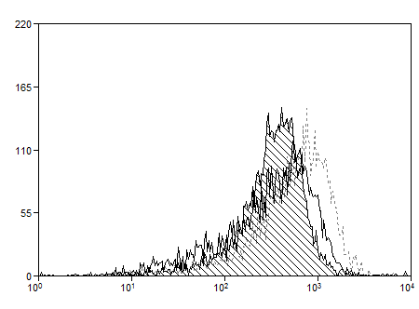
CD6
Th17pol
Thnp
Cell count
Unstimulated

Increased expression of CD6 on activated T cells in Th17 polarizing conditions

