S3 Fig

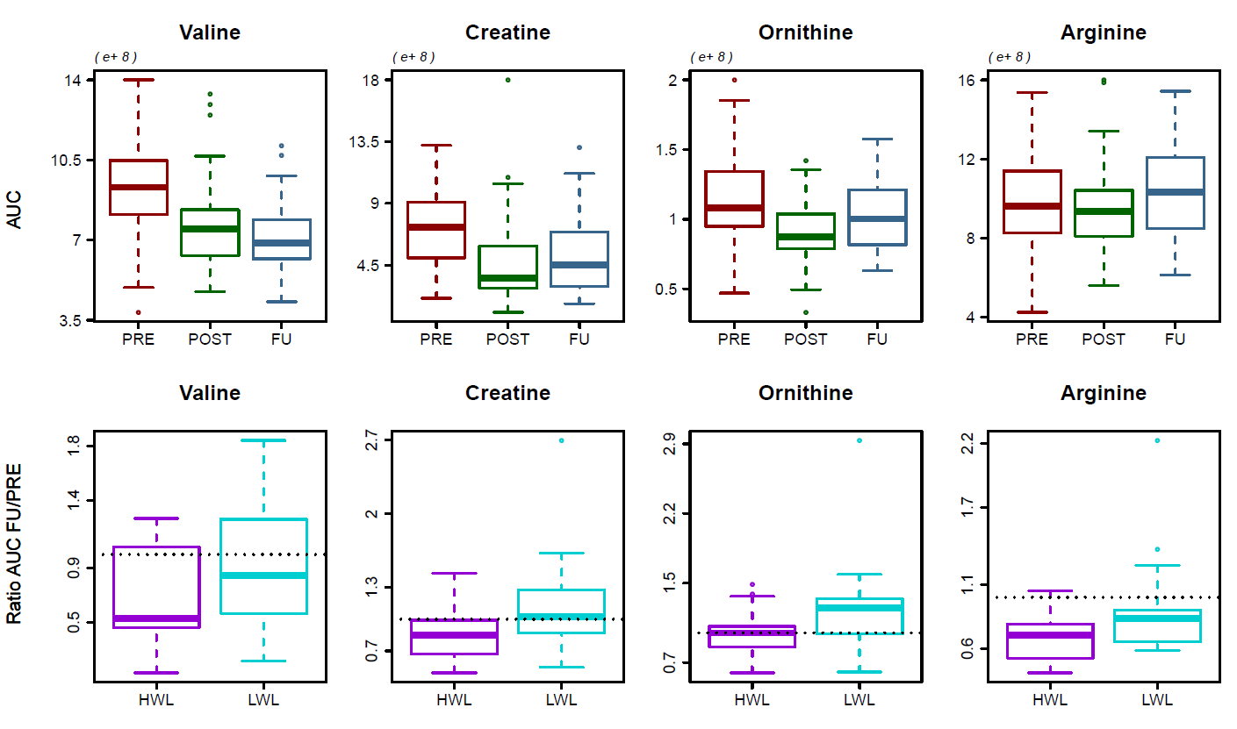
S3 Fig: Metabolites with significant changes between high and low-weight loss patients.

