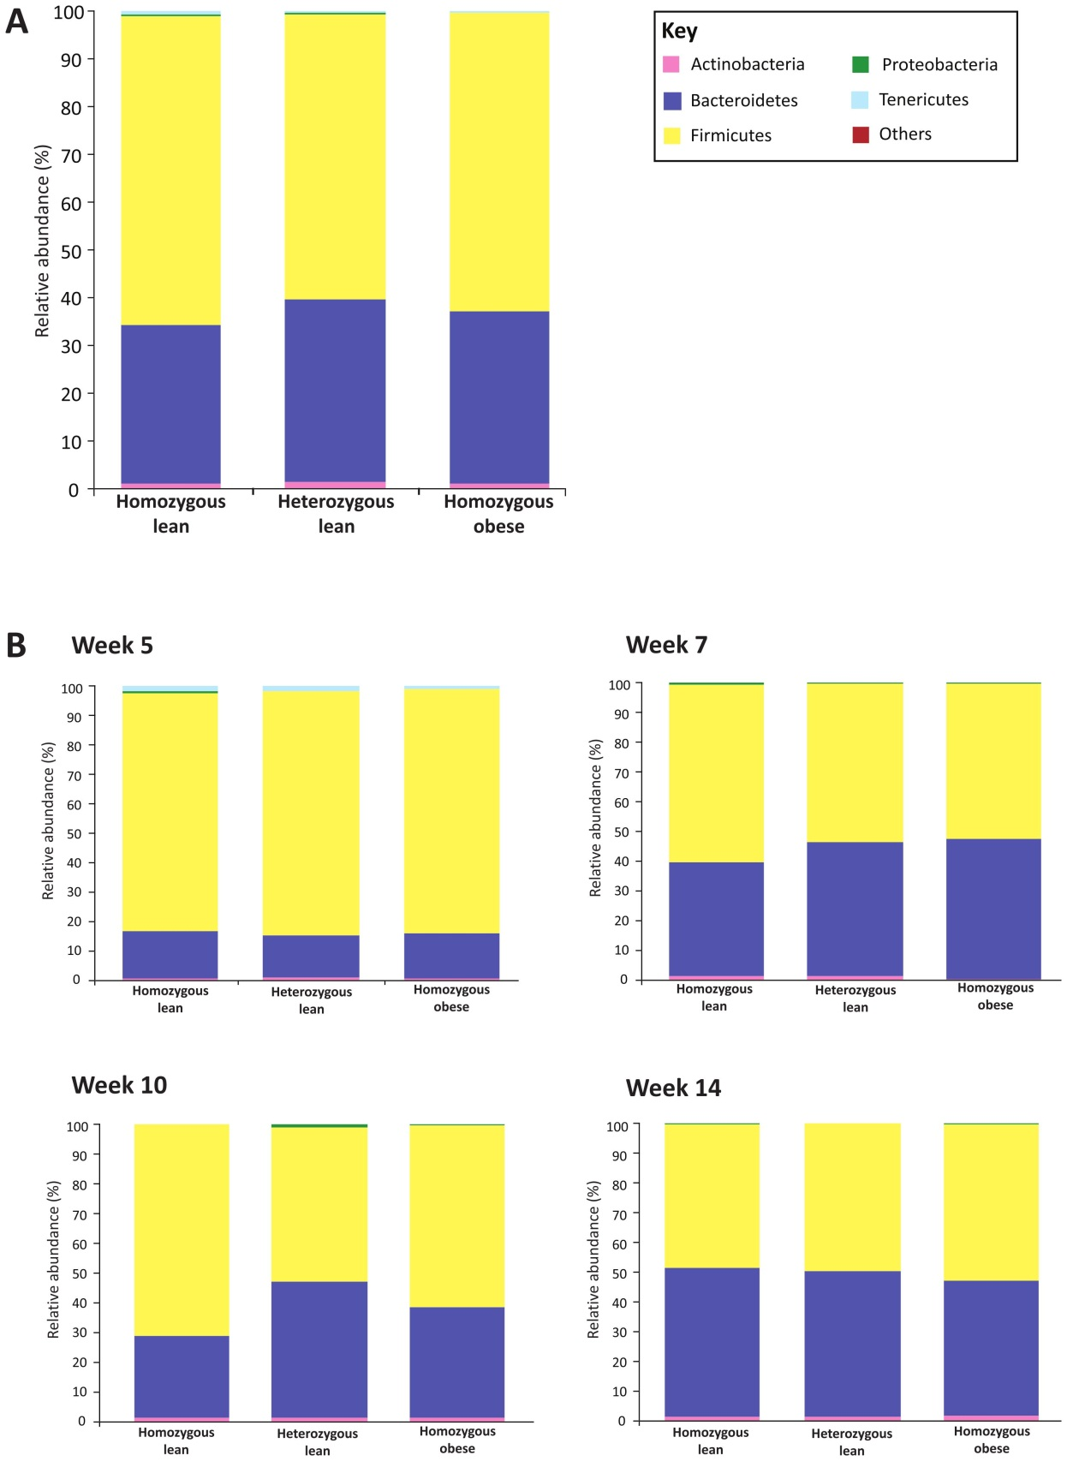
Figure S15: A: mean relative abundances of each phylum for each genotype (all time points included). B: mean relative abundances of each phylum for each genotype at each time point separately. Phylum key: ‘Others’ composed of TM7 and Verrucomicrobia.

