High prevalence and putative lineage maintenance of avian coronaviruses in Scandinavian waterfowl

M Wille, S Muradrasoli, A Nilsson, J D Järhult

S1 Fig

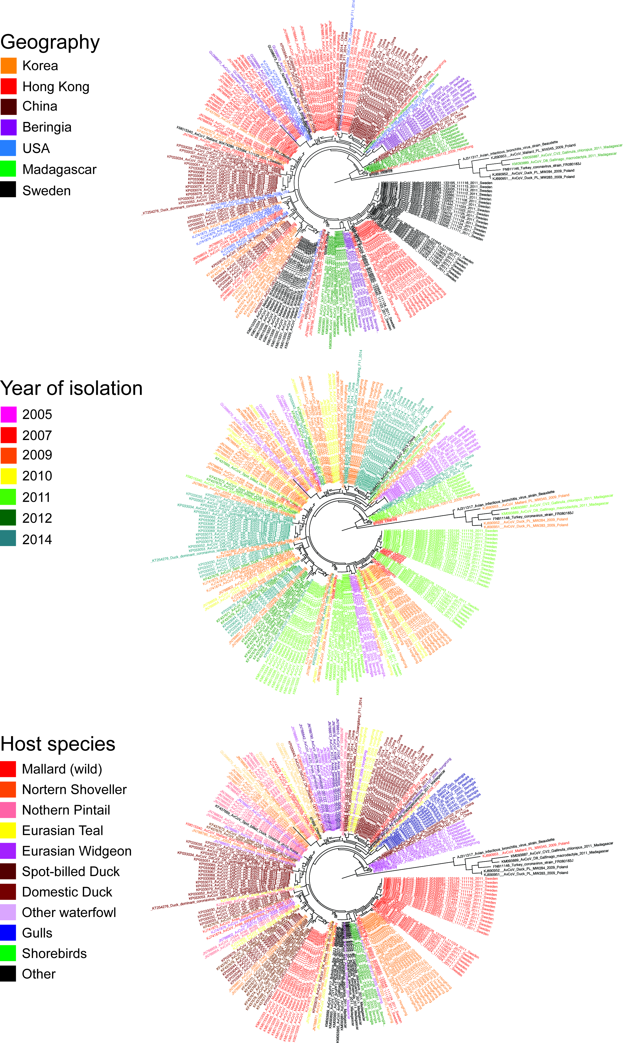

S1 Fig: Avian coronavirus RNA-dependant RNA polymerase phylogeny shows no spatial, temporal or host species patterns. Sequence metadata are provided in Table S2

