S1 Table. Increase in CD6 MFI on CD4⁺ and CD8⁺ lymphocytes upon activation.
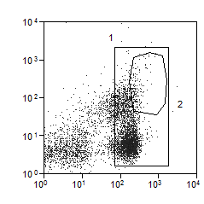
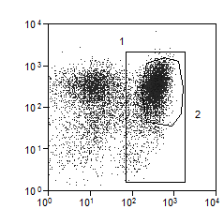
CD25
Unstimulated
Stimulated
CD4

Experiment repeats | CD6 MFI (median) on Gate 1 (CD4⁺) lymphocytes |  | CD6 MFI (median) on Gate 2 (CD4⁺CD25^{hi}) lymphocytes
n | Unstimulated cells | Stimulated cells | Stimulated cells
1 | 113.48 | 168.83 | 188.15
2 | 73.56 | 131.11 | 140.94
3 | 49.44 | 73.56 | 81.98
 | CD6 MFI (median) on Gate 1 (CD8⁺) lymphocytes |  | CD6 MFI (median) on Gate 2 (CD8⁺CD25^{hi}) lymphocytes
n | Unstimulated cells | Stimulated cells | Stimulated cells
1 | 57.13 | 109.45 | 113.48
2 | 39.81 | 91.37 | 94.73
3 | 29.82 | 46.00 | 49.44

