The ARRIVE Guidelines Checklist
Animal Research: Reporting In Vivo Experiments
Carol Kilkenny¹, William J Browne², Innes C Cuthill³, Michael Emerson⁴ and Douglas G Altman⁵
¹The National Centre for the Replacement, Refinement and Reduction of Animals in Research, London, UK, ²School of Veterinary Science, University of Bristol, Bristol, UK, ³School of Biological Sciences, University of Bristol, Bristol, UK, ⁴National Heart and Lung Institute, Imperial College London, UK, ⁵Centre for Statistics in Medicine, University of Oxford, Oxford, UK.

 | ITEM | RECOMMENDATION | Section/  Paragraph
 |  |  | Title
 |  |  | Abstract
INTRODUCTION
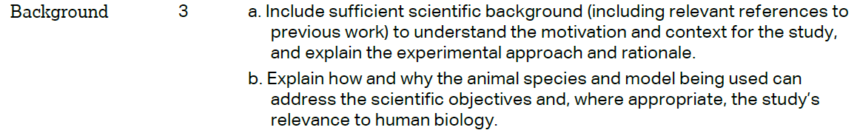 |  |  | Introduaction, Paragraph 1
 |  |  | Introduaction, Paragraph 3
METHODS
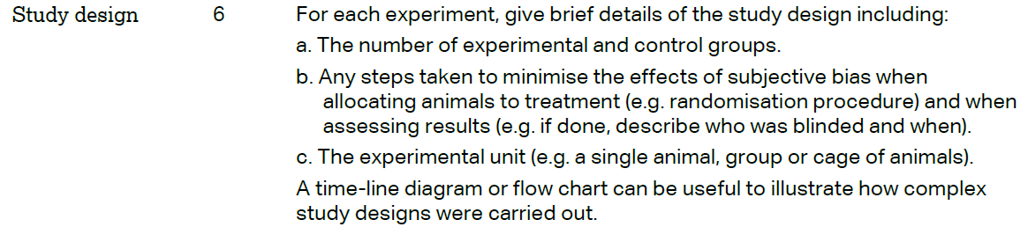
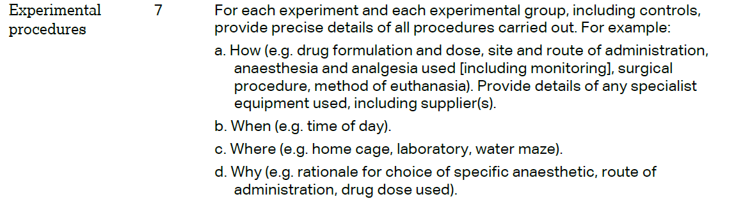
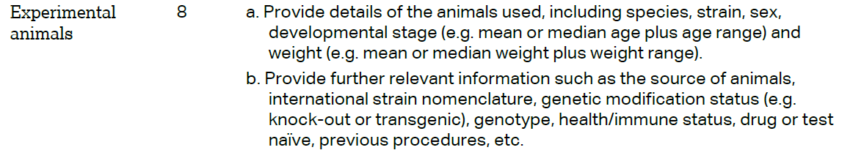
The ARRIVE guidelines. Originally published in PLoS Biology, June 2010¹
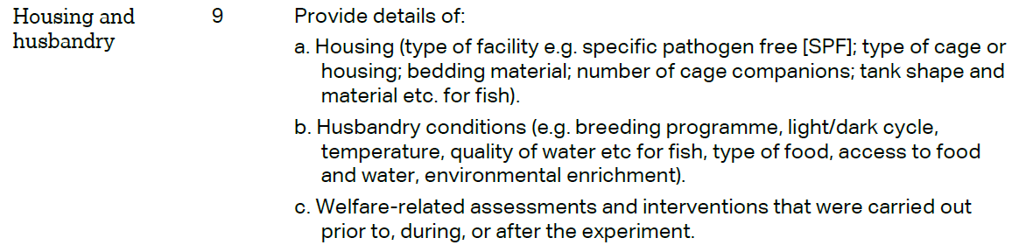
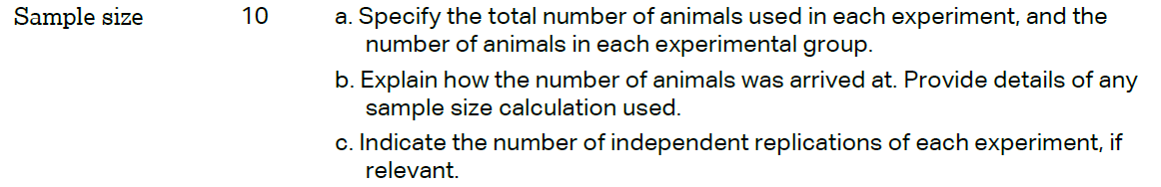
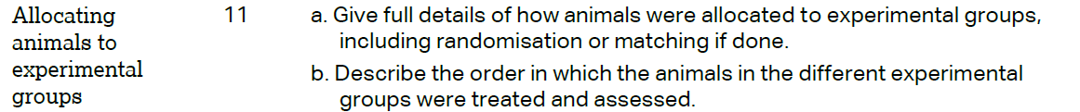
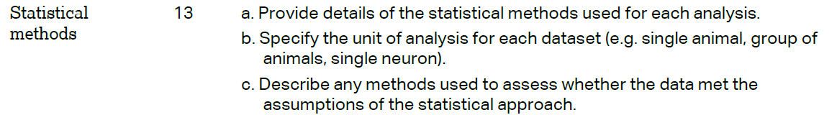
RESULTS
DISCUSSION
