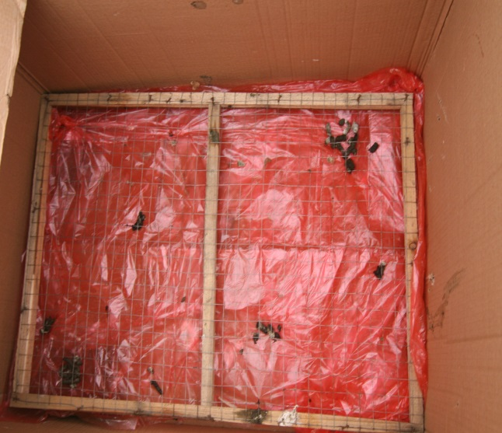
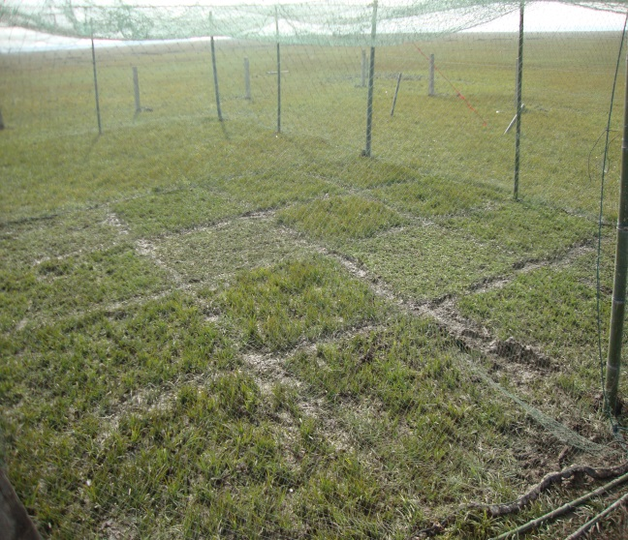
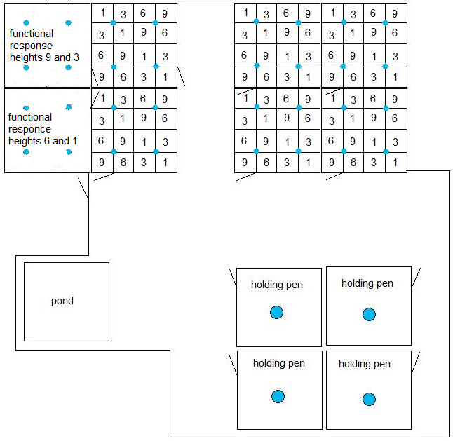
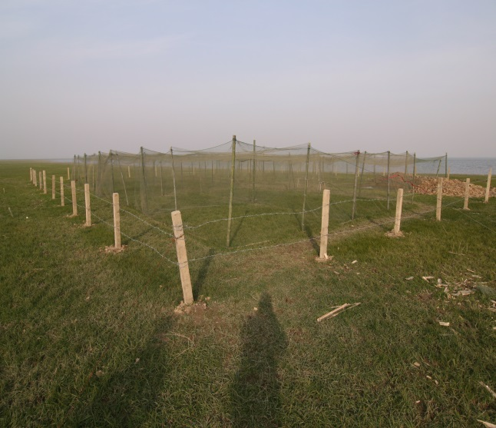
d
c
a
b

S1 Figure: Pictures illustrating the experimental setup. a: a diagram of the enclosures setup. The enclosure consisted of a pond, eight experimental enclosures (5 × 5 m, with 2 m high wire fence), and four holding pens. The blue dots (small and large) indicate the locations where clean water was available, and the oblique lines indicate the entrances. b: overview of the enclosure. c: swards were mowed to different heights (1, 3, 6, 9 cm) following a randomized Latin square design. d: container with a mesh floor used to collect the droppings of the goose after trial.

