S4 Fig

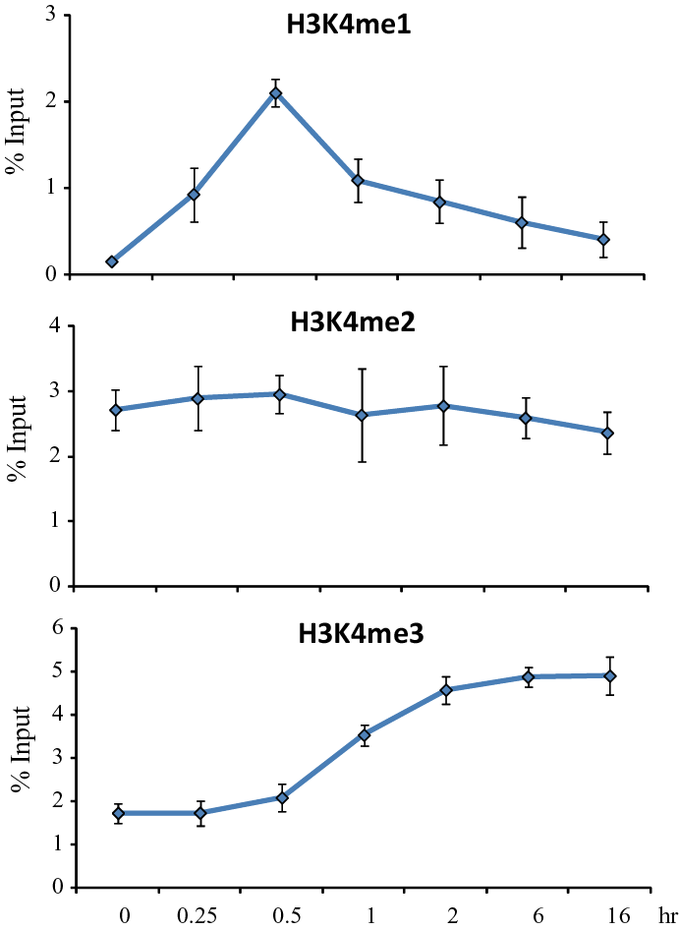
S4 Fig. Kinetic ChIP experiments were performed using H3K4me1, H3K4me2 and H3K4me3 specific antibodies. Cells were treated with 2.5 mM α-amanitin for 2 h followed with 10 nM E2 treatment to carry out the kinetic ChIP assay. A single chromatin was prepared for ChIP assay at each time point.

