Comparative genome analyses reveal distinct structure in the saltwater crocodile MHC

PLOS ONE

Weerachai Jaratlerdsiri¹, Janine Deakin^{2,3}, Ricardo Godinez M.^{4,14}, Xueyan Shan⁵, Daniel G. Peterson⁶, Sylvain Marthey⁷, Eric Lyons⁸, Fiona M. McCarthy⁹, Sally R. Isberg^{1,10}, Damien P. Higgins¹, Amanda Y. Chong¹, John St John¹¹, Travis C. Glenn¹², David A. Ray^{5,6,13}, Jaime Gongora^{1,*}

¹ Faculty of Veterinary Science, University of Sydney, Sydney, New South Wales 2006, Australia

² Evolution Ecology and Genetics, Research School of Biology, Australian National University, Canberra, Australian Capital Territory 2601, Australia

³ Institute for Applied Ecology, University of Canberra, Canberra, Australian Capital Territory 2601, Australia

⁴ Department of Organismic and Evolutionary Biology, Harvard University, Cambridge, Massachusetts 02138, United States of America

⁵ Department of Biochemistry, Molecular Biology, Entomology and Plant Pathology, Mississippi State University, Mississippi State, Mississippi 39762, United States of America

⁶ Institute for Genomics, Biocomputing and Biotechnology (IGBB), Mississippi State University, Mississippi State, Mississippi 39762, United States of America

⁷ Animal Genetics and Integrative Biology, INRA, UMR 1313 Jouy-en-Josas 78352, France

⁸ School of Plant Science, University of Arizona, Tucson, Arizona 85721, United States of America

⁹ School of Animal and Comparative Biomedical Sciences, University of Arizona, Tucson, Arizona 85721, United States of America

¹⁰ Center for Crocodile Research, P.O. Box 329, Noonamah, Northern Territory 0837, Australia

¹¹ Department of Biomolecular Engineering, University of California, Santa Cruz, California 95064, United States of America

¹² Department of Environmental Health Science, University of Georgia, Athens, Georgia 30602, United States of America

¹³ Current Address: Department of Biological Sciences, Texas Tech University, Lubbock, Texas 79409, United States of America

¹⁴ Department of Genetics, Harvard Medical School, 77 Louis Pasteur Ave., Boston, Massachusetts 02115, United States of America

* Corresponding author: Phone: +61-2 9036 9348. Fax: +61-2 9351 3957. E-mail: jaime.gongora@sydney.edu.au

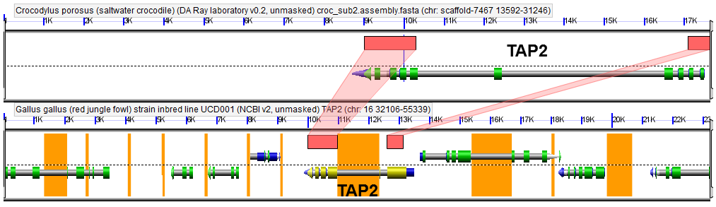

Figure S3. Syntenic areas (red) between saltwater crocodile TAP2 (MHC gene cluster 3.2 or scaffold-7467 described in Table 1) and jungle fowl TAP2 (ID 2731, v2, unmasked and CDS). Gray arrows indicate gene models; green arrows indicate protein coding sequences (CDS); blue arrows (on top of gray genes) indicate mRNA; and yellow arrows indicate approximately 50% GC content in codon wobble positions. Areas highlighted in orange show unsequenced positions

