S1 Fig A and Table A
Skull Landmarks
1 | Occipital condyle
3 | Posterior squamosal process
5 | Posterior edge of quadratojugal bone
7 | Anterior squamosal process (next to orbit)
9 | Anterior edge of fossa between pterygoid and quadratojugal
11 | Widest point of curve on fronto-parietal bone
13 | Upper curve of nasal bone (dorsal)
15 | Lower curve of nasal bone (dorsal)
17 | Terminal edge of premaxillary bone
19 | Top of dentary bone
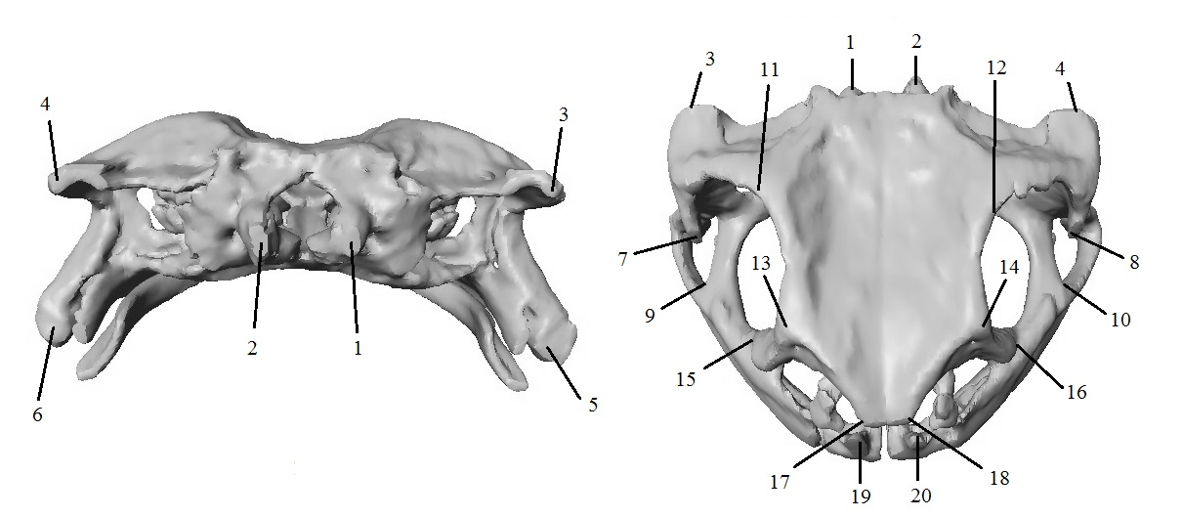

S1 Fig B and Table B
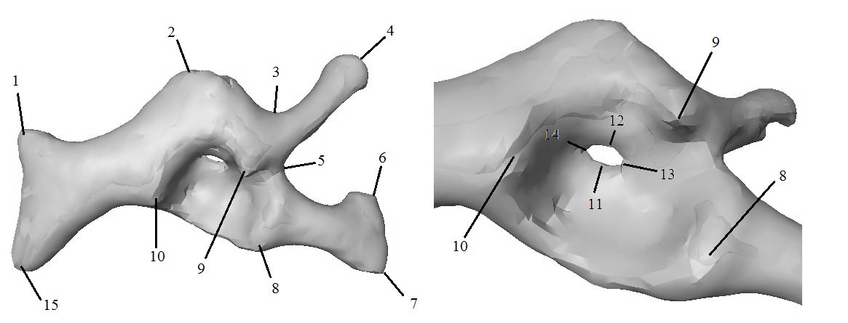

Pectoral Girdle Landmarks
1 | (Scapula) Anterior articulation point with suprascapula
2 | Highest point on connecting cartilage between clavicle and scapula
3 | Lowest point in groove of clavicle
4 | Terminal end of clavical (sternoclavicular joint)
5 | Mid-point on groove between clavicle and coracoid
6 | Anterior process of coracoid (articulation point with sternum)
7 | Posterior process of coracoid (articulation point with sternum)
8 | Proximal ridge of glenohumeral joint
9 | Medial ridge of glenohumeral joint
10 | Distal ridge of glenohumeral joint
11 | Dorsal aperture of glenohumeral fossa
12 | Ventral aperture of glenohumeral fossa
13 | Distal aperture of glenohumeral fossa
14 | Proximal aperture of glenohumeral fossa
15 | (Scapula) Posterior articulation point with suprascapula

S1 Fig C and Table C
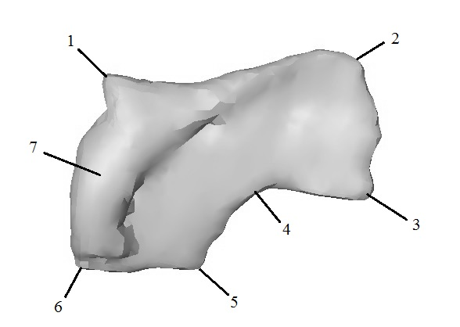

Suprascapular Landmarks
1 | Anterior distal edge, at articulation point with scapula
2 | Anterior proximal edge of bone
3 | Posterior proximal edge of bone
4 | Mid-point of curvature between points #3 and #4
5 | Posterior distal edge – opposite point #6
6 | Posterior distal edge, at articulation point with scapula
7 | Highest point on cleithrum

S1 Fig D and Table D
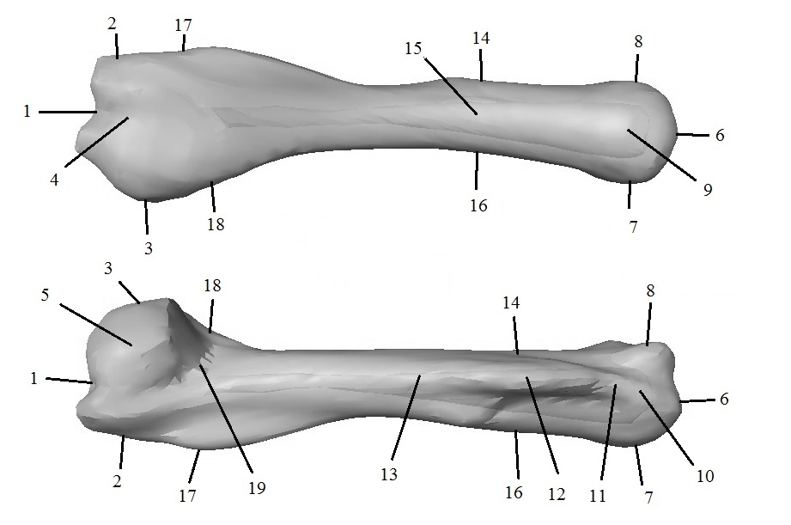

Humerus Landmarks
1 | Terminal end of posterior extremity (cubital joint)
2 | Lateral edge of posterior extremity (trochlear side)
3 | Opposite point #2 (non-trochlear side)
4 | Doral edge of posterior extremity
5 | Opposite point #4 (ventral)
6 | Terminal end of anterior extremity (glenohumeral joint)
7 | Lateral edge of anterior extremity (non-trochlear side)
8 | Opposite point #7 (trochlear side)
9 | Dorsal edge of anterior extremity
10 | Opposite point #9 (ventral)
11 | Anterior edge of crista deltoidea
12 | Mid-point of crista deltoidea
13 | Posterior edge of crista deltoidea
14 | Lateral mid-point of bone (non-trochlear side)
15 | Opposite point #12
16 | Opposite point #14
17 | Lateral edge of crista medialis (where it meets head of humerus)
18 | Opposite point # 17
19 | Groove under head at cubital joint

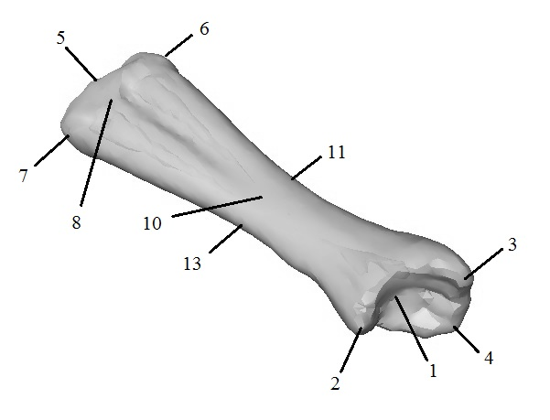
S1 Fig E and Table E

Radioulna Landmarks
1 | Centre of greater sigmoid cavity (cubital joint)
2 | Capitulum radii
3 | Lower ridge of olecranon
4 | Upper ridge of olecranon
5 | Terminal end, at groove between ulna and radius (radiocarpal joint)
6 | Lateral (ulnar) terminal end
7 | Lateral (radial) terminal end
8 | Dorsal terminal end
9 | Ventral terminal end
10 | Dorsal midpoint of bone
11 | Lateral (ulnar) midpoint
12 | Opposite point #10 (ventral)
13 | Opposite point #11 (radial)

S1 Fig F and Table F
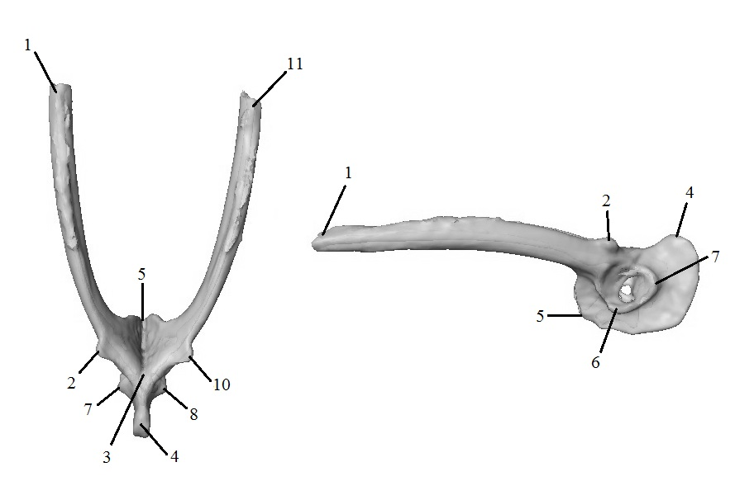

Pelvic Girdle Landmarks
1 | Terminal point of left iliac arm
2 | Superior process of left ilium
3 | Meeting point between iliac arms
4 | Tuber ischii
5 | Inferior process of the ilium
6 | Left ischial acetabular margin
7 | Left pubic acetabular margin
8 | Right ischial acetabular margin
9 | Right pubic acetabular margin
10 | Superior process of right ilium
11 | Terminal point of right iliac arm

S1 Fig G and Table G

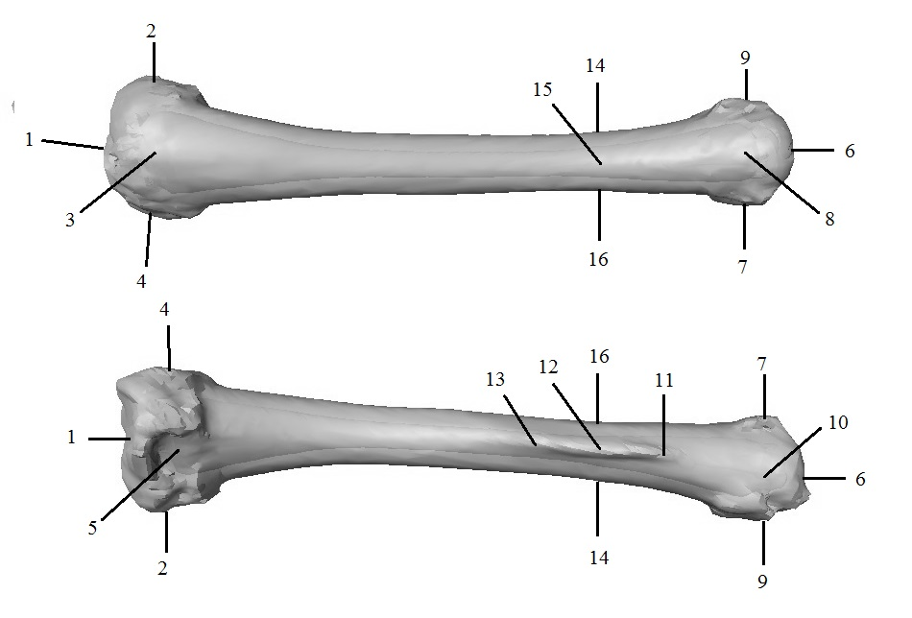

Femur Landmarks
1 | Terminal end of posterior extremity (patellofemoral joint)
2 | Lateral end of posterior extremity (left side)
3 | Opposite point #3
4 | Dorsal end of posterior extremity (top of knee)
5 | Opposite point #5 (ventral)
6 | Terminal end of anterior extremity (acetabular joint)
7 | Lateral end of anterior extremity (right side)
8 | Opposite point #7
9 | Dorsal end of anterior extremity
10 | Opposite point #9 (ventral)
11 | Anterior edge of crista femoralis
12 | Mid-point of crista femoralis
13 | Posterior edge of crista femoralis
14 | Lateral mid-point of bone (right side)
15 | Opposite point #12 (dorsal)
16 | Opposite point #14

S1 Fig H and Table H
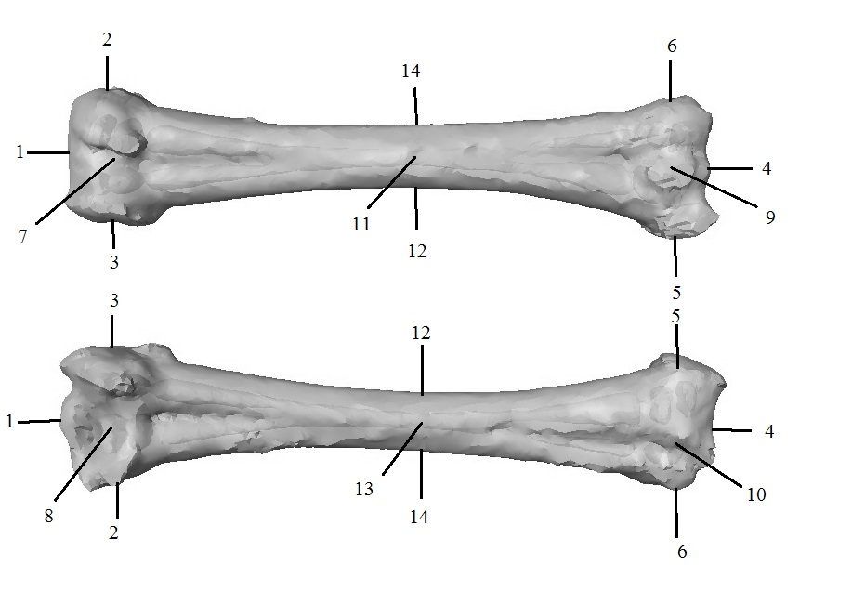

Tibiofibula Landmarks
1 | Terminal edge of anterior extremity (patellofemoral joint)
2 | Lateral end of anterior extremity (left side)
3 | Opposite point #2
4 | Terminal edge of posterior extremity (articulation point with tarsus)
5 | Lateral edge of posterior extremity (same side as calcaneum)
6 | Opposite point #5 (same side as astragalus)
7 | Dorsal end of anterior extremity
8 | Opposite point #7 (inside of knee)
9 | Dorsal end of posterior extremity (inside of ankle)
10 | Opposite point #9
11 | Mid-point of bone (outside edge)
12 | Lateral midpoint (right side)
13 | Opposite point #11 (inside edge)
14 | Opposite point #12

S1 Table I

Bone | PC Axis | Description (of large PC value)
Skull | 1 | Increased cranial height, shortening of distance between posterior squamosal processes (points 3 and 4) and fronto-parietal curve above orbit (points 11 and 12), resulting in lateral skull compression.
Pectoral girdle | 2 | Increased aperture of glenohumoral fossa (points 11-14). Decreased height of connecting cartilage between clavicle and scapula (point 2).
Pectoral girdle | 3 | Increased curvature of pectoral girdle, larger glenohumoral joint (points 8, 9 and 10).
Humerus | 1 | Increased bone straightness (angle between points 1 and 6). Larger head of bone at cubital joint (increased distance between points 4 and 5).
Radioulna | 3 | Compression of cubital joint (decreased distance between 2, 3 and 4). Increased height of bone at radiocarpal joint (points 8 and 9).
Radioulna | 4 | Increased distance between points 2 and 4 (at cubial joint). Ulnar end of radiocarpal joint (point 6) less angular, resulting in flattening at wrist.
Pelvic girdle | 3 | Increased distance and angle between iliac arms (points 1, 11). Inferior process of ilium upturned (decreased distance between points 3 and 5).
Pelvic girdle | 6 | Broadening of acetabulum, increased height of superior iliac processes (points 2, 10), decreased height of tuber ischium.
Femur | 3 | Heads of bone larger at patellofemoral (points 1-5) and acetabular joints (points 6-10)
Tibiofibula | 2 | Heads of bone smaller at patellofemoral (points 1,2,3,7,8) and tarsal joint (points 4,5,6,9,10).
Tibiofibula | 5 | Reduced size of patellofemoral head, expressed as increased distance of point 1 from midpoint

