Effect of quambalarine B on Jurkat cell line - Quantitation of the intracellular MitoTracker® Red CMXRos signal

Biological activity of all isolated naphthoquinones was tested on suspension tumor-derived cell lines (REH, NALM 6 and Jurkat) using flow cytometry. Representative example of the FACS-based bioassay of the mitochondrial activity performed on Jurkat cell line is shown.

Experimental procedure
Tested cell types were cultivated in 96 well plates (Nunc, Thermo Fisher Scientific, Waltham, MA, USA) and treated with compounds dissolved in the DMSO (stock solution 10 mM) for various times and concentrations and measured using FACS LSR II (Becton Dickinson) for MitoTracker® Red CMXRos (Molecular Probes, Invitrogen, Carlsbad, CA, USA) signal.

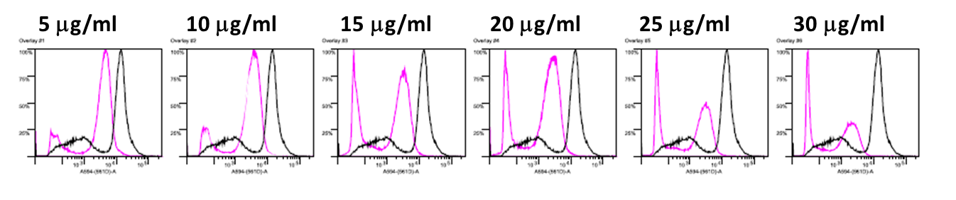
Figure S3. Quantitation of the MitoTracker® Red CMXRos signal after 24h treatment of Jurkat cell line with various concentrations of quambalarine B (5-30μg/ml). Fluorescence signal reflecting proton gradient presence in experimental conditions (red) is overlayed with the data acquired on the control cells (black line). Note the concentration-dependent drop in MitoTracker® Red CMXRos fluorescence intensity (logarithmic x-axis).

