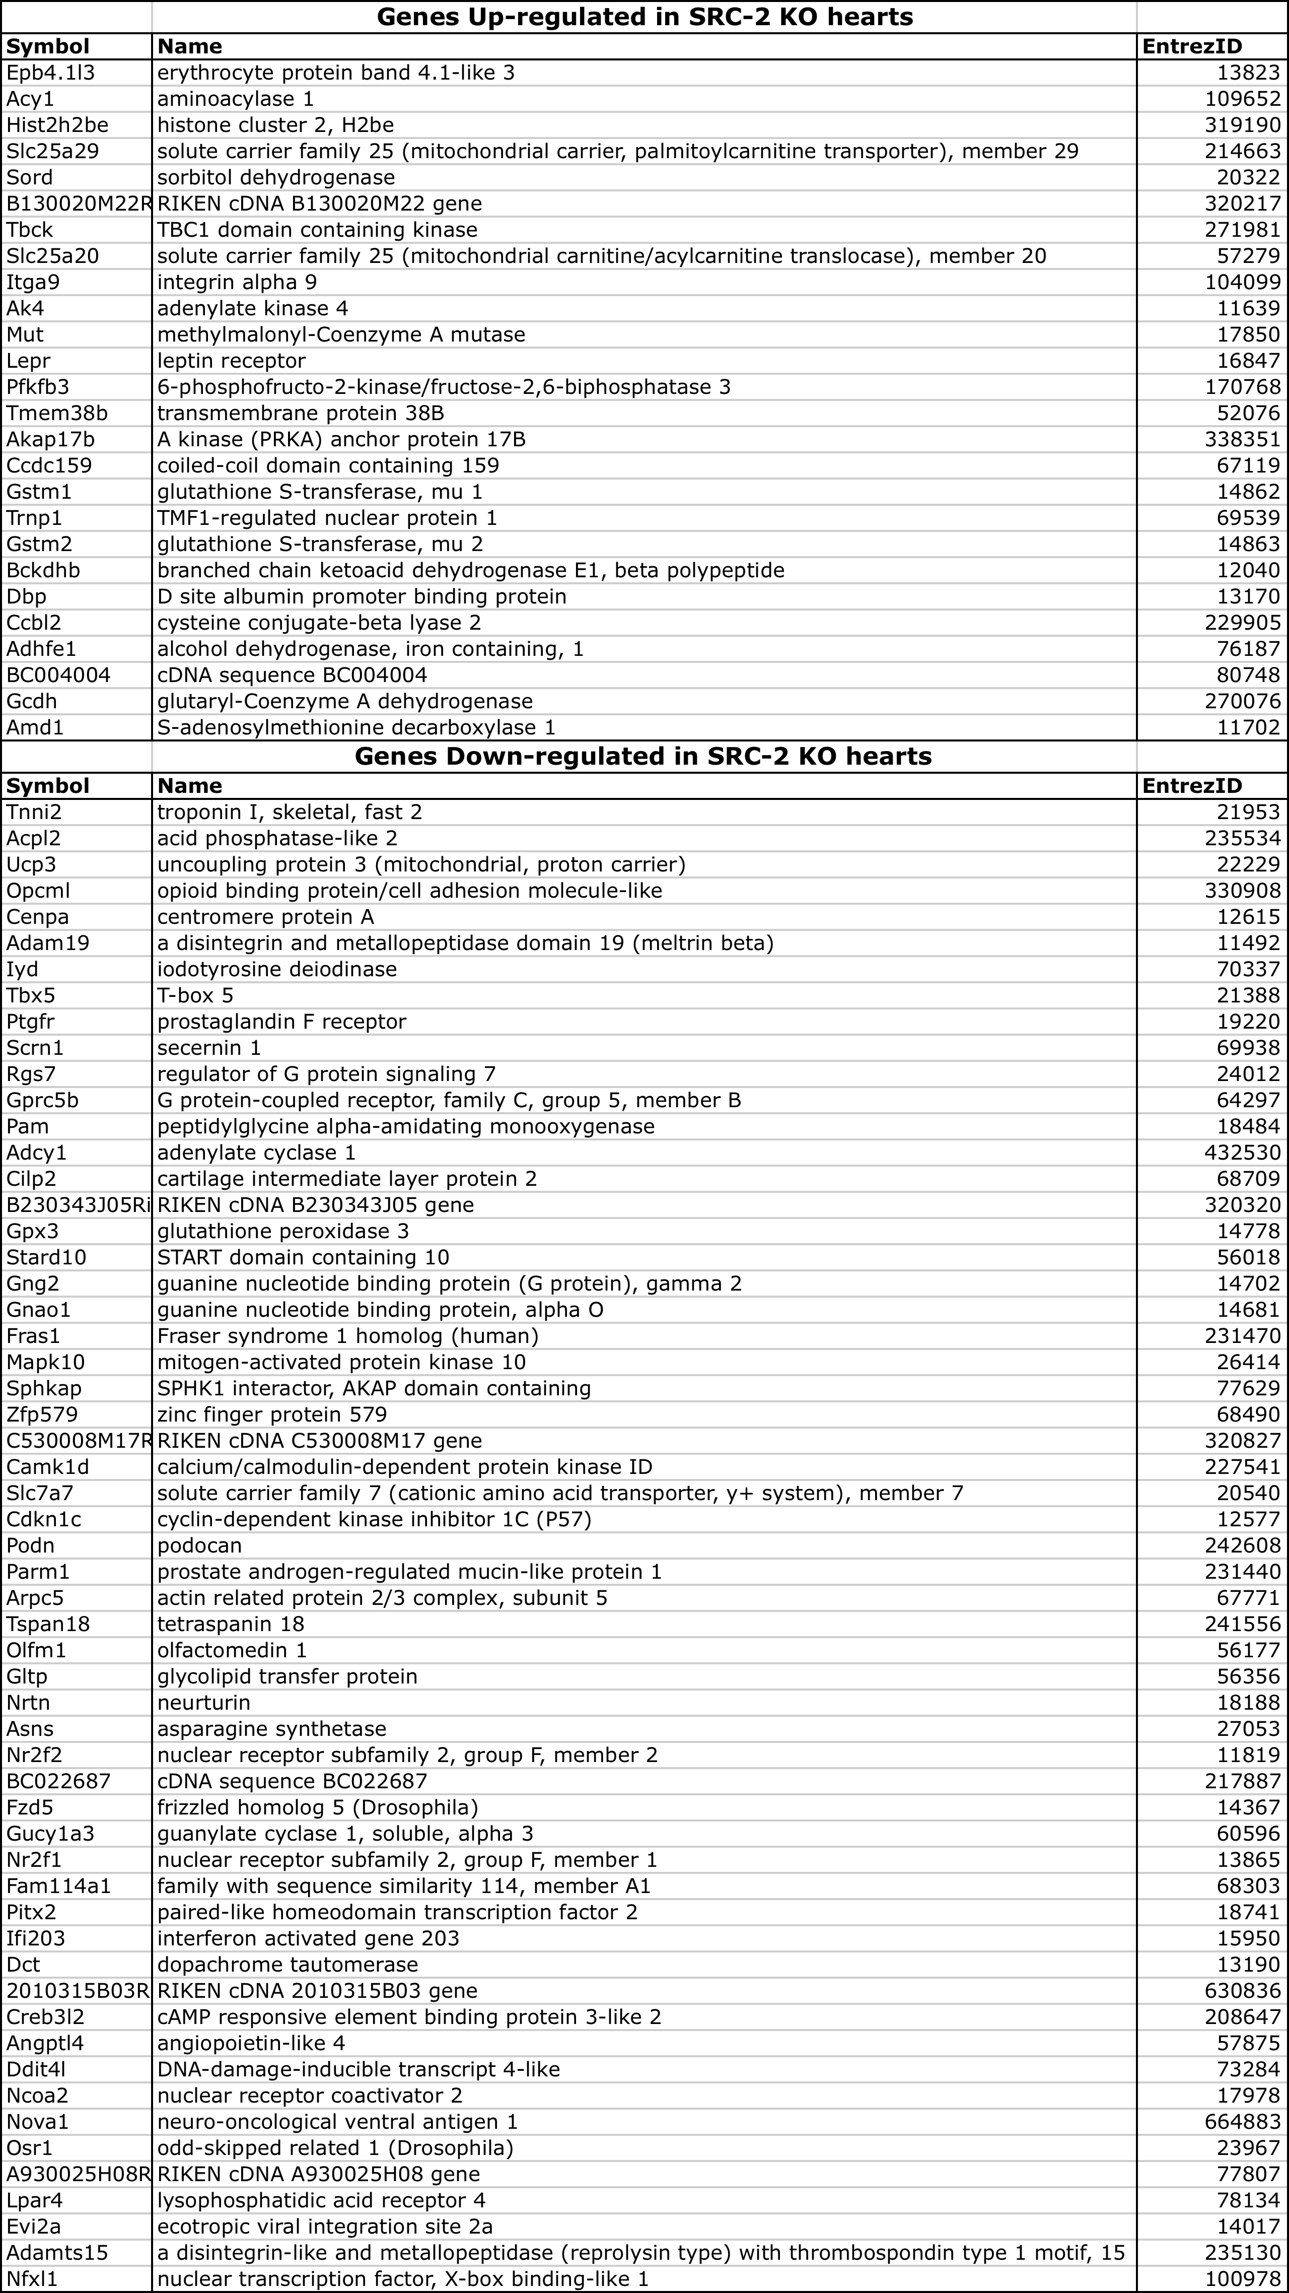
Table S1. Genes significantly altered in SRC-2 KO heart microarray.

