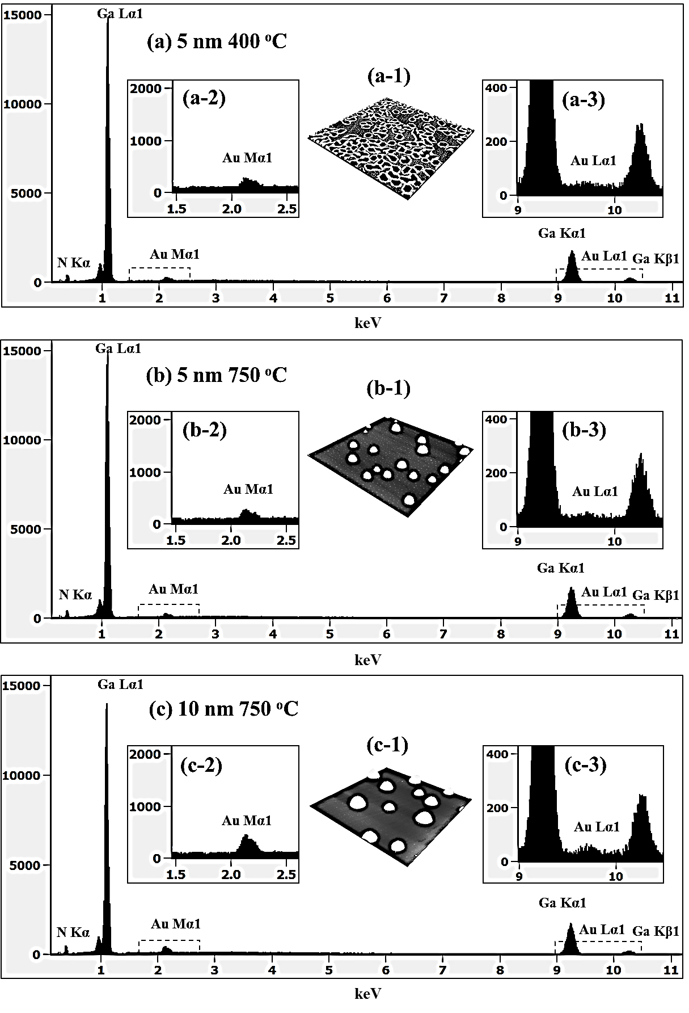
S11 Fig. EDS spectra of (a) 5 nm of Au deposition with 400 ºC of annealing and (b) 750 ºC, and (c) 10 nm of Au deposition annealed at 750 ºC. The Y-axis is counts and the X-axis is the energy of corresponding counts. (a-1) - (c-1) are AFM side-views (5 × 5 μm²). (a-2) - (c-2) are enlarged spectra between 1.5 and 2.5 keV, and that of (a-3) – (c-3) are between 9 and 10.5 keV.

Figure S11 shows the EDS spectra of 5 nm Au deposition annealed at 400 ºC in Fig. S11(a) and at 750 ºC in Fig. S11(b). Fig. S11(c) shows the spectra with the 10 nm Au deposition at 750 ºC for 300 s. The Y-axis shows the counts and the X-axis indicates the energy level of corresponding counts. The enlarged spectra between 1.5 and 2.5 keV show the peak count of Au Mα1 in Figs. S11(a-2) – S11(c-2) and similarly the enlarged spectra between 9 and 10.5 keV show the peak count of Au Lα1 in Figs. S11(a-3) – S11(c-3). As shown in Fig. S11(a) – S11(b), with the variation of T_{a} of 400 and 750 ºC with 5 nm deposition, although the AFM side-view of corresponding samples show the distinctive morphologies in Figs. S11(a-1) and S11(b-1), the Au Mα1 peak at 2.136 keV and Au Lα1peak at 9.741 keV were nearly identical. But when the Au deposition amount was raised to 10 nm keeping T_{a} fixed 750 ºC, comparatively higher Au Mα1 peak at 2.136 keV was observed as shown in Fig. S11(c) likely due to the increased interaction volume of Au atoms with X-ray. When Au deposition amount was increased to 10 nm, Au Mα1 peak showed approximately

