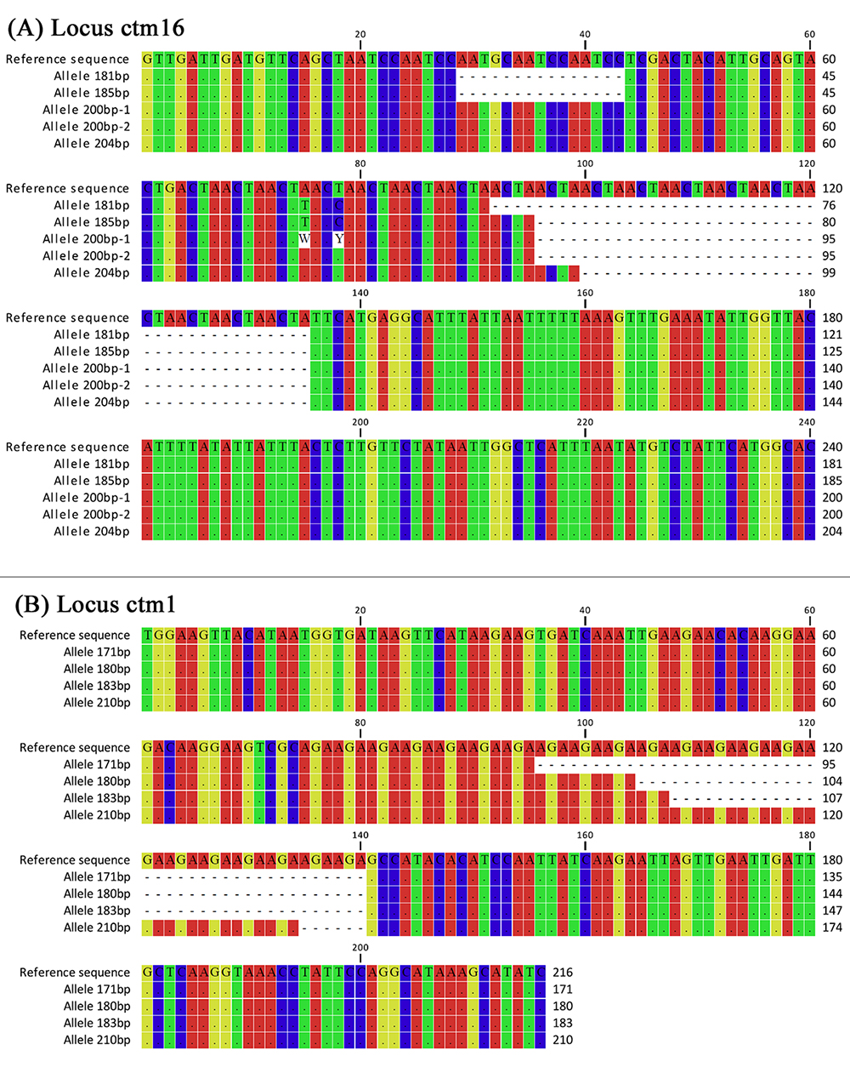
S1 Figure. Sequence alignment for part of different alleles. Reference sequence were from C. tropicalis genome strain MYA-3404. (A) Locus ctm16, showing the number of repeats of each allele (repeat motif ‘ACTA’, alignment positions 92-135 bp) and unstable flanking regions (alignment positions 29-44 bp). (B) Locus ctm1, showing the number of repeats (repeat motif ‘AGA’, alignment positions 96-140 bp) and stable flanking regions.

