Appendix S2: Results
1. Climate windows and signals 1
2. Climate Sensitivities 7
3. Species Signal 10
4. Species and site traits 14
- Climate windows and signals
Table A. Importance values, calculated as the sum of ‘Akaike weights’ over all models, for each climate variable in the final model for each species. Variables are represented by NA if they did not have any windows below the cut-off value or were subsequently removed as they appeared to be hitchhiker values. The sexed column shows which species were able to be accurately sexed, and therefore which species had sex differences included in the models. Temp is temperature, DTR is the climate variable daily temperature range.
 | Common name | Species name | Temp | Rain | Sun | Humid | Wind | DTR | Sexed
1 | Bearded reedling | Panurus biarmicus | 0.55 | 0.57 | NA | 1.00 | 0.92 | 0.92 | yes
2 | Bluethroat | Luscinia svecica | NA | 1.00 | 0.92 | 0.64 | 0.98 | 1.00 | yes
3 | Common blackbird | Turdus merula | 0.87 | NA | 0.57 | 0.61 | 1.00 | 1.00 | yes
4 | Common chaffinch | Fringilla coelebs | 0.68 | 0.99 | NA | 0.65 | NA | NA | yes
5 | Common chiffchaff | Phylloscopus collybita | 0.56 | 1.00 | 0.73 | 0.91 | 1.00 | 1.00 | no
6 | Common grasshopper warbler | Locustella naevia | NA | NA | 0.98 | NA | 0.96 | 0.84 | no
7 | Common linnet | Carduelis cannabina | 0.56 | 1.00 | NA | NA | 1.00 | 0.46 | yes
8 | Common redstart | Phoenicurus phoenicurus | 0.81 | NA | 0.84 | 0.77 | NA | NA | yes
9 | Common reed bunting | Emberiza schoeniclus | 1.00 | 0.97 | 0.98 | 1.00 | 1.00 | 0.51 | yes
10 | Common starling | Sturnus vulgaris | 0.94 | 0.99 | 1.00 | 0.93 | 0.92 | NA | yes
11 | Common whitethroat | Sylvia communis | NA | 0.81 | 0.97 | 0.99 | NA | 0.75 | yes
12 | Dunnock | Prunella modularis | 0.85 | 0.94 | NA | 0.63 | 0.91 | NA | no
13 | Eurasian blackcap | Sylvia atricapilla | 1.00 | 0.92 | NA | 0.89 | 0.89 | NA | yes
14 | Eurasian blue tit | Cyanistes caeruleus formerly Parus caeruleus | NA | 0.99 | 0.89 | 0.78 | 1.00 | 1.00 | no
15 | Eurasian bullfinch | Pyrrhula pyrrhula | 1.00 | NA | NA | 0.99 | NA | 0.63 | yes
16 | Eurasian jay | Garrulus glandarius | NA | 0.98 | NA | 0.95 | 0.90 | NA | no
17 | Eurasian reed warbler | Acrocephalus scirpaceus | 1.00 | 0.99 | 1.00 | 1.00 | NA | 1.00 | no
18 | Eurasian tree sparrow | Passer montanus | 0.58 | NA | NA | NA | 0.53 | 0.90 | no
19 | Eurasian wren | Troglodytes troglodytes | 0.53 | 0.99 | 0.84 | NA | 0.77 | 1.00 | no
20 | European crested tit | Lophophanes cristatus, previously Parus cristatus | NA | 0.84 | NA | 0.87 | 0.99 | 0.92 | no
21 | European goldfinch | Carduelis carduelis | NA | 1.00 | NA | 0.99 | NA | NA | yes
22 | European greenfinch | Carduelis chloris | NA | 0.72 | NA | 0.94 | NA | 0.97 | yes
23 | European pied flycatcher | Ficedula hypoleuca | NA | NA | NA | NA | 0.80 | 0.99 | yes
24 | European robin | Erithacus rubecula | 0.99 | 0.57 | 0.89 | NA | 1.00 | NA | no
25 | European stonechat | Saxicola torquata rubicola | NA | NA | 0.51 | 0.79 | 0.71 | 0.82 | yes
26 | Garden warbler | Sylvia borin | NA | NA | NA | NA | NA | 1.00 | no
27 | Great tit | Parus major | NA | 1.00 | 0.89 | 0.69 | 1.00 | 0.57 | yes
28 | House sparrow | Passer domesticus | 0.89 | NA | NA | NA | 0.92 | 0.96 | yes
29 | Icterine warbler | Hippolais icterina | NA | NA | NA | 1.00 | NA | NA | no
30 | Long-tailed tit | Aegithalos caudatus | 0.99 | 0.93 | 0.58 | NA | 1.00 | NA | no
31 | Marsh tit | Poecile palustris | NA | NA | 1.00 | NA | NA | NA | no
32 | Marsh warbler | Acrocephalus palustris | NA | NA | 0.98 | 0.97 | 0.99 | NA | no
33 | Sedge warbler | Acrocephalus schoenobaenus | NA | 1.00 | 1.00 | NA | 0.89 | 1.00 | no
34 | Short-toed treecreeper | Certhia brachydactyla | 0.98 | 1.00 | 0.74 | 0.55 | NA | NA | no
35 | Song thrush | Turdus philomelos | NA | 0.98 | 0.78 | NA | NA | 0.99 | no
36 | Spotted flycatcher | Muscicapa striata | NA | 1.00 | NA | NA | NA | NA | no
37 | Tree pipit | Anthus trivialis | NA | 0.97 | NA | NA | 0.77 | NA | no
38 | Willow tit | Parus montanus | NA | NA | NA | NA | NA | 1.00 | no
39 | Willow warbler | Phylloscopus trochilus | 1.00 | 1.00 | 0.64 | 0.78 | 1.00 | 1.00 | no
40 | Common nightingale | Luscinia megarhynchos | NA | NA | NA | NA | NA | NA | no
41 | Eurasian nuthatch | Sitta europaea | NA | NA | NA | NA | NA | NA | yes
42 | Goldcrest | Regulus regulus | NA | NA | NA | NA | NA | NA | yes
43 | Great spotted woodpecker | Dendrocopos major | NA | NA | NA | NA | NA | NA | yes
44 | Lesser whitethroat | Sylvia curruca | NA | NA | NA | NA | NA | NA | yes
45 | Savi's warbler | Locustella luscinioides | NA | NA | NA | NA | NA | NA | no
46 | White wagtail | Motacilla alba | NA | NA | NA | NA | NA | NA | yes

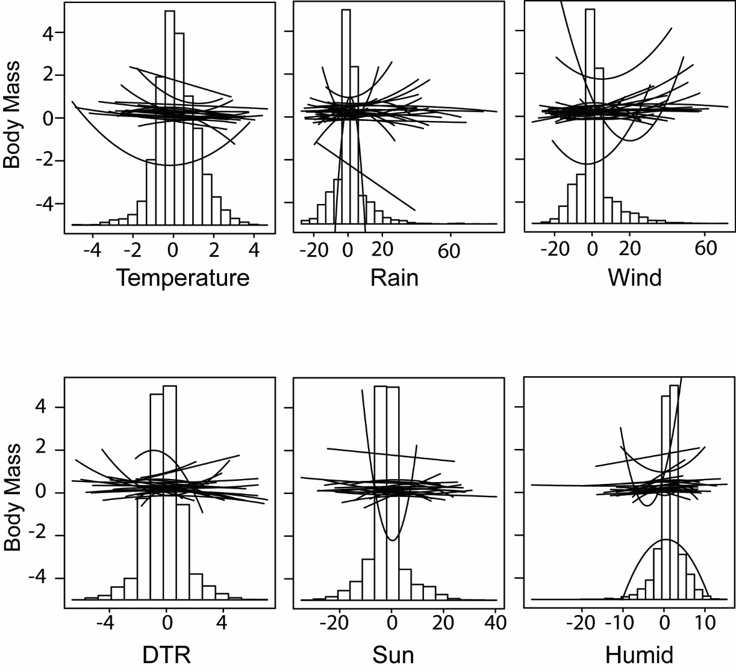
Fig A. Model averaged slope estimates for the climate impacts on body condition. Each line shows the relationship between climate and body condition for a different species. The histogram shows the distribution of mean annual climate values (i.e. the range of climate experienced over the study period).

Table B. Climate windows for all species. Blank spaces indicate where those climate variables had no effect on body condition. From and till indicate the earliest and latest dates of the windows, respectively. Italicised dates indicate secondary windows. Temp is temperature and CTR is daily temperature range. The I.D. refers to the Species I.D. in Fig 3.
 |  | Temp |  | Rain |  | Sun |  | Humid |  | DTR |  | Wind
I.D. | Species | from | till | from | till | from | till | from | till | from | till | from | till
1 | Bearded reedling | 1-Sep | 17-Oct | 23-Jun | 1-Jul |  |  | 20-Nov | 13-Feb | 6-Aug | 11-Aug | 2-Apr | 8-Apr
2 | Bluethroat |  |  | 2-May | 7-May | 6-Nov | 14-Dec | 15-Jan | 30-Jan | 19-May | 24-May | 2-Apr | 7-Apr
3 | Common blackbird | 29-May | 12-Jul |  |  | 24-Jun | 18-Jul | 27-Jun | 17-Jul | 2-Jan | 30-Jan | 20-Nov | 24-Dec
4 | Common chaffinch | 29-May | 23-Jul | 20-Apr | 30-Apr |  |  | 27-Jun | 9-Aug
5 | Common chiffchaff | 25-Jul | 6-Aug | 3-Jun | 8-Jun | 12-May | 17-May | 12-Mar | 10-Aug | 5-Jul  4-Feb | 2-Aug  17-Feb | 8-Feb | 18-Feb
6 | Common grasshopper warbler |  |  |  |  | 30-May | 9-Jun |  |  | 7-Apr | 7-Jul | 21-Sep | 11-Oct
7 | Common linnet | 29-May | 9-Jul | 13-Dec | 28-Dec |  |  |  |  | 23-Mar | 29-Apr | 18-Feb | 27-Feb
8 | Common redstart | 13-Jun | 1-Jul |  |  | 14-Feb | 22-Apr | 9-Jul | 14-Jul
9 | Common reed bunting | 29-May | 15-Jun | 20-Apr | 25-Apr | 27-Dec | 20-Jan | 30-Oct | 26-Apr | 12-Sep | 5-Jul | 26-Aug | 21-Nov
10 | Common starling | 5-Mar | 12-Mar | 4-Dec | 27-Dec | 14-Jan | 14-Mar | 4-Mar | 9-Mar |  |  | 24-Nov | 5-Feb
11 | Common whitethroat |  |  | 10-Feb | 17-Feb | 2-Feb | 22-Feb | 9-May | 30-Jun | 5-Jan | 25-Jan
12 | Dunnock | 28-May | 2-Jul | 11-Sep | 14-Oct |  |  | 6-Apr | 22-May |  |  | 9-Feb | 25-Feb
13 | Eurasian blackcap | 12-May | 9-Jul | 24-Jun | 2-Jul |  |  | 25-Jun | 2-Jul |  |  | 4-Apr | 9-Apr
14 | Eurasian blue tit |  |  | 24-Nov | 25-Jun | 7-Jul | 19-Jul | 19-Jun  24-Dec | 3-Aug  21-Jan | 10-Jan | 26-Jan | 12-Jun  22-Jan | 20-Jun  20-Feb
15 | Eurasian bullfinch | 8-Jun | 29-Jun |  |  |  |  | 20-Jan | 4-Feb | 4-Dec | 19-Dec
16 | Eurasian jay |  |  | 14-Mar | 3-Jul |  |  | 11-Sep | 28-Sep |  |  | 2-Mar | 7-Mar
17 | Eurasian reed warbler | 14-May | 23-May | 8-Nov | 1-Dec | 3-Apr | 25-May | 18-Jan | 13-Feb | 21-Jan  16-May | 6-Feb  21-May
18 | Eurasian tree sparrow | 22-Sep | 18-May |  |  |  |  |  |  | 1-Feb | 19-Feb | 21-Feb | 27-Feb
19 | Eurasian wren | 28-May | 8-Jul | 9-Sep  16-Feb | 6-Oct  23-Feb | 2-Feb | 1-Mar |  |  | 11-Apr | 21-Apr | 11-Feb | 22-Feb
20 | European crested tit |  |  | 8-Feb | 17-Feb |  |  | 29-Aug | 17-Sep | 21-Nov | 21-Dec | 11-Mar | 2-May
21 | European goldfinch |  |  | 30-Apr | 12-May |  |  | 18-Dec | 2-Jan
22 | European greenfinch |  |  | 17-Sep | 28-Nov |  |  | 22-Aug | 24-Jul | 12-Feb | 17-Feb
23 | European pied flycatcher |  |  |  |  |  |  |  |  | 30-May | 16-Jun | 8-Mar | 27-Mar
24 | European robin | 28-May | 8-Jul | 26-Aug | 30-Sep | 28-Jan | 25-Feb |  |  |  |  | 27-Jan  28-Mar | 7-Mar  2-Apr
25 | European stonechat |  |  |  |  | 18-Nov | 12-Dec | 6-Oct | 13-Nov | 24-Dec | 9-Feb | 2-Sep | 28-Sep
26 | Garden warbler |  |  |  |  |  |  |  |  | 8-Feb | 17-Feb
27 | Great tit |  |  | 7-Dec | 17-Apr | 5-Jun | 17-Jun | 27-Feb | 7-Mar | 6-Jun | 17-Jun | 16-Feb | 21-Feb
28 | House sparrow | 14-May  12-Mar | 4-Jun  26-Mar |  |  |  |  |  |  | 22-May | 31-May | 11-Feb | 23-Feb
29 | Icterine warbler |  |  |  |  |  |  | 15-Apr | 15-Aug
30 | Long-tailed tit | 9-Jun | 22-Jun | 2-Feb  7-Aug | 25-Feb  13-Aug | 7-Jul | 14-Jul |  |  |  |  | 3-Apr | 11-Apr
31 | Marsh tit |  |  |  |  | 10-May | 15-Aug
32 | Marsh warbler |  |  |  |  | 17-Aug | 19-Jul | 20-Jun | 19-Jul |  |  | 5-May | 10-May
33 | Sedge warbler |  |  | 27-Aug | 18-Oct | 16-Aug | 7-Mar |  |  | 21-Nov | 8-Dec | 18-May | 23-May
34 | Short-toed treecreeper | 27-Apr | 17-May | 20-May | 6-Jun | 25-Jul | 31-Jul | 24-Jul | 12-Aug
35 | Song thrush |  |  | 15-Nov | 26-Jan | 19-Oct | 8-Dec |  |  | 2-Mar | 7-Mar
36 | Spotted flycatcher |  |  | 7-Dec | 23-Dec
37 | Tree pipit |  |  | 28-Aug | 15-Sep |  |  |  |  |  |  | 3-Feb | 24-Feb
38 | Willow tit |  |  |  |  |  |  |  |  | 18-Nov | 18-Feb
39 | Willow warbler | 10-Jun | 27-Jun | 28-Aug  11-Nov | 12-Sep  11-Dec | 25-Jan | 11-Mar | 17-Mar | 22-Mar | 19-May | 25-May | 27-Aug  20-May | 11-Sep  25-May

Climate Sensitivities
Table C. The sensitivity estimates (as % change in total body condition per climate unit) for each species and climate variable. The % column gives the sensitivity, the SE column shows the standard error, and the Lin column describes whether the relationship between mass and each climate variable was linear (L), quadratic (Q), or no relationship was found (NA).
 |  |  | Temperature |  |  | Humid |  |  | Rain |  |  | Wind |  |  | DTR |  |  | Sunshine
 | Common name | Species name | % | SE | Lin | % | SE | Lin | % | SE | Lin | % | SE | Lin | % | SE | Lin | % | SE | Lin
1 | Bearded reedling | Panurus biarmicus | 0.559 | 0.266 | Q | -0.057 | 0.103 | Q | -0.013 | 0.008 | L | -0.019 | 0.022 | Q | 0.056 | 0.069 | Q | NA | NA | NA
2 | Bluethroat | Luscinia svecica | NA | NA | NA | -0.057 | 0.032 | L | -0.038 | 0.008 | Q | -0.019 | 0.011 | Q | -0.105 | 0.044 | Q | -0.031 | 0.023 | Q
3 | Common blackbird | Turdus merula | -0.308 | 0.147 | L | 0.038 | 0.031 | L | NA | NA | NA | -0.020 | 0.010 | Q | -0.488 | 0.158 | Q | -0.013 | 0.011 | L
4 | Common chaffinch | Fringilla coelebs | -0.372 | 0.254 | L | 0.110 | 0.078 | L | 0.055 | 0.020 | Q | NA | NA | NA | NA | NA | NA | NA | NA | NA
5 | Common chiffchaff | Phylloscopus collybita | -0.087 | 0.056 | L | 0.035 | 0.012 | Q | 0.014 | 0.004 | Q | 0.033 | 0.008 | Q | -0.180 | 0.047 | Q | 0.009 | 0.007 | Q
6 | Common grasshopper warbler | Locustella naevia | NA | NA | NA | NA | NA | NA | NA | NA | NA | 0.049 | 0.035 | Q | -0.452 | 0.207 | Q | -0.037 | 0.016 | Q
7 | Common Lnet | Carduelis cannabina | -0.559 | 0.350 | L | NA | NA | NA | 0.044 | 0.021 | Q | 0.061 | 0.025 | Q | -0.245 | 0.147 | L | NA | NA | NA
8 | Common redstart | Phoenicurus phoenicurus | -0.764 | 0.332 | L | 0.171 | 0.077 | L | NA | NA | NA | NA | NA | NA | NA | NA | NA | 0.151 | 0.056 | Q
9 | Common reed bunting | Emberiza schoeniclus | -0.234 | 0.060 | Q | 0.174 | 0.046 | L | -0.013 | 0.013 | Q | 0.013 | 0.021 | Q | -0.167 | 0.186 | Q | 0.015 | 0.013 | Q
10 | Common starLg | Sturnus vulgaris | 0.067 | 0.134 | Q | 0.035 | 0.053 | Q | -0.077 | 0.023 | L | 0.026 | 0.027 | Q | NA | NA | NA | -0.054 | 0.073 | Q
11 | Common whitethroat | Sylvia communis | NA | NA | NA | 0.155 | 0.049 | Q | 0.007 | 0.011 | Q | NA | NA | NA | -0.334 | 0.166 | L | -0.024 | 0.013 | Q
12 | Dunnock | Prunella modularis | -0.437 | 0.182 | L | 0.003 | 0.042 | Q | 0.034 | 0.014 | Q | 0.026 | 0.010 | L | NA | NA | NA | NA | NA | NA
13 | Eurasian blackcap | Sylvia atricapilla | -0.206 | 0.108 | Q | 0.057 | 0.017 | L | 0.013 | 0.005 | Q | 0.027 | 0.007 | Q | NA | NA | NA | NA | NA | NA
14 | Eurasian blue tit | Parus caeruleus | NA | NA | NA | 0.092 | 0.030 | Q | -0.005 | 0.021 | Q | -0.015 | 0.011 | Q | -0.316 | 0.095 | Q | -0.004 | 0.007 | Q
15 | Eurasian bullfinch | Pyrrhula pyrrhula | -1.996 | 0.435 | Q | 0.024 | 0.080 | Q | NA | NA | NA | NA | NA | NA | 0.838 | 0.432 | Q | NA | NA | NA
16 | Eurasian jay | Garrulus glandarius | NA | NA | NA | 0.449 | 0.141 | Q | 0.125 | 0.090 | Q | -0.123 | 0.041 | Q | NA | NA | NA | NA | NA | NA
17 | Eurasian reed warbler | Acrocephalus scirpaceus | 0.053 | 0.029 | Q | -0.059 | 0.014 | L | -0.016 | 0.005 | Q | NA | NA | NA | 0.239 | 0.050 | Q | -0.037 | 0.008 | Q
18 | Eurasian tree sparrow | Passer montanus | -0.818 | 0.267 | Q | NA | NA | NA | NA | NA | NA | -0.047 | 0.026 | Q | 0.518 | 0.237 | Q | NA | NA | NA
19 | Eurasian wren | Troglodytes troglodytes | -0.284 | 0.206 | L | NA | NA | NA | 0.023 | 0.009 | Q | 0.020 | 0.009 | L | -0.250 | 0.058 | Q | 0.013 | 0.011 | Q
20 | European crested tit | Parus cristatus | NA | NA | NA | 0.212 | 0.110 | Q | -0.015 | 0.019 | Q | -0.381 | 0.085 | Q | -1.302 | 0.464 | L | NA | NA | NA
21 | European goldfinch | Carduelis carduelis | NA | NA | NA | 0.001 | 0.104 | Q | -0.020 | 0.019 | Q | NA | NA | NA | NA | NA | NA | NA | NA | NA
22 | European greenfinch | Carduelis chloris | NA | NA | NA | 0.455 | 0.155 | L | -0.012 | 0.036 | Q | NA | NA | NA | 0.624 | 0.178 | L | NA | NA | NA
23 | European pied flycatcher | Ficedula hypoleuca | NA | NA | NA | NA | NA | NA | NA | NA | NA | 0.045 | 0.047 | Q | 0.273 | 0.245 | Q | NA | NA | NA
24 | European robin | Erithacus rubecula | -0.901 | 0.171 | L | NA | NA | NA | 0.010 | 0.013 | Q | 0.025 | 0.013 | Q | NA | NA | NA | 0.025 | 0.012 | Q
 | European stonechat | Saxicola rubicola | NA | NA | NA | -0.420 | 0.193 | L | NA | NA | NA | 0.114 | 0.055 | Q | -1.447 | 0.728 | L | 0.099 | 0.066 | Q
26 | Garden warbler | Sylvia borin | NA | NA | NA | NA | NA | NA | NA | NA | NA | NA | NA | NA | 0.189 | 0.073 | Q | NA | NA | NA
27 | Great tit | Parus major | NA | NA | NA | -0.014 | 0.018 | Q | -0.011 | 0.014 | Q | 0.036 | 0.006 | Q | 0.053 | 0.040 | Q | -0.013 | 0.009 | Q
28 | House sparrow | Passer domesticus | -0.709 | 0.242 | Q | NA | NA | NA | NA | NA | NA | 0.062 | 0.020 | L | -0.406 | 0.136 | L | NA | NA | NA
29 | Icterine warbler | Hippolais icterina | NA | NA | NA | 0.256 | 0.085 | Q | NA | NA | NA | NA | NA | NA | NA | NA | NA | NA | NA | NA
30 | Long-tailed tit | Aegithalos caudatus | -0.280 | 0.170 | Q | NA | NA | NA | 0.060 | 0.024 | Q | 0.059 | 0.026 | Q | NA | NA | NA | -0.010 | 0.016 | Q
31 | Marsh tit | Parus palustris | NA | NA | NA | NA | NA | NA | NA | NA | NA | NA | NA | NA | NA | NA | NA | -0.265 | 0.068 | Q
32 | Marsh warbler | Acrocephalus palustris | NA | NA | NA | 0.084 | 0.026 | L | NA | NA | NA | 0.001 | 0.009 | Q | NA | NA | NA | -0.162 | 0.041 | L
33 | Sedge warbler | Acroce-phalus schoenobaenus | NA | NA | NA | NA | NA | NA | 0.031 | 0.007 | Q | -0.016 | 0.006 | L | 0.423 | 0.081 | L | 0.033 | 0.031 | Q
34 | Short-toed treecreeper | Certhia brachydactyla | -0.398 | 0.154 | Q | 0.140 | 0.102 | L | -0.017 | 0.028 | Q | NA | NA | NA | NA | NA | NA | -0.048 | 0.027 | L
35 | Song thrush | Turdus philomelos | NA | NA | NA | NA | NA | NA | -0.035 | 0.029 | Q | NA | NA | NA | -0.072 | 0.091 | Q | 0.079 | 0.037 | L
36 | Spotted flycatcher | Muscicapa striata | NA | NA | NA | NA | NA | NA | 0.029 | 0.040 | Q | NA | NA | NA | NA | NA | NA | NA | NA | NA
37 | Tree pipit | Anthus trivialis | NA | NA | NA | NA | NA | NA | 0.242 | 0.050 | Q | 0.164 | 0.053 | L | NA | NA | NA | NA | NA | NA
38 | Willow tit | Parus montanus | NA | NA | NA | NA | NA | NA | NA | NA | NA | NA | NA | NA | -0.430 | 0.401 | Q | NA | NA | NA
39 | Willow warbler | Phylloscopus trochilus | -0.342 | 0.065 | Q | -0.038 | 0.018 | L | 0.030 | 0.005 | Q | 0.008 | 0.006 | Q | -0.068 | 0.026 | Q | 0.011 | 0.012 | Q

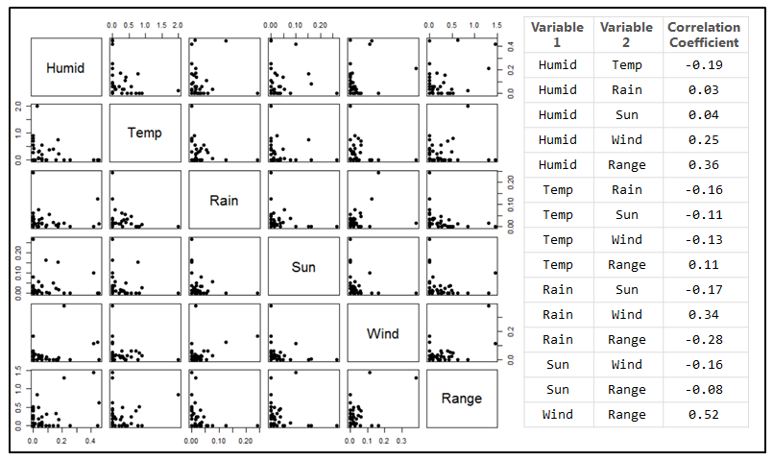
Fig B. Correlations between species sensitivities to climate variables. Temp is temperature and range is daily temperature range.
Species Signal
Table D. The amount of variance explained by the random factor species ($u$), the within-species variance ($v$) (including sampling variance), and the % among-species variation. The % among-species variation is calculated as $u/{(u+v)}$. DTR is daily temperature range.
Climate Variables | u | V | % among-species variation
Temperature | 0.03025 | 1.840 | 1.6
Wind | 0.00046 | 0.286 | 0.2
Sun | 0.00007 | 0.204 | 0.03
Rain | 0.00001 | 0.210 | 0.005
Humid | 0.00000 | 0.415 | 0.000
DTR | 0.00000 | 2.289 | 0.000
Vulnerability | 0.00000 | 2.722 | 0.000

Table E. Model selection table for all combinations of species characteristics explaining variation in climate sensitivities. Shows the best to worst models for each of the six climate variables (ranked by AICc). Each model included either all or none of the habitat characteristics (including open, urban, wet and woodland habitats). The column Int. shows the intercept value, df the degrees of freedom and logLik the log-likelihood value. DTR is the daily temperature range.
Climate variable | Int. | Body Cond. | Migrat-ion | Life-span | Open | Urban | Wet | Wood-land | R² | df | logLik | AICc
Humid | 0.040 | NA | NA | NA | NA | NA | NA | NA | 0.000 | 2.000 | 16.436 | -28.301
Humid | -0.122 | NA | NA | 0.096 | NA | NA | NA | NA | 0.080 | 3.000 | 17.437 | -27.675
Humid | 0.015 | 0.001 | NA | NA | NA | NA | NA | NA | 0.078 | 3.000 | 17.414 | -27.628
Humid | 0.072 | NA | -0.028 | NA | NA | NA | NA | NA | 0.060 | 3.000 | 17.173 | -27.146
Humid | -0.106 | 0.001 | NA | 0.075 | NA | NA | NA | NA | 0.124 | 4.000 | 18.019 | -25.934
Humid | -0.076 | NA | -0.023 | 0.084 | NA | NA | NA | NA | 0.119 | 4.000 | 17.959 | -25.812
Humid | 0.042 | 0.001 | -0.018 | NA | NA | NA | NA | NA | 0.100 | 4.000 | 17.701 | -25.296
Humid | 0.058 | NA | NA | NA | -0.115 | 0.031 | -0.078 | -0.005 | 0.263 | 6.000 | 20.098 | -23.255
Humid | -0.077 | 0.001 | -0.016 | 0.072 | NA | NA | NA | NA | 0.141 | 5.000 | 18.260 | -23.187
Humid | -0.106 | NA | NA | 0.104 | -0.113 | 0.023 | -0.100 | -0.009 | 0.352 | 7.000 | 21.642 | -22.284
Humid | 0.056 | 0.001 | NA | NA | -0.116 | 0.018 | -0.084 | -0.011 | 0.286 | 7.000 | 20.472 | -19.944
Humid | 0.087 | NA | -0.013 | NA | -0.122 | 0.018 | -0.086 | -0.014 | 0.271 | 7.000 | 20.236 | -19.472
Humid | -0.096 | 0.000 | NA | 0.097 | -0.113 | 0.017 | -0.101 | -0.011 | 0.357 | 8.000 | 21.728 | -17.856
Humid | -0.090 | NA | -0.005 | 0.101 | -0.115 | 0.018 | -0.102 | -0.013 | 0.353 | 8.000 | 21.668 | -17.735
Humid | 0.075 | 0.001 | -0.008 | NA | -0.120 | 0.010 | -0.089 | -0.016 | 0.289 | 8.000 | 20.531 | -15.462
Humid | -0.085 | 0.000 | -0.004 | 0.096 | -0.115 | 0.014 | -0.103 | -0.014 | 0.357 | 9.000 | 21.740 | -12.622
Temp | -0.247 | NA | NA | NA | NA | NA | NA | NA | 0.000 | 2.000 | -9.851 | 24.452
Temp | -0.388 | NA | 0.136 | NA | NA | NA | NA | NA | 0.124 | 3.000 | -8.598 | 24.796
Temp | 0.188 | NA | NA | -0.262 | NA | NA | NA | NA | 0.040 | 3.000 | -9.465 | 26.529
Temp | -0.241 | 0.000 | NA | NA | NA | NA | NA | NA | 0.000 | 3.000 | -9.848 | 27.296
Temp | -0.069 | NA | 0.126 | -0.186 | NA | NA | NA | NA | 0.143 | 4.000 | -8.385 | 27.627
Temp | -0.441 | 0.002 | 0.150 | NA | NA | NA | NA | NA | 0.135 | 4.000 | -8.477 | 27.811
Temp | 0.285 | -0.002 | NA | -0.302 | NA | NA | NA | NA | 0.047 | 4.000 | -9.390 | 29.636
Temp | -0.153 | 0.001 | 0.136 | -0.154 | NA | NA | NA | NA | 0.146 | 5.000 | -8.354 | 31.324
Temp | -0.443 | NA | NA | NA | 0.079 | -0.184 | 0.425 | 0.173 | 0.267 | 6.000 | -6.897 | 32.794
Temp | 0.474 | NA | NA | -0.533 | -0.003 | -0.193 | 0.457 | 0.114 | 0.410 | 7.000 | -4.834 | 33.850
Temp | -0.607 | NA | 0.107 | NA | 0.055 | -0.116 | 0.453 | 0.221 | 0.330 | 7.000 | -6.045 | 36.272
Temp | -0.523 | 0.005 | NA | NA | 0.132 | -0.328 | 0.437 | 0.188 | 0.326 | 7.000 | -6.106 | 36.393
Temp | 0.264 | NA | 0.068 | -0.471 | -0.009 | -0.149 | 0.471 | 0.151 | 0.433 | 8.000 | -4.452 | 39.305
Temp | 0.327 | 0.003 | NA | -0.471 | 0.033 | -0.265 | 0.460 | 0.128 | 0.424 | 8.000 | -4.615 | 39.631
Temp | -0.721 | 0.006 | 0.122 | NA | 0.112 | -0.271 | 0.470 | 0.245 | 0.406 | 8.000 | -4.908 | 40.216
Temp | 0.002 | 0.004 | 0.086 | -0.369 | 0.041 | -0.239 | 0.478 | 0.181 | 0.458 | 9.000 | -4.024 | 46.048
DTR | -0.047 | NA | NA | NA | NA | NA | NA | NA | 0.000 | 2.000 | -9.162 | 22.895
DTR | -0.097 | NA | 0.046 | NA | NA | NA | NA | NA | 0.022 | 3.000 | -8.892 | 24.985
DTR | -0.011 | -0.002 | NA | NA | NA | NA | NA | NA | 0.013 | 3.000 | -9.008 | 25.215
DTR | -0.119 | NA | NA | 0.043 | NA | NA | NA | NA | 0.001 | 3.000 | -9.152 | 25.503
DTR | -0.068 | -0.001 | 0.038 | NA | NA | NA | NA | NA | 0.026 | 4.000 | -8.850 | 27.806
DTR | -0.118 | NA | 0.045 | 0.013 | NA | NA | NA | NA | 0.022 | 4.000 | -8.891 | 27.888
DTR | -0.124 | -0.002 | NA | 0.070 | NA | NA | NA | NA | 0.015 | 4.000 | -8.981 | 28.068
DTR | -0.121 | -0.001 | 0.036 | 0.034 | NA | NA | NA | NA | 0.026 | 5.000 | -8.844 | 31.022
DTR | -0.196 | NA | NA | NA | 0.079 | 0.178 | 0.228 | -0.010 | 0.094 | 6.000 | -7.981 | 32.903
DTR | -0.167 | -0.004 | NA | NA | 0.087 | 0.252 | 0.249 | 0.004 | 0.135 | 7.000 | -7.423 | 35.846
DTR | -0.220 | NA | 0.073 | NA | -0.041 | 0.209 | 0.155 | -0.058 | 0.131 | 7.000 | -7.472 | 35.944
DTR | 0.047 | NA | NA | -0.178 | 0.115 | 0.218 | 0.280 | 0.018 | 0.105 | 7.000 | -7.834 | 36.668
DTR | 0.180 | NA | 0.093 | -0.299 | -0.013 | 0.284 | 0.223 | -0.023 | 0.160 | 8.000 | -7.073 | 39.745
DTR | -0.191 | -0.003 | 0.058 | NA | -0.009 | 0.262 | 0.187 | -0.036 | 0.157 | 8.000 | -7.117 | 39.833
DTR | 0.095 | -0.004 | NA | -0.192 | 0.126 | 0.296 | 0.305 | 0.034 | 0.148 | 8.000 | -7.244 | 40.088
DTR | 0.195 | -0.003 | 0.077 | -0.289 | 0.017 | 0.333 | 0.252 | -0.003 | 0.183 | 9.000 | -6.733 | 44.323
Sunshine | -0.007 | NA | NA | NA | NA | NA | NA | NA | 0.000 | 2.000 | 31.992 | -59.318
Sunshine | 0.071 | NA | NA | -0.047 | NA | NA | NA | NA | 0.041 | 3.000 | 32.429 | -57.446
Sunshine | -0.005 | NA | -0.003 | NA | NA | NA | NA | NA | 0.003 | 3.000 | 32.024 | -56.636
Sunshine | -0.009 | 0.000 | NA | NA | NA | NA | NA | NA | 0.002 | 3.000 | 32.014 | -56.616
Sunshine | 0.082 | NA | -0.005 | -0.051 | NA | NA | NA | NA | 0.049 | 4.000 | 32.522 | -54.544
Sunshine | 0.069 | 0.000 | NA | -0.048 | NA | NA | NA | NA | 0.044 | 4.000 | 32.460 | -54.420
Sunshine | -0.007 | 0.000 | -0.002 | NA | NA | NA | NA | NA | 0.004 | 4.000 | 32.033 | -53.565
Sunshine | 0.080 | 0.000 | -0.004 | -0.051 | NA | NA | NA | NA | 0.050 | 5.000 | 32.529 | -51.058
Sunshine | -0.043 | NA | NA | NA | 0.067 | -0.020 | 0.019 | 0.048 | 0.133 | 6.000 | 33.490 | -48.980
Sunshine | 0.029 | NA | NA | -0.049 | 0.076 | -0.017 | 0.031 | 0.054 | 0.173 | 7.000 | 33.981 | -45.347
Sunshine | -0.043 | 0.000 | NA | NA | 0.064 | -0.027 | 0.015 | 0.045 | 0.149 | 7.000 | 33.690 | -44.765
Sunshine | -0.036 | NA | -0.006 | NA | 0.071 | -0.023 | 0.021 | 0.047 | 0.143 | 7.000 | 33.611 | -44.606
Sunshine | 0.058 | NA | -0.010 | -0.061 | 0.085 | -0.021 | 0.038 | 0.053 | 0.200 | 8.000 | 34.330 | -40.661
Sunshine | 0.030 | 0.000 | NA | -0.050 | 0.074 | -0.024 | 0.027 | 0.051 | 0.190 | 8.000 | 34.207 | -40.414
Sunshine | -0.038 | 0.000 | -0.004 | NA | 0.067 | -0.028 | 0.017 | 0.044 | 0.155 | 8.000 | 33.760 | -39.521
Sunshine | 0.055 | 0.000 | -0.008 | -0.060 | 0.082 | -0.026 | 0.034 | 0.051 | 0.210 | 9.000 | 34.466 | -34.569
Wind | 0.011 | NA | NA | NA | NA | NA | NA | NA | 0.000 | 2.000 | 37.841 | -71.137
Wind | 0.021 | -0.001 | NA | NA | NA | NA | NA | NA | 0.074 | 3.000 | 38.797 | -70.452
Wind | 0.057 | NA | NA | -0.028 | NA | NA | NA | NA | 0.035 | 3.000 | 38.291 | -69.438
Wind | 0.008 | NA | 0.002 | NA | NA | NA | NA | NA | 0.002 | 3.000 | 37.871 | -68.599
Wind | 0.041 | 0.000 | NA | -0.013 | NA | NA | NA | NA | 0.079 | 4.000 | 38.874 | -67.748
Wind | 0.024 | -0.001 | -0.002 | NA | NA | NA | NA | NA | 0.075 | 4.000 | 38.820 | -67.640
Wind | 0.055 | NA | 0.002 | -0.028 | NA | NA | NA | NA | 0.036 | 4.000 | 38.305 | -66.609
Wind | 0.042 | 0.000 | -0.002 | -0.012 | NA | NA | NA | NA | 0.081 | 5.000 | 38.892 | -64.625
Wind | 0.021 | NA | NA | NA | 0.003 | -0.002 | -0.022 | -0.007 | 0.032 | 6.000 | 38.243 | -59.819
Wind | 0.025 | -0.001 | NA | NA | 0.001 | 0.009 | -0.019 | -0.002 | 0.120 | 7.000 | 39.442 | -58.297
Wind | 0.062 | NA | NA | -0.027 | 0.003 | 0.001 | -0.019 | -0.006 | 0.063 | 7.000 | 38.649 | -56.711
Wind | 0.013 | NA | 0.005 | NA | 0.003 | 0.001 | -0.021 | -0.004 | 0.037 | 7.000 | 38.317 | -56.046
Wind | 0.039 | -0.001 | NA | -0.009 | 0.001 | 0.009 | -0.018 | -0.003 | 0.123 | 8.000 | 39.485 | -53.971
Wind | 0.021 | -0.001 | 0.002 | NA | 0.001 | 0.010 | -0.019 | -0.001 | 0.122 | 8.000 | 39.461 | -53.921
Wind | 0.054 | NA | 0.004 | -0.027 | 0.003 | 0.004 | -0.019 | -0.003 | 0.068 | 8.000 | 38.719 | -52.438
Wind | 0.035 | -0.001 | 0.002 | -0.010 | 0.001 | 0.011 | -0.018 | -0.001 | 0.125 | 9.000 | 39.506 | -49.012
Rain | 0.008 | NA | NA | NA | NA | NA | NA | NA | 0.000 | 2.000 | 46.508 | -88.495
Rain | -0.031 | NA | NA | 0.024 | NA | NA | NA | NA | 0.029 | 3.000 | 46.895 | -86.698
Rain | 0.012 | 0.000 | NA | NA | NA | NA | NA | NA | 0.009 | 3.000 | 46.628 | -86.165
Rain | 0.005 | NA | 0.003 | NA | NA | NA | NA | NA | 0.005 | 3.000 | 46.579 | -86.067
Rain | -0.031 | 0.000 | NA | 0.027 | NA | NA | NA | NA | 0.046 | 4.000 | 47.123 | -84.342
Rain | -0.037 | NA | 0.004 | 0.025 | NA | NA | NA | NA | 0.038 | 4.000 | 47.012 | -84.120
Rain | 0.009 | 0.000 | 0.002 | NA | NA | NA | NA | NA | 0.012 | 4.000 | 46.662 | -83.420
Rain | -0.036 | 0.000 | 0.003 | 0.028 | NA | NA | NA | NA | 0.050 | 5.000 | 47.180 | -81.361
Rain | 0.037 | NA | NA | NA | 0.001 | -0.006 | -0.038 | -0.023 | 0.137 | 6.000 | 48.429 | -80.438
Rain | -0.022 | NA | NA | 0.041 | 0.001 | -0.009 | -0.047 | -0.028 | 0.218 | 7.000 | 49.708 | -79.194
Rain | 0.034 | NA | 0.003 | NA | 0.000 | -0.005 | -0.039 | -0.023 | 0.142 | 7.000 | 48.497 | -76.772
Rain | 0.039 | 0.000 | NA | NA | 0.001 | -0.004 | -0.038 | -0.023 | 0.141 | 7.000 | 48.477 | -76.731
Rain | -0.023 | 0.000 | NA | 0.043 | 0.000 | -0.006 | -0.046 | -0.028 | 0.228 | 8.000 | 49.867 | -75.264
Rain | -0.029 | NA | 0.004 | 0.042 | -0.001 | -0.007 | -0.048 | -0.028 | 0.227 | 8.000 | 49.853 | -75.236
Rain | 0.035 | 0.000 | 0.003 | NA | 0.000 | -0.003 | -0.038 | -0.023 | 0.144 | 8.000 | 48.531 | -72.591
Rain | -0.029 | 0.000 | 0.003 | 0.044 | -0.001 | -0.005 | -0.047 | -0.028 | 0.234 | 9.000 | 49.979 | -70.709

Species and site traits
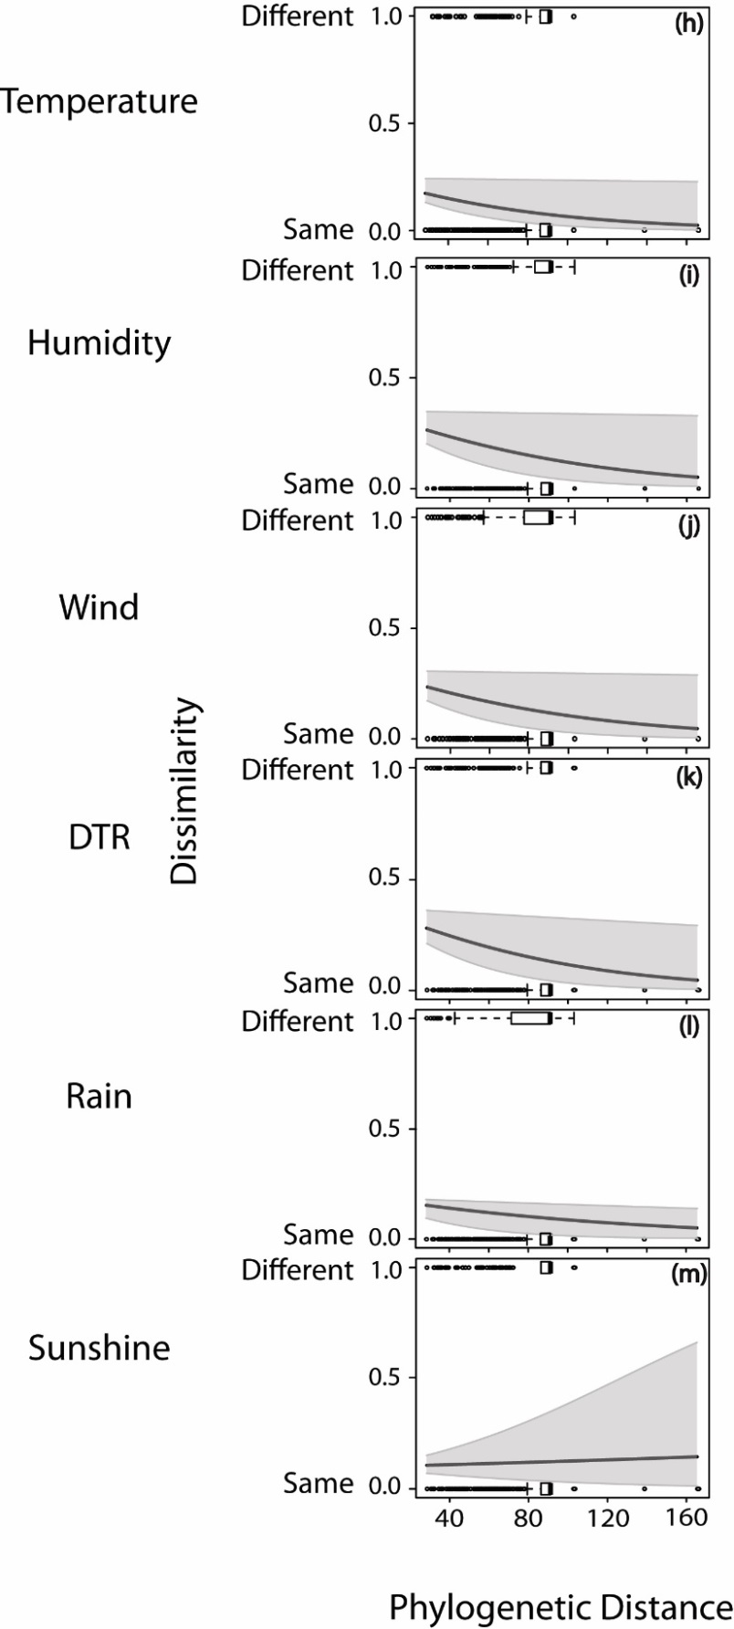
Fig C. The effect of phylogenetic relatedness on whether species are affected by the same climate variables. Displays the pairwise phylogenetic distance in relation to whether species are impacted by the same climate variables (i.e. whether both species are or are not affected by that climate variable, or if one species is affected by that climate variable, but the other is not) with 95% confidence intervals. The boxplots show the distribution of the underlying data.
Table F. Model selection table for all combinations of species characteristics explaining variation in climate vulnerabilities. Shows the best to worst models for each of the six climate variables (ranked by AICc). Each model included either all or none of the habitat characteristics (including open, urban, wet and woodland habitats).The column Int. shows the intercept value, df the degrees of freedom and logLik the log-likelihood value. DTR is the daily temperature range.
Int. | Body condition | Migration | Survival | Open | Urban | Wet | Wood  land | R² | df | logLik | AICc
-0.017 | NA | NA | NA | NA | NA | NA | NA | 0.000 | 2.000 | -22.121 | 48.584
-0.056 | NA | 0.026 | NA | NA | NA | NA | NA | 0.012 | 3.000 | -21.894 | 50.495
-0.013 | 0.000 | NA | NA | NA | NA | NA | NA | 0.001 | 3.000 | -22.100 | 50.907
-0.009 | NA | NA | -0.004 | NA | NA | NA | NA | 0.000 | 3.000 | -22.118 | 50.943
-0.088 | NA | 0.029 | 0.014 | NA | NA | NA | NA | 0.013 | 4.000 | -21.872 | 52.957
-0.067 | 0.000 | 0.030 | NA | NA | NA | NA | NA | 0.013 | 4.000 | -21.877 | 52.967
-0.054 | -0.001 | NA | 0.027 | NA | NA | NA | NA | 0.002 | 4.000 | -22.078 | 53.369
-0.086 | 0.000 | 0.029 | 0.013 | NA | NA | NA | NA | 0.013 | 5.000 | -21.872 | 55.619
0.014 | NA | NA | NA | -0.460 | -0.022 | -0.030 | -0.012 | 0.031 | 6.000 | -21.524 | 57.758
-0.060 | NA | 0.029 | NA | -0.434 | -0.006 | -0.019 | 0.012 | 0.042 | 7.000 | -21.303 | 60.340
0.014 | 0.000 | NA | NA | -0.459 | -0.020 | -0.029 | -0.008 | 0.032 | 7.000 | -21.507 | 60.748
0.014 | NA | NA | 0.000 | -0.460 | -0.022 | -0.030 | -0.012 | 0.031 | 7.000 | -21.524 | 60.781
-0.069 | 0.000 | 0.033 | NA | -0.432 | -0.006 | -0.019 | 0.012 | 0.043 | 8.000 | -21.292 | 63.551
-0.076 | NA | 0.031 | 0.010 | -0.435 | -0.008 | -0.021 | 0.010 | 0.043 | 8.000 | -21.294 | 63.553
-0.041 | -0.001 | NA | 0.041 | -0.467 | -0.027 | -0.035 | -0.017 | 0.034 | 8.000 | -21.462 | 63.890
-0.071 | 0.000 | 0.032 | 0.002 | -0.433 | -0.007 | -0.019 | 0.012 | 0.043 | 9.000 | -21.292 | 67.013

Table G. The delta AICc values for the two population-level predictor variables (habitat and density) tested for each climate variable. Here, the null model does not contain any predictors but does include the random effect of species (Sensitivity ~ 1 + (1|species)), the habitat model includes the explanatory variable habitat (wet or dry) and includes a random slope term across all species (Sensitivity ~ Habitat + (1|species) + (0 + Habitat|species)), null habitat model is the same as the habitat model but does not include a random slopes term (Sensitivity ~ Habitat + (1|species)) and the density model includes the explanatory variable with a random intercept term(Sensitivity ~ Density + (1|species)). A delta AICc value of 0 indicated that it was the best model.
 | Model delta AICc Values
Climatic Variable | Null | Habitat | Null Habitat | Density
Humid | 6.9 | 10.6 | 8.5 | 0
Rain | 0.5 | 2.0 | 0 | 2.5
Temperature | 3.8 | 1.7 | 0 | 3.7
Sunshine | 0 | 3.8 | 1.7 | 1.5
Wind | 0 | 1.7 | 0.1 | 2.1
DTR | 0 | 3.7 | 1.6 | 0.4
Vulnerability | 0 | 4.0 | 1.9 | 2.0
In populations with higher densities (i.e. better habitats), birds experienced stronger declines in body condition per percent change in humidity compared with those in lower densities (slope of -1.03 change in sensitivity per birds/net metre/day; Fig D).
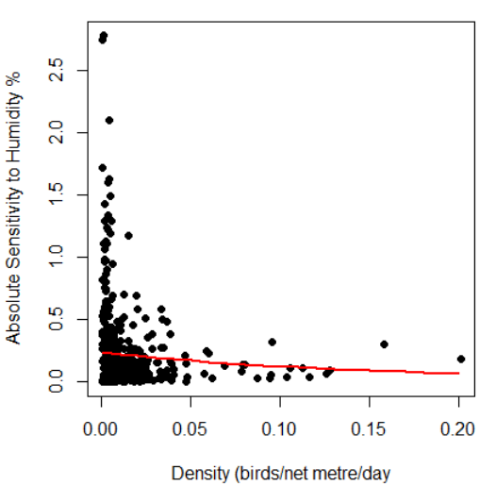
Fig D. The relationship between body condition sensitivity to humidity (as a percent of total boy mass) and habitat density (slope = -1.03).
Nine species were found to have more similar sensitivities at sites that were closer together (Table H). As we did not take into account the effects of multiple testing, some of these species would likely be significant due to chance. However, five species (the common chaffinch, garden warbler, short-toed treecreeper, sedge warbler and willow warbler) all had multiple positive relationships for different climate variables (or the only climate variable they were sensitive to), suggesting that these similarities are not due to chance. Overall vulnerabilities were more similar in populations that were closer together for 24% (7 out of 29) of species (Table H).
Table H. Species with significant relationships between distance (km) and dissimilarity in sites sensitivities and vulnerabilities. Species that have population sensitivities which are more similar at closer distances for each climatic variable are marked with an X. The grey cells indicate that the species was not affected by those climate variables (i.e. they did not have a climate window for that climatic variable).
Species | Humid | Temperature | DTR | Rain | Wind | Sunshine | Vulnerability
Willow warbler |  |  | X | X |  |  | X
Common chaffinch | X |  |  | X
Common chiffchaff |  | X |  |  |  |  | X
Bearded reedling |  | X |  |  |  |  | X
Garden warbler |  |  | X |  |  |  | X
Short-toed treecreeper | X |  |  |  |  | X
Sedge warbler |  |  |  | X | X
Eurasian tree sparrow |  |  |  |  | X
European robin |  |  |  |  |  | X
Eurasian blackcap |  |  |  |  |  |  | X
Bluethroat |  |  |  |  |  |  | X
Common grasshopper warbler |  |  |  |  |  |  | X

