S5 Fig

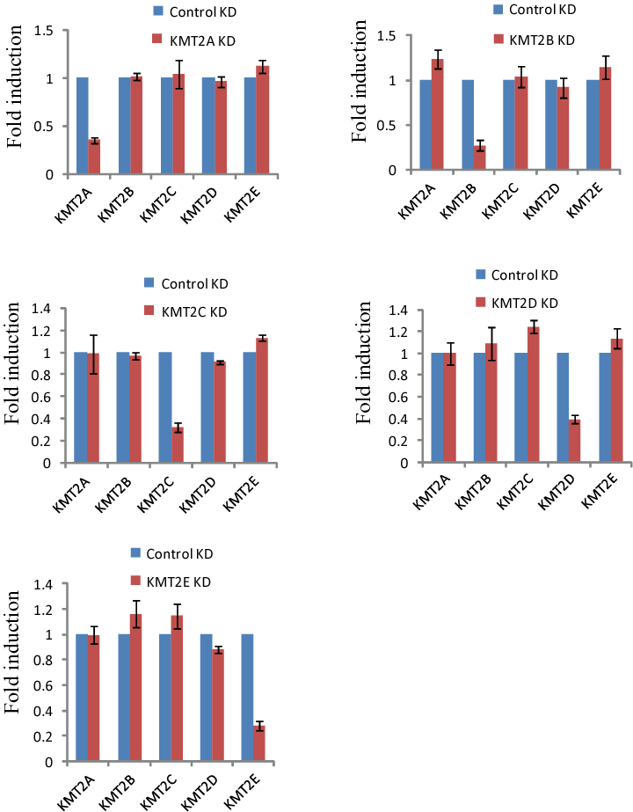
S5 Fig. Expression of KMTs was determined by RT-qPCR in KMT2A, KMT2B, KMT2C, KMT2D and KMT2E-depleted MCF-7 cells and normalized against 18s rRNA.

