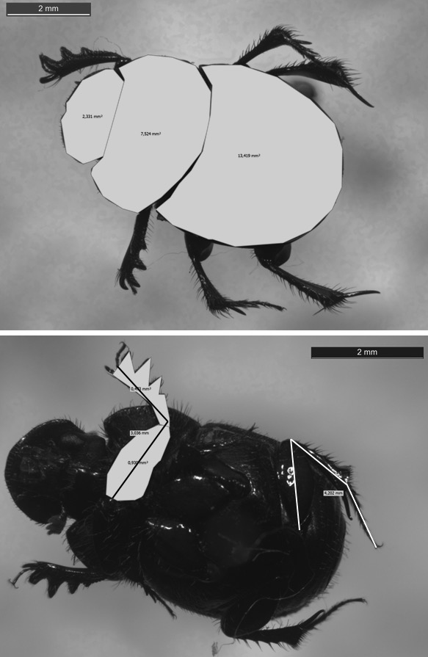
Dung beetle trait measurements collected using Leica M250 microscope and Life Measurement software. Dorsal measurements (top panel): head area, pronotum area, elytra area; ventral measurements (bottom panel): front and back leg length, femur area, tibia area. The scale bar represents 2mm, the species shown is Cathidium deyrollei.

