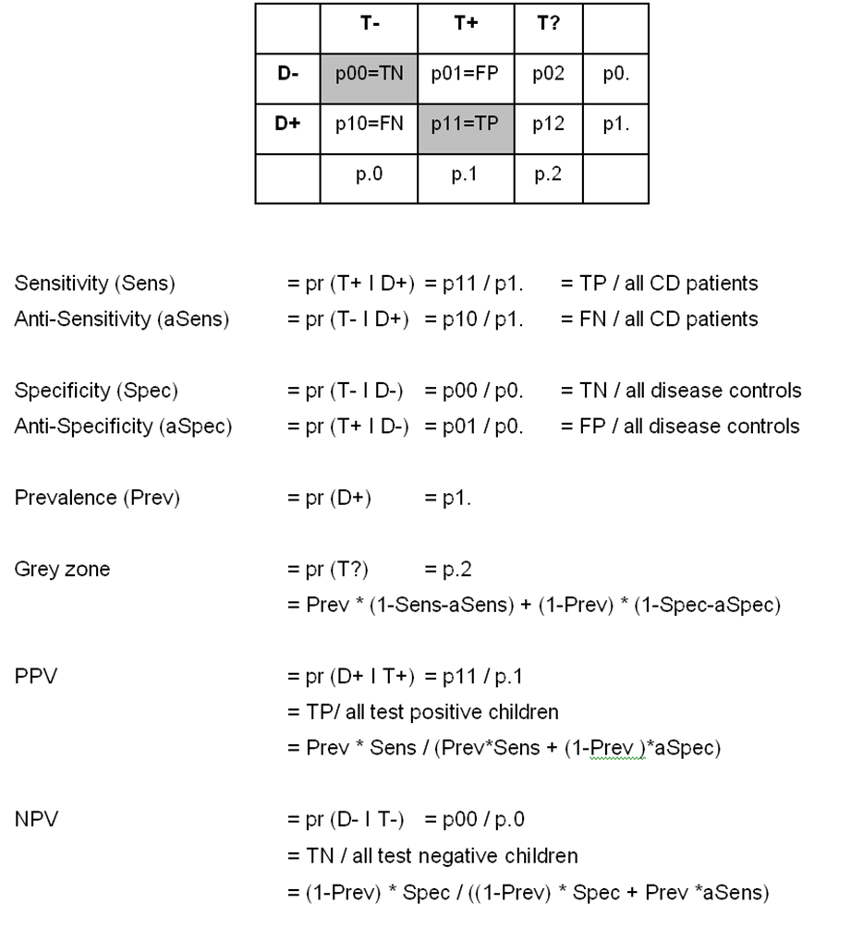
Figure S2: Calculation of PPV, NPV and proportion of patients without reliable diagnosis for given prevalence. D- disease controls, D+ CD patients, T- test negative, T+ test positive, T? test result in grey zone, FN-false negative, FP-false negative, TN- true negative TP- true positive.

