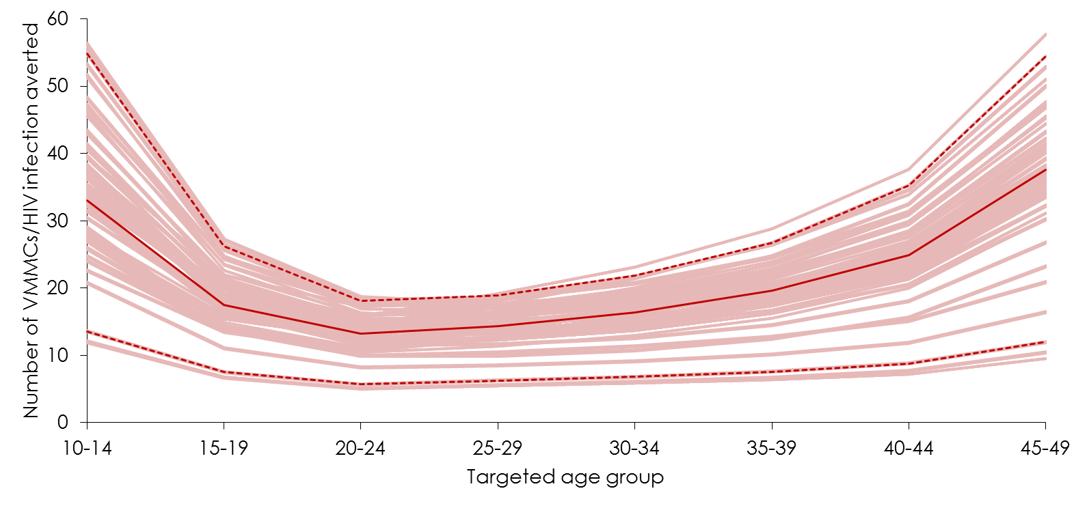
Fig. S8. Uncertainty intervals by prioritized age group for the number of voluntary medical male circumcisions (VMMCs) needed to avert one HIV infection by 2025. The solid red line represents the geometric mean of model runs, while the dashed lines bracket the 95% uncertainty interval.

