Supporting Information Jain et al.

Figure S4

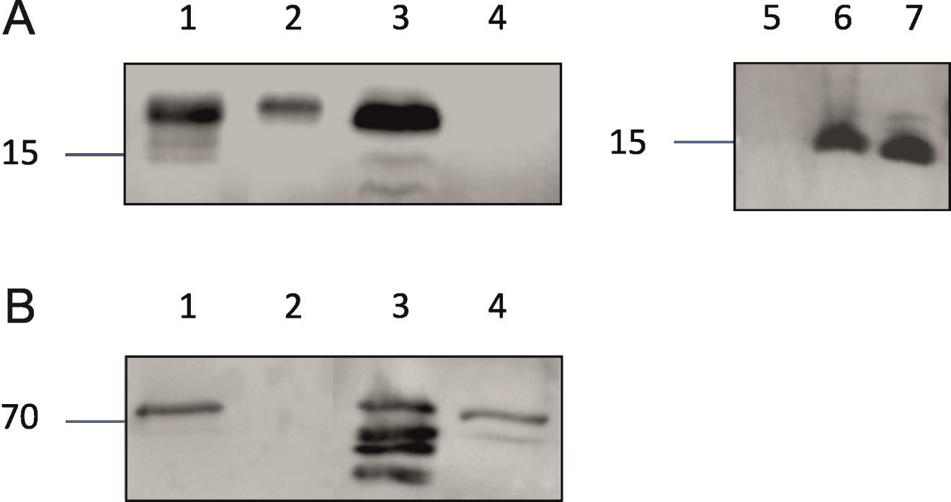

Figure S4. Immunoblots on Neisseria membranes with PilE and PilQ antibody. (A) Western blot using a monoclonal antibody raised against N.meningitidis PilE-SM1. Lanes show outer membrane enriched samples from N.gonorrhoeae MS11 (lane 1), and the pilQ (Lane 2), pilP (Lane 3) and pilE mutants (Lane 4), and N.meningitidis strains M986 (lane 5), H44/76 (lane 6) and HB1 (lane 7). (B) Western blot using the monoclonal antibody raised against N.meningitidis PilQ on phenol treated outer membrane enriched samples from N.gonorrhoeae MS11 (lane 1), and pilQ (Lane 2), pilP (Lane 3), and pilE (Lane 4) mutants.

