Using data of Table S1 and for both parameters the average values were determined for each location on each sampling year and were used in a PCA analysis.
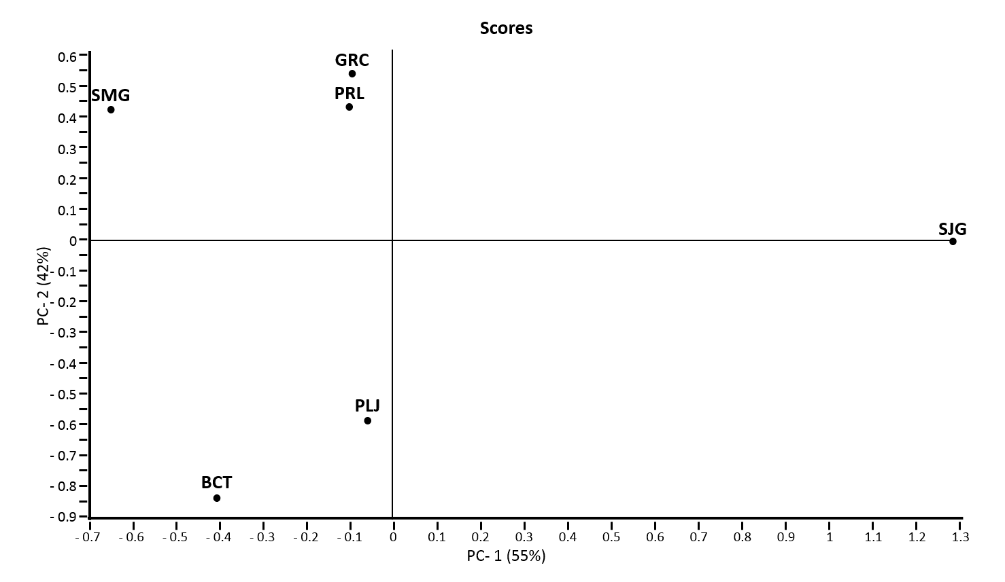
A

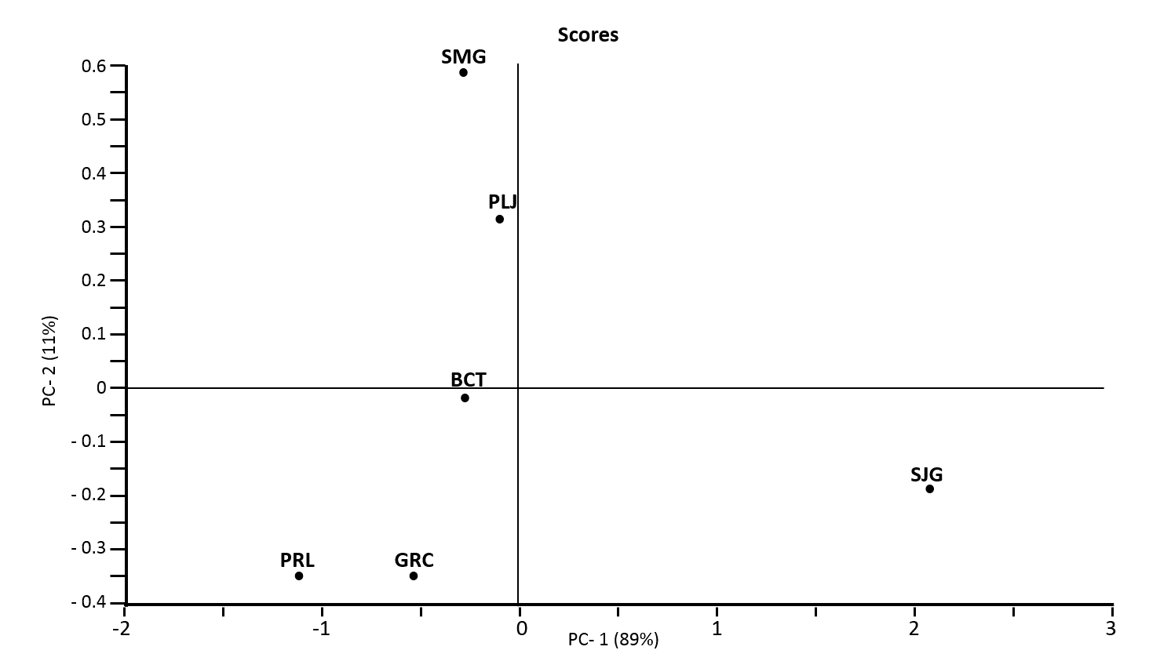
B

Figure S1: PCA visualization obtained using average values of Shannon’s index and number of yeast species per sample or fermentation determined in six wine-producing areas of the Azores Archipelago (SMG – S. Miguel, BCT – Biscoitos, GRC – Graciosa, PLG – Lajidos, PRL – “Pico remaining locations”, SJG – S. Jorge).

