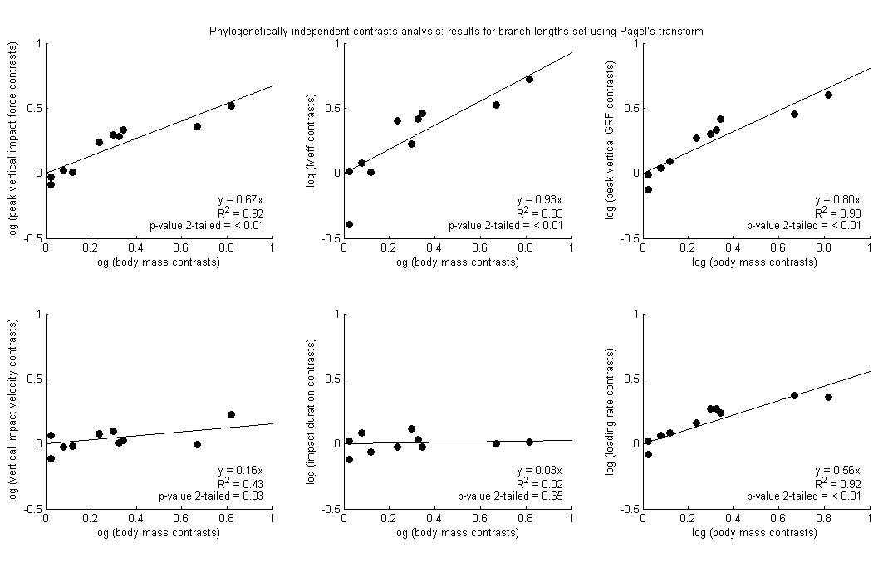
Supplementary Figure S32: Results of independent contrasts analysis: branch lengths set using Pagel’s transform. These results focus on logarithmically transformed data from the forelimb at walking speeds; peak vertical impact force, M_{eff}, peak vertical ground reaction force, vertical impact velocity, impact duration and loading rate (calculated over a 0.5% window during the impact period). See also Figure S31 caption.

