S1_Dataset

Table A. Basic Data.
Table A. Basic Data. Excel file above (double click to activate) contains all basic data for this paper. Abbreviations: RRMS (relapsing-remitting MS), PPMS (primary-progressive MS), SPMS (secondary-progressive MS), CIS (clinically isolated syndrome), SC (symptomatic controls with normal or abnormal MRI), n (number of persons), CSF (cerebrospinal fluid), y (years), d (days), Gender (1=male; 2=female) TNL (Total number of white matter lesions).

Do-file and output for correlation analysis in STATA.
Table B. Do-file and output of the Spearman correlation analysis without the Bonferroni correction on RRMS and SC.
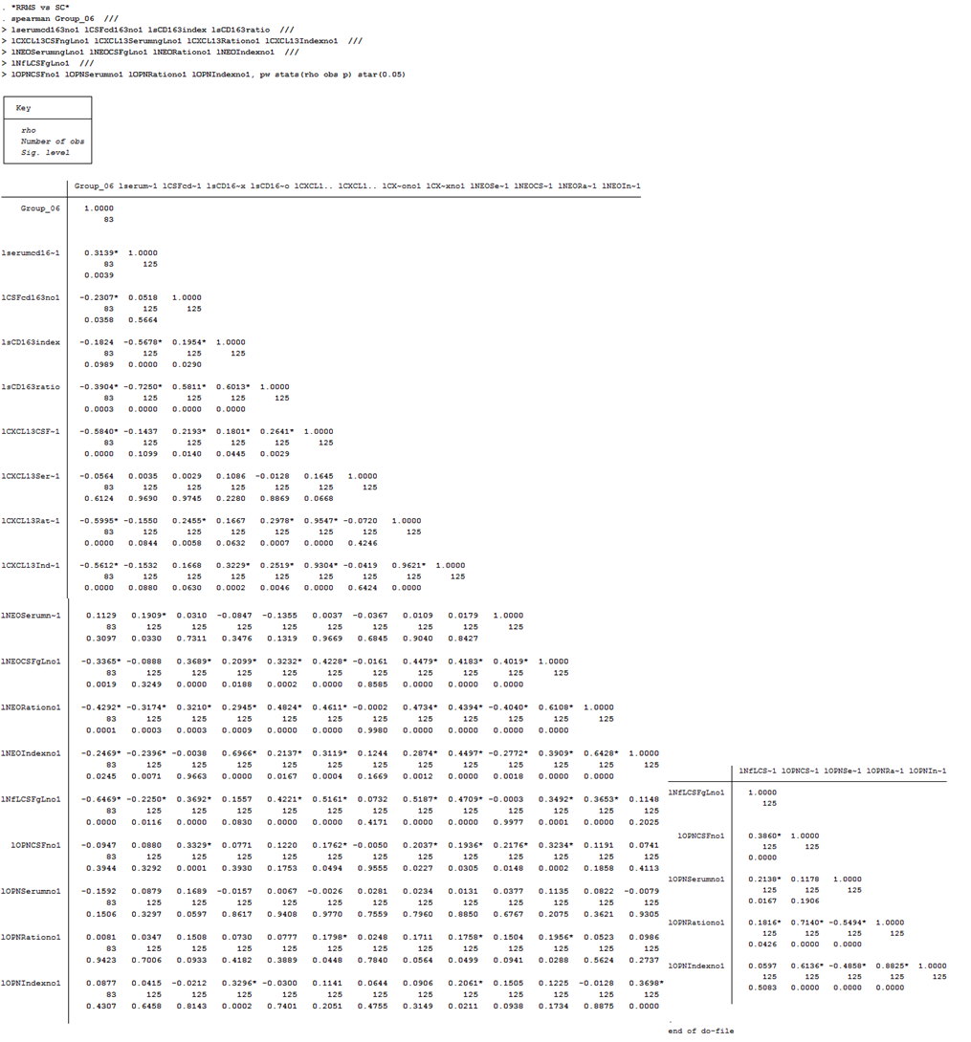

Table C. Do-file and output of the Spearman correlation analysis with the Bonferroni correction on RRMS and SC.
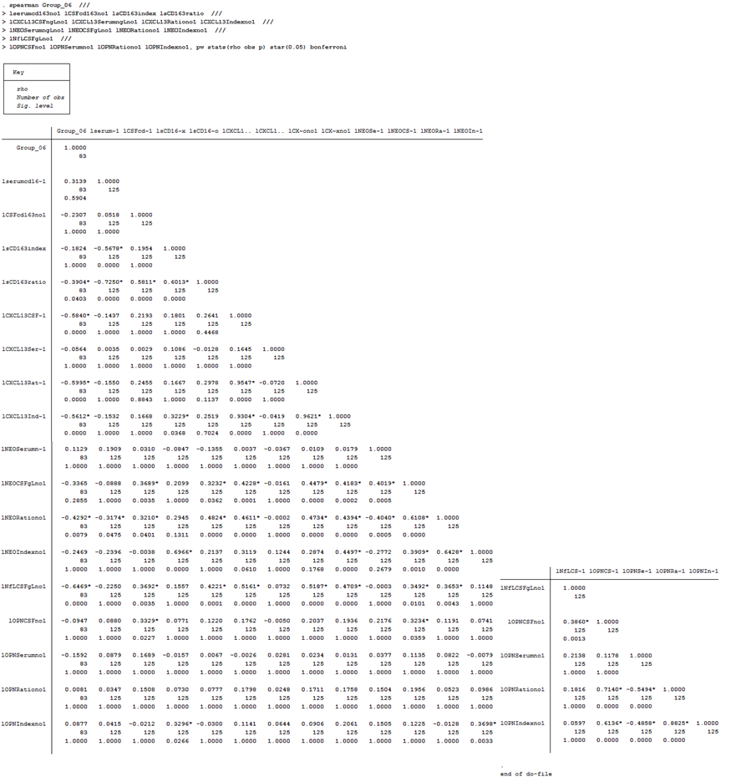

Table D. Do-file and output of the Spearman correlation analysis without the Bonferroni correction on PPMS and SC.
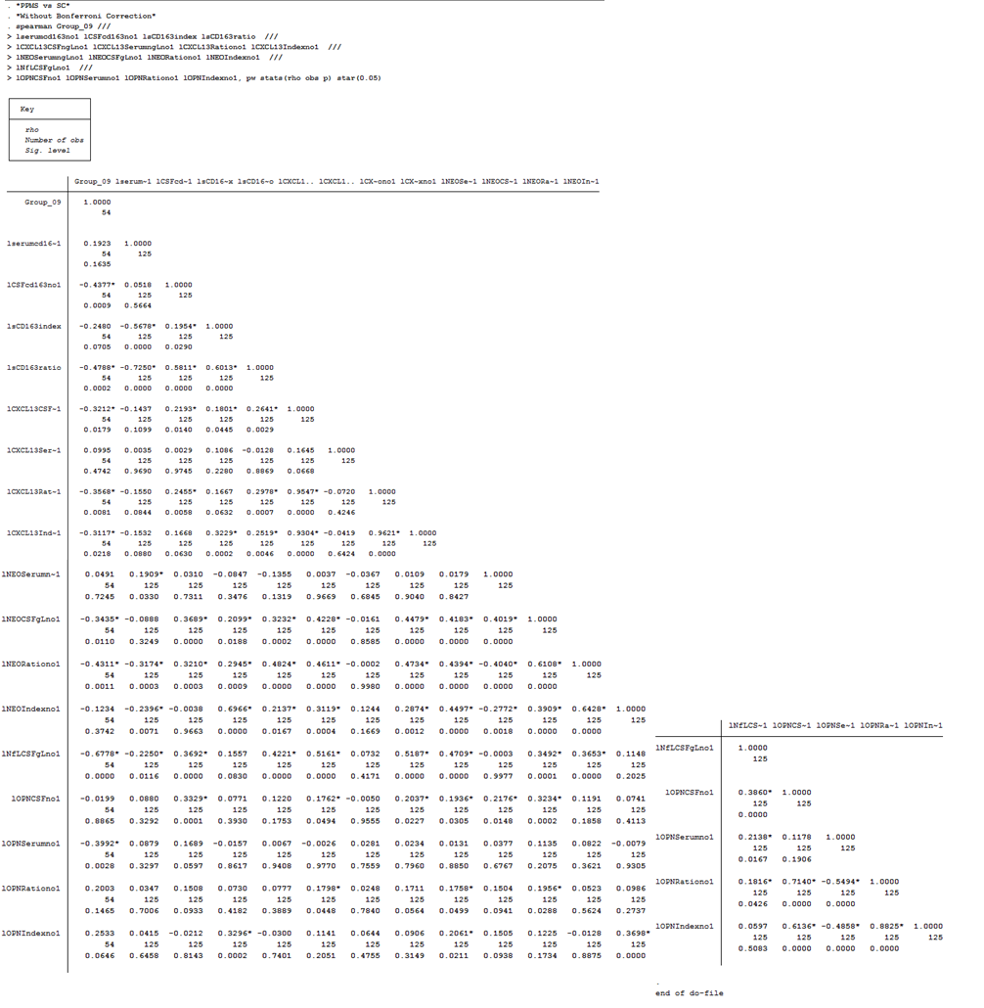

Table E. Do-file and output of the Spearman correlation analysis with the Bonferroni correction on PPMS and SC.
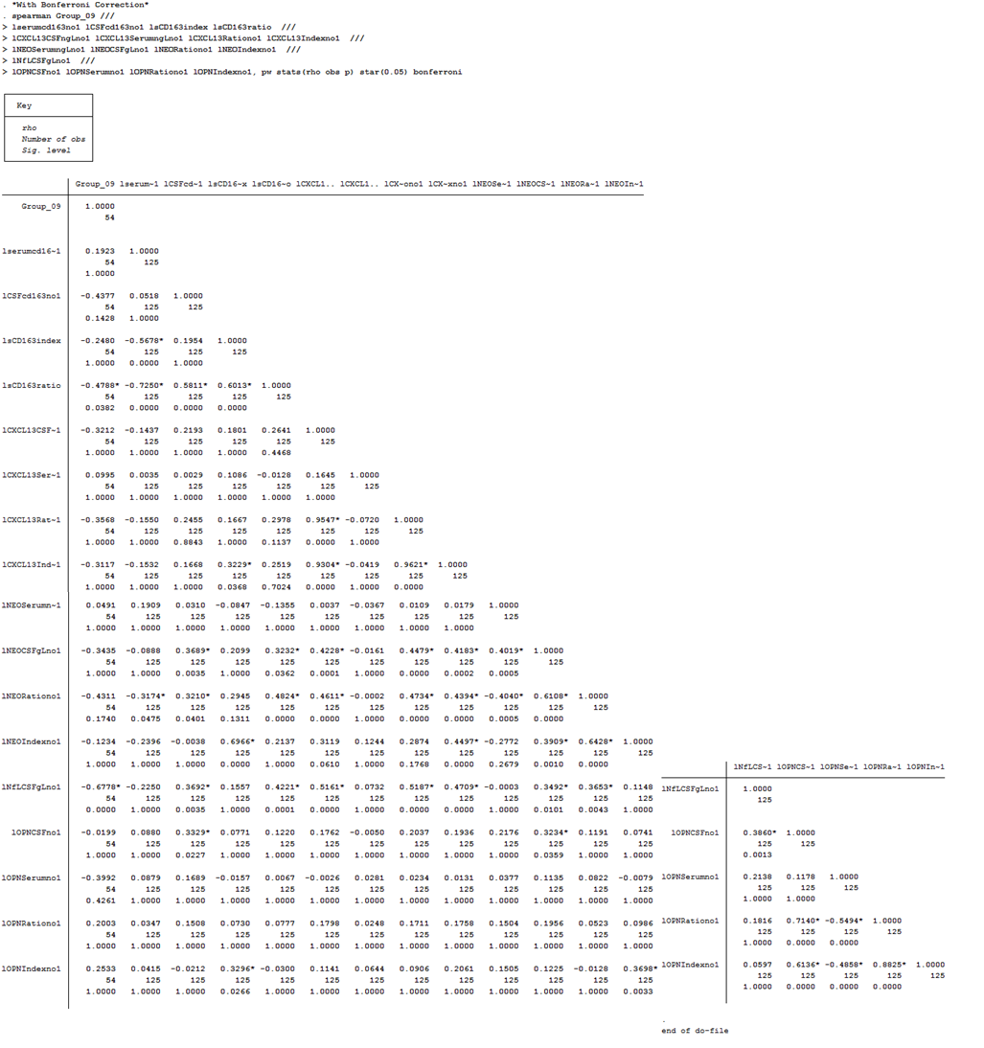

Table F. Do-file and output of the Spearman correlation analysis without the Bonferroni correction on CIS and SC.
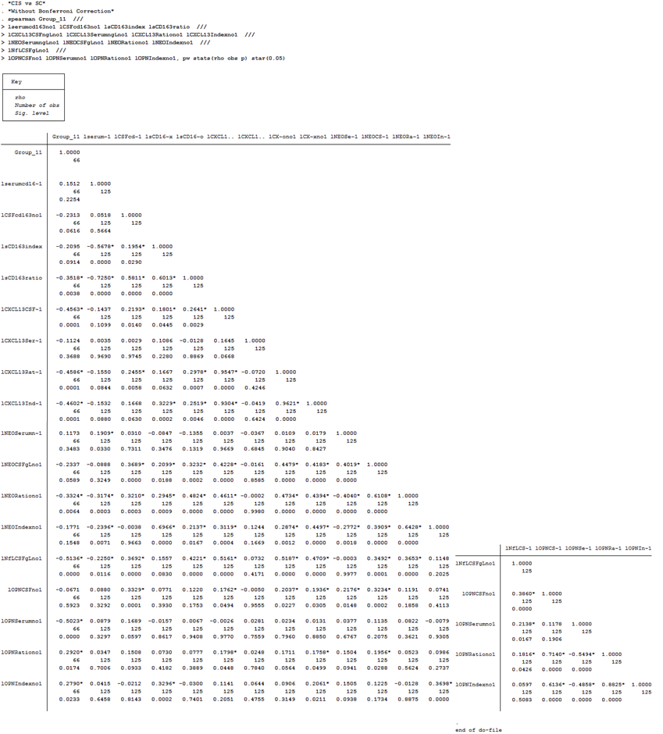

Table G. Do-file and output of the Spearman correlation analysis with the Bonferroni correction on CIS and SC.
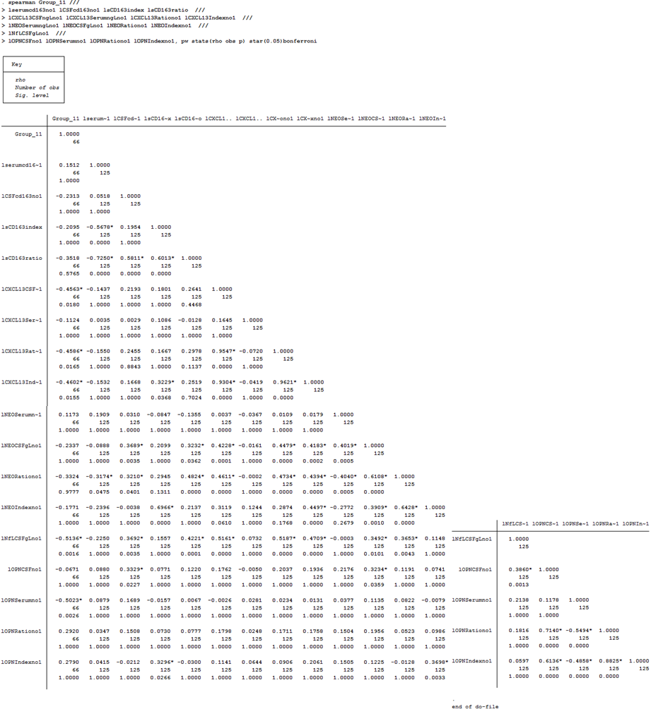

Table H. Do-file and output of the Spearman correlation analysis without the Bonferroni correction on Gender and Number of Attacks.
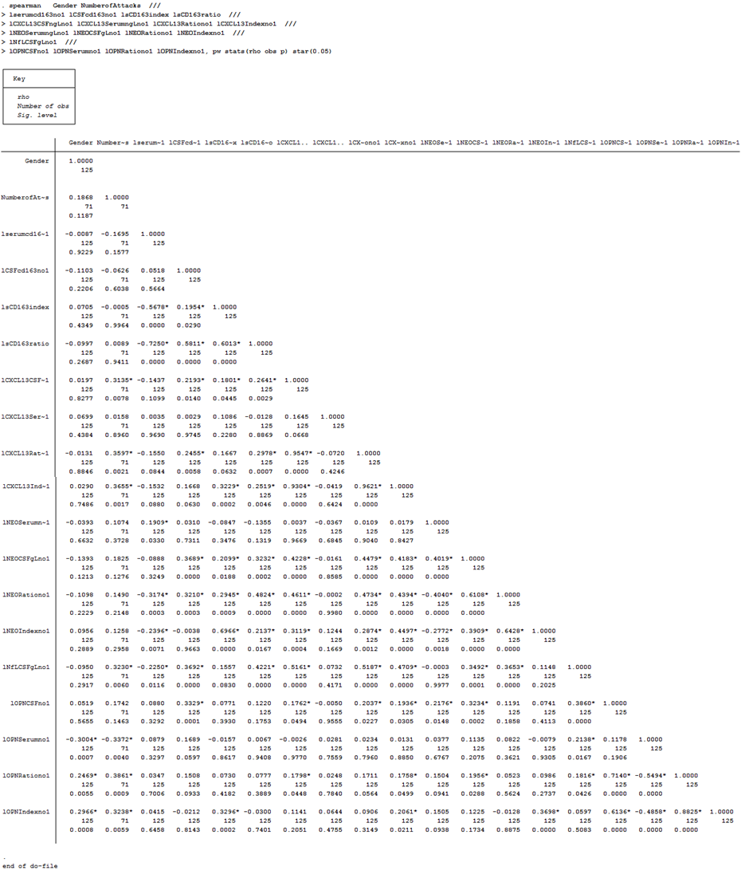

Table I. Do-file and output of the Spearman correlation analysis with the Bonferroni correction on Gender and Number of Attacks.
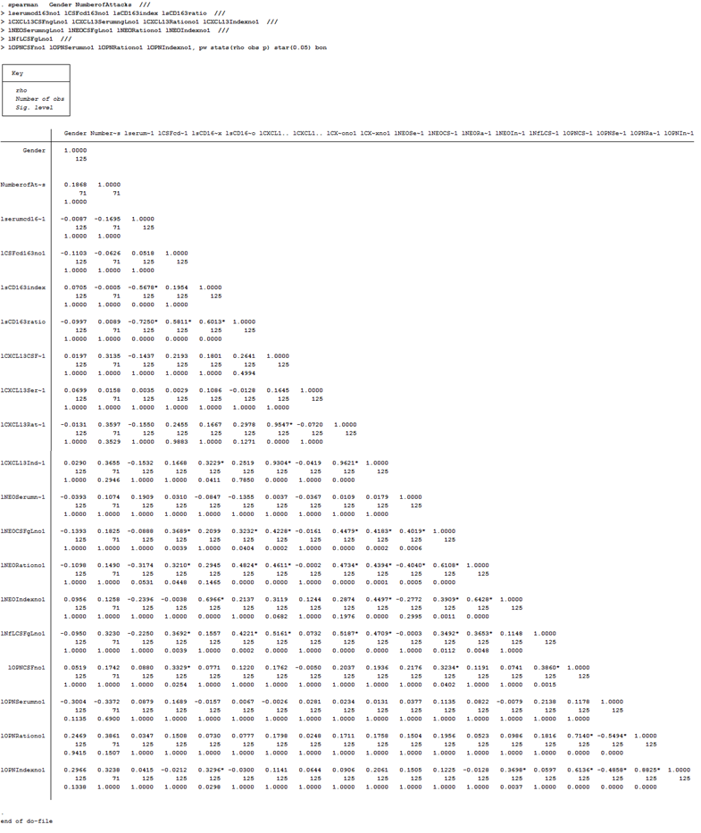

Table J. Do-file and output of the Pearson correlation analysis without the Bonferroni correction on Age.

Table K. Do-file and output of the Pearson correlation analysis with the Bonferroni correction on Age.

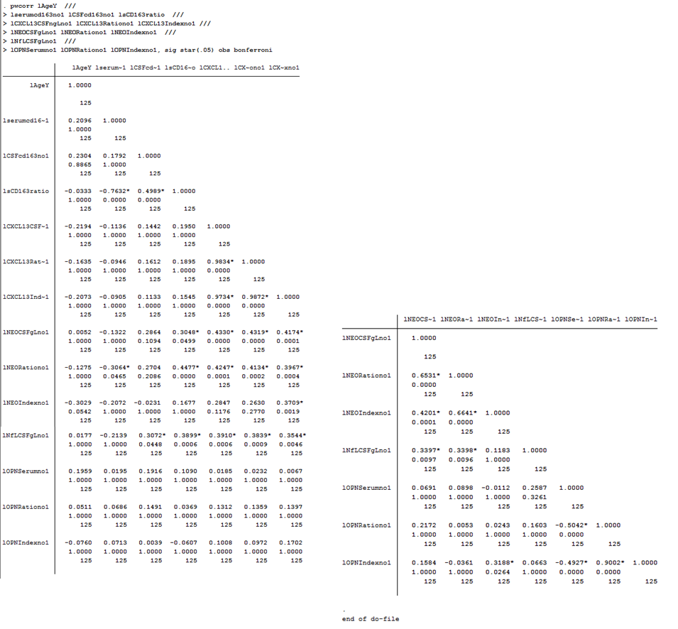

Table L. Do-file and output of the Pearson correlation analysis without the Bonferroni correction on EDSS at time of diagnosis.
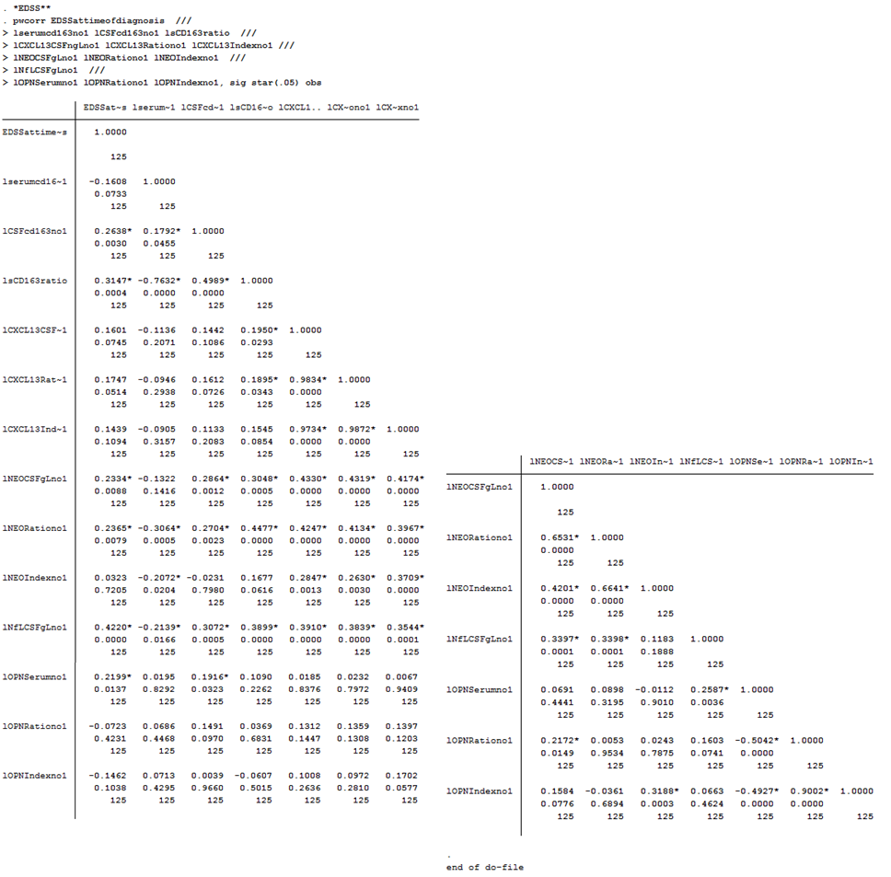

Table M. Do-file and output of the Pearson correlation analysis with the Bonferroni correction on EDSS at time of diagnosis.
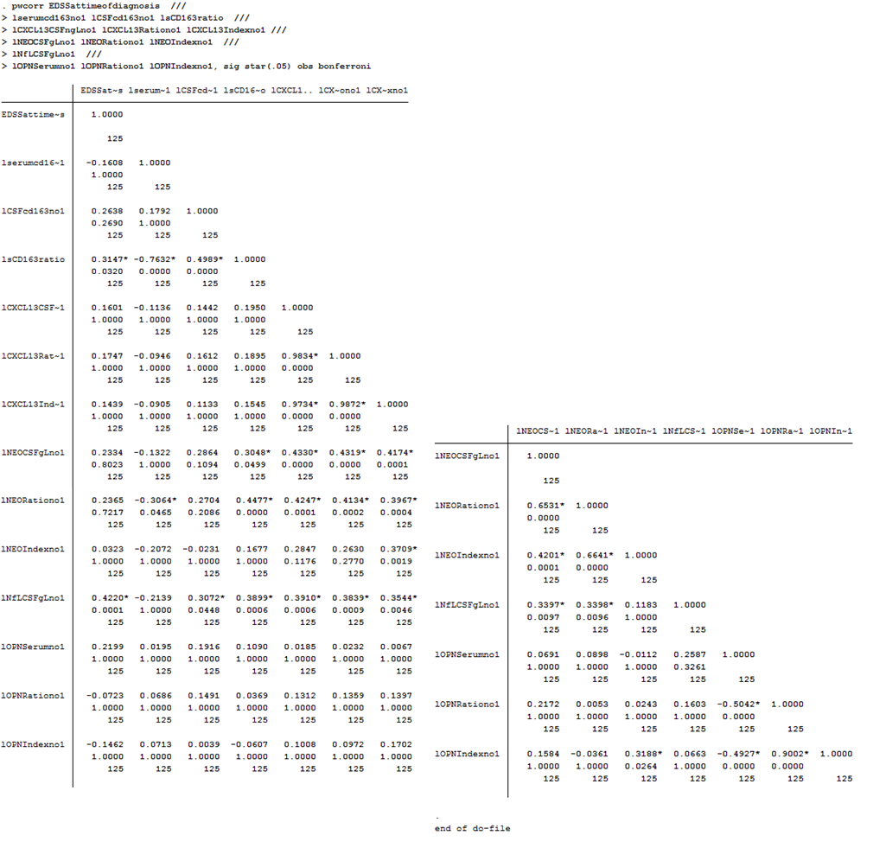

Table N. Do-file and output of the Pearson correlation analysis without the Bonferroni correction on Disease duration (months).
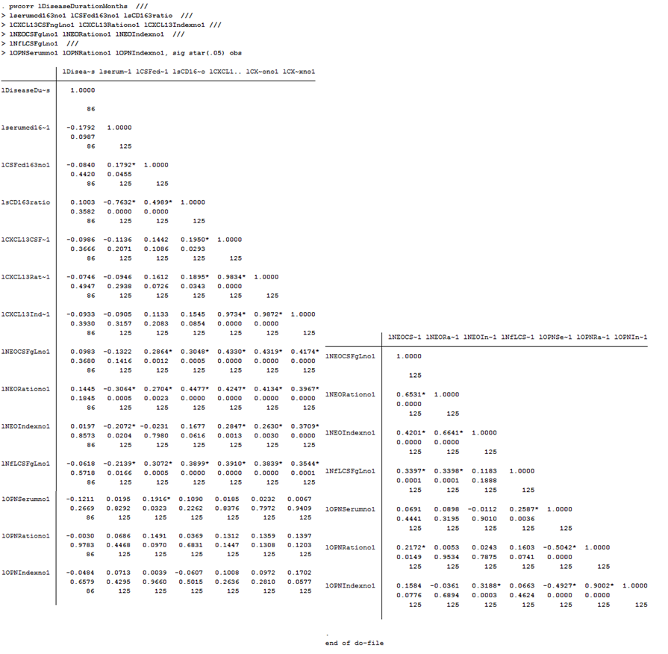

Table O. Do-file and output of the Pearson correlation analysis with the Bonferroni correction on Disease duration (months).
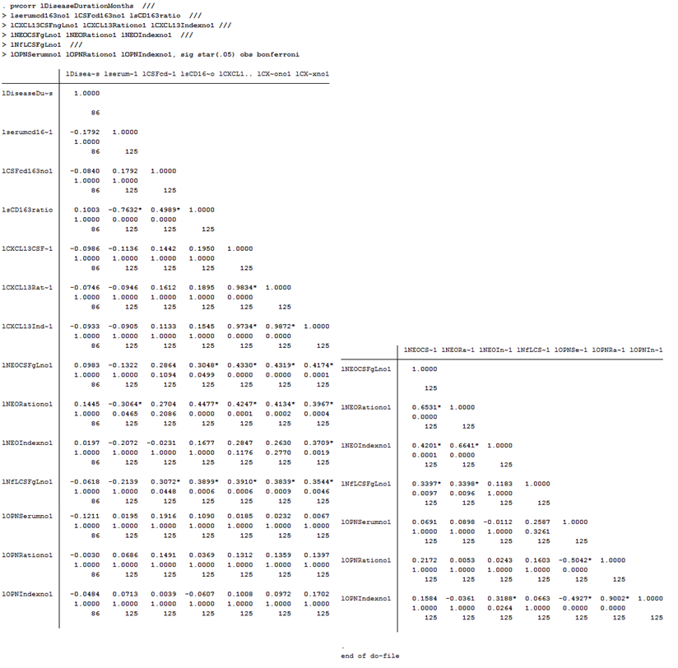

Table P. Do-file and output of the Pearson correlation analysis without the Bonferroni correction on Time since last attack (days).
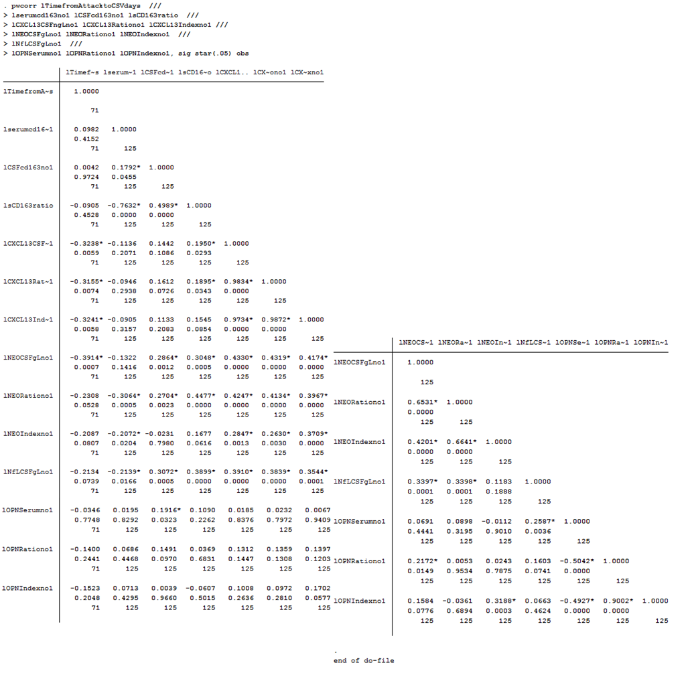

Table Q. Do-file and output of the Pearson correlation analysis with the Bonferroni correction on Time since last attack (days).
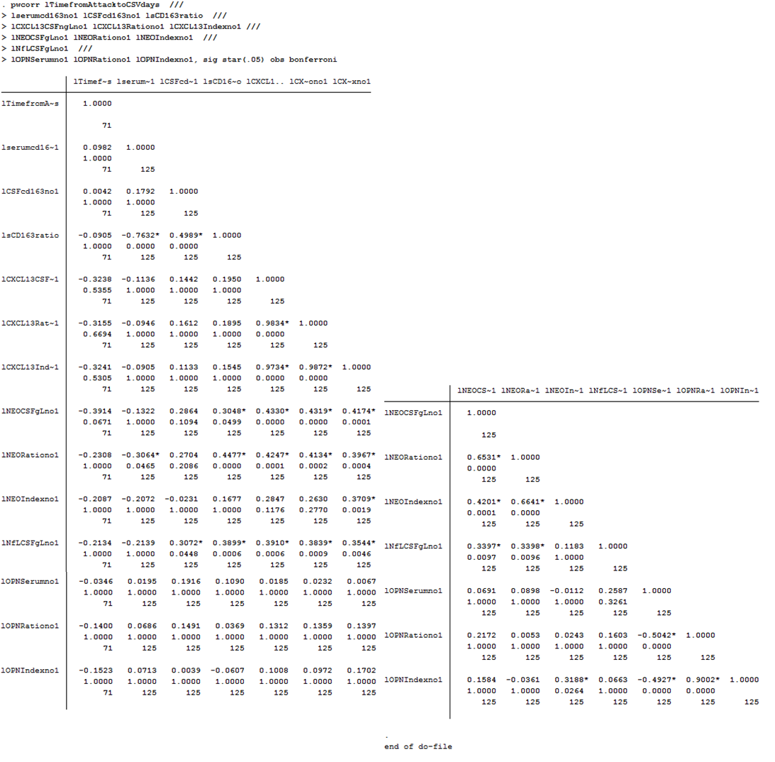

Table R. Do-file and output of the Pearson correlation analysis without the Bonferroni correction on CSF Protein.
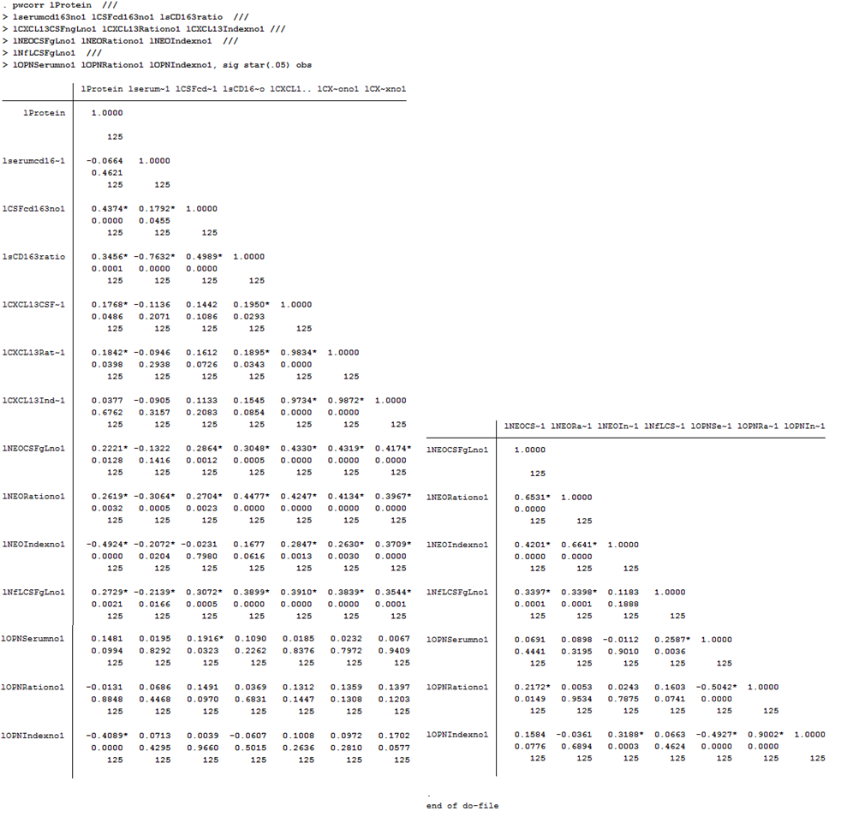

Table S. Do-file and output of the Pearson correlation analysis with the Bonferroni correction on CSF Protein.
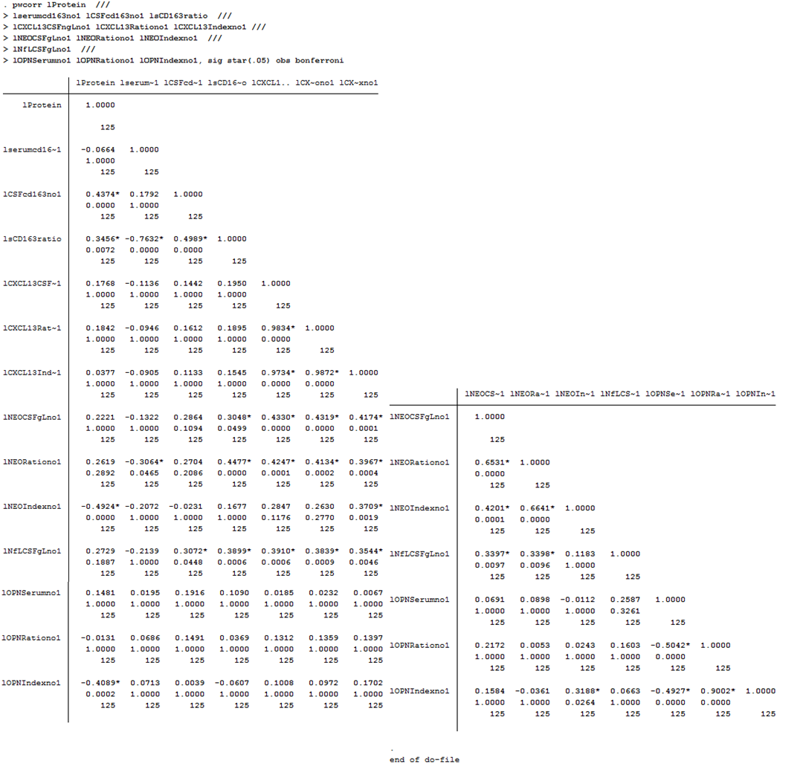

Table T. Do-file and output of the Pearson correlation analysis without the Bonferroni correction on CSF Cells.
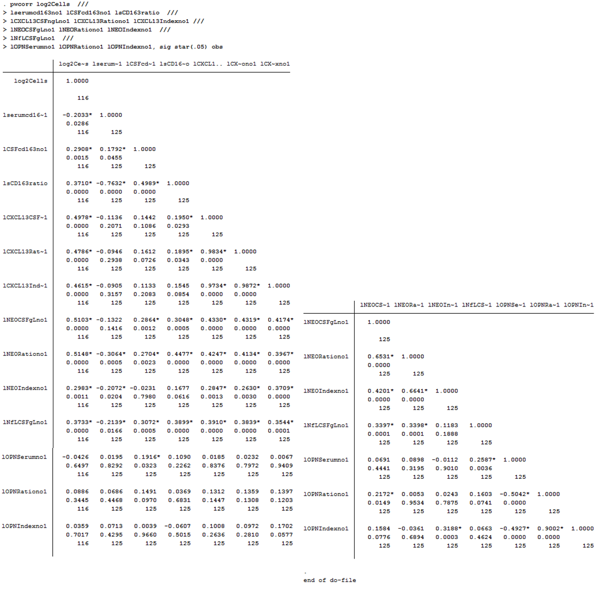

Table U. Do-file and output of the Pearson correlation analysis with the Bonferroni correction on CSF Cells.
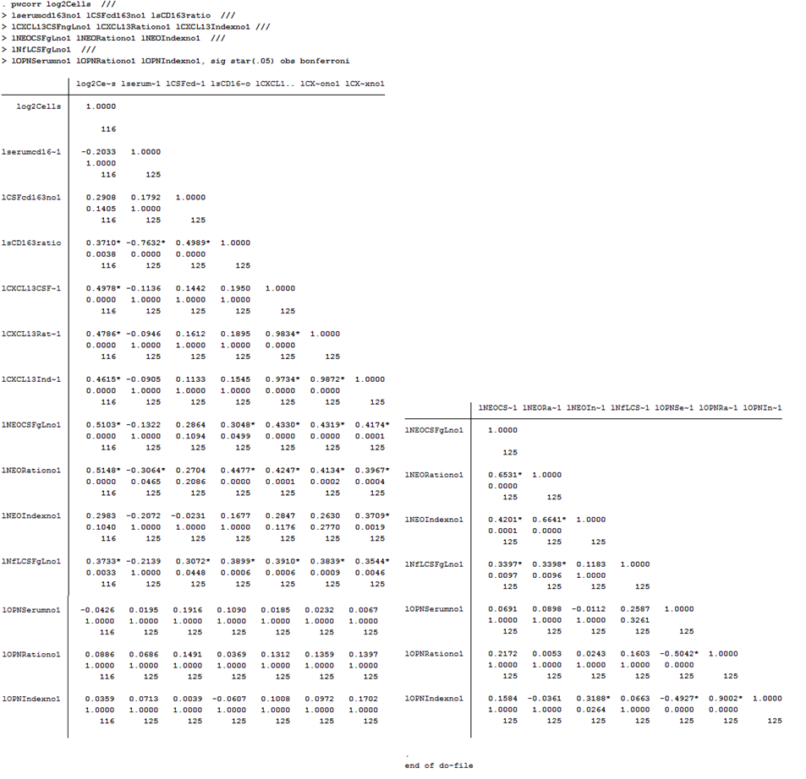

Table V. Do-file and output of the Pearson correlation analysis without the Bonferroni correction on the IgG index.
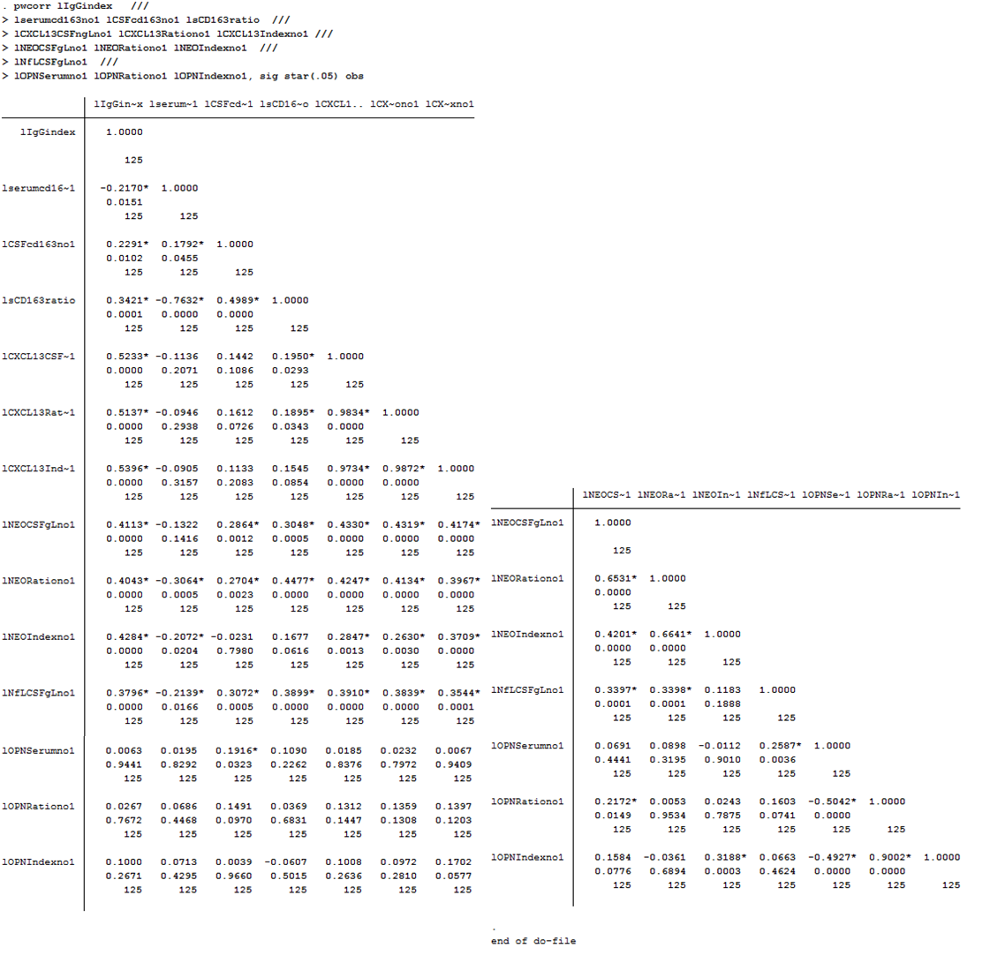

Table W. Do-file and output of the Pearson correlation analysis with the Bonferroni correction on the IgG index.
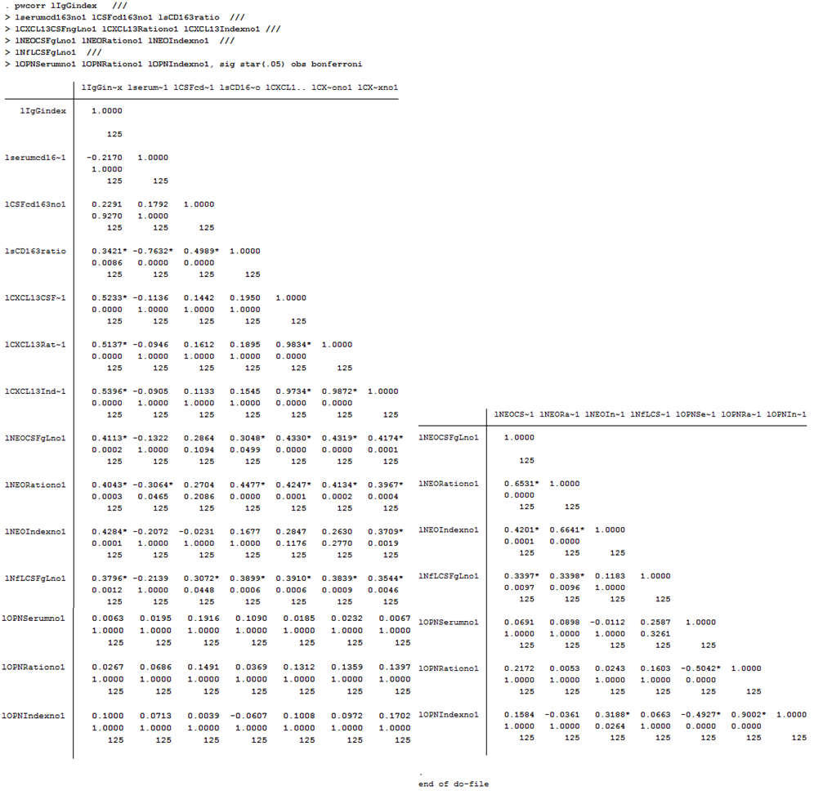

Table X. Do-file and output of the Pearson correlation analysis without the Bonferroni correction on the Total number of MRI white matter lesions.
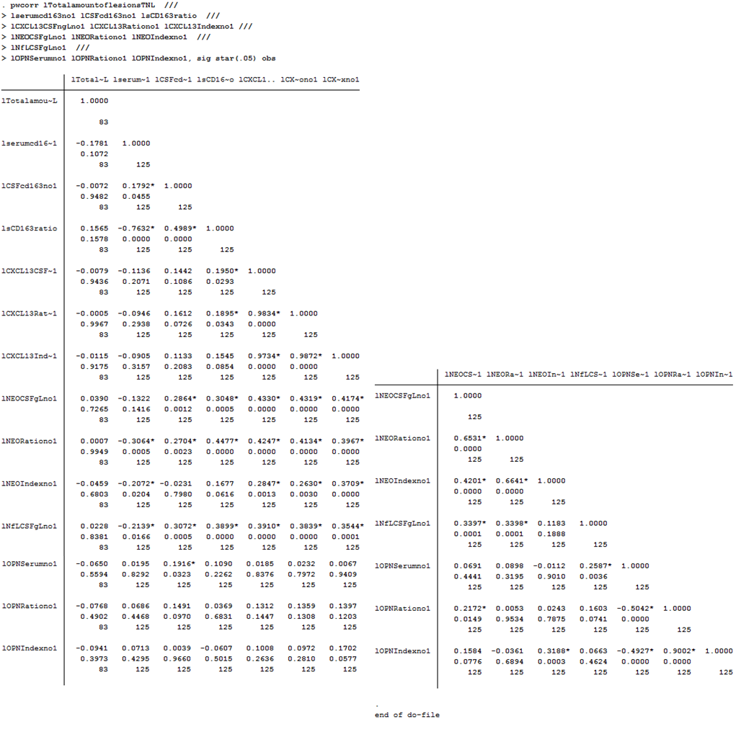

Table Y. Do-file and output of the Pearson correlation analysis with the Bonferroni correction on the Total number of MRI white matter lesions.
.
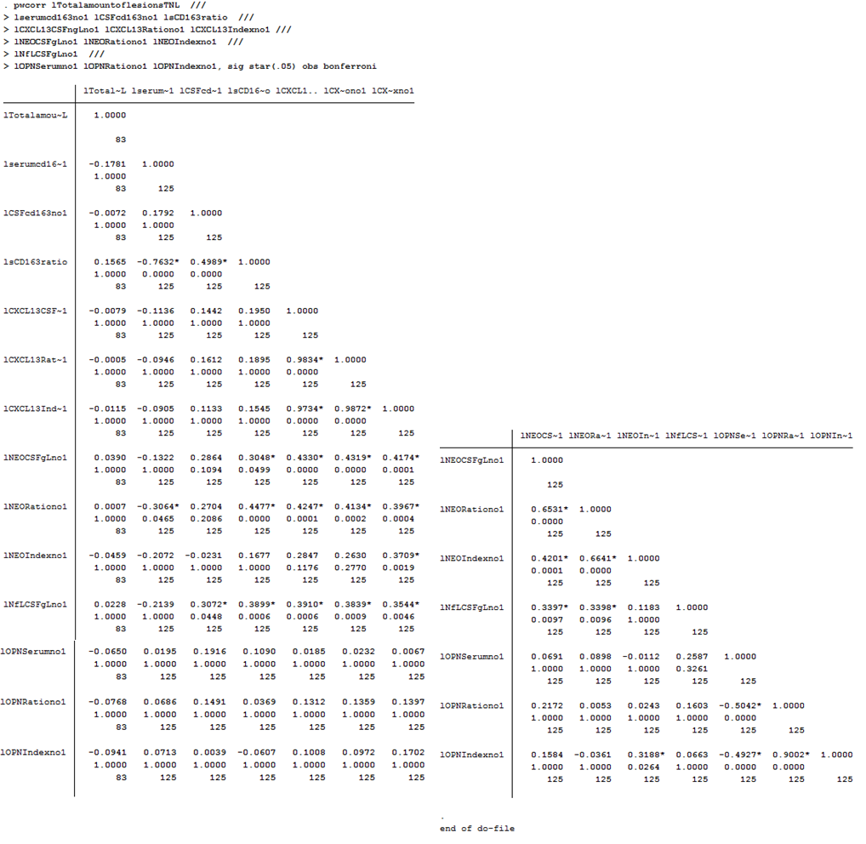

Table Z. Do-file and output of the Pearson correlation analysis without the Bonferroni correction on the biomarker intercorrelations.
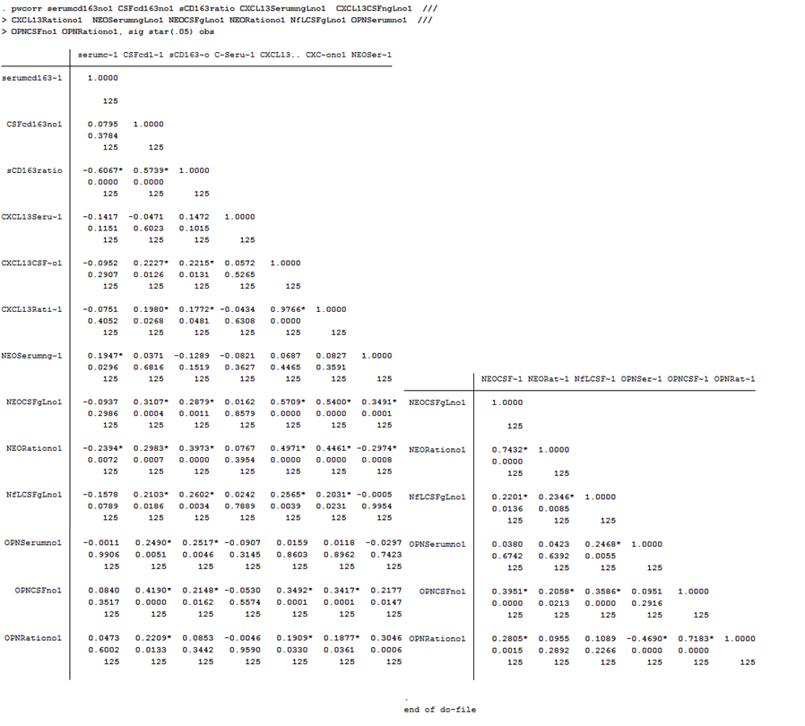

Table AA. Do-file and output of the Pearson correlation analysis with the Bonferroni correction on the biomarker intercorrelations.
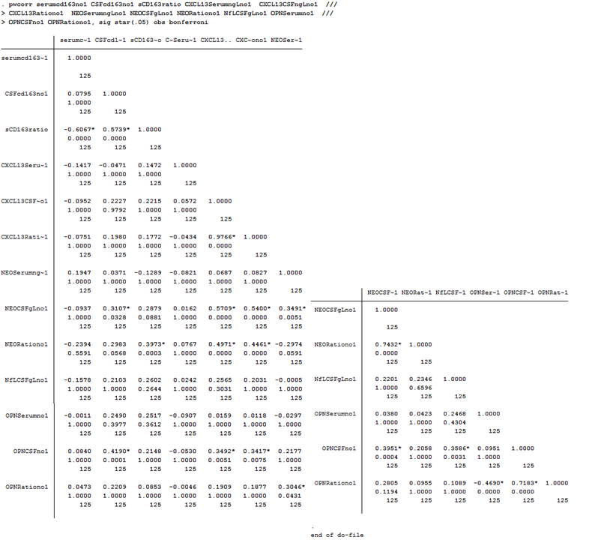

Do-file and output for the regression analyses in STATA.
The regression analysis was performed as described in our previously published paper [18] with the details for the STATA methods as reported in [60].

Table AB. Example of do-file and output of the regression analysis on log transformed sCD163 CSF/serum values (lsCD163ratio).

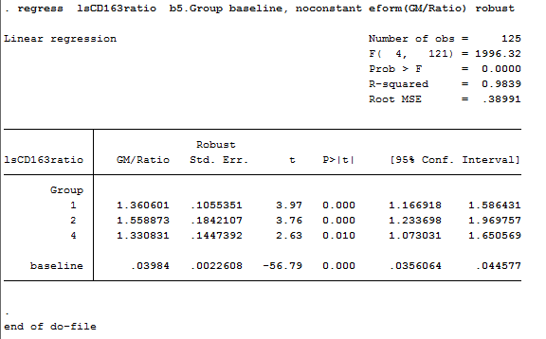

Do-file and output for the ROC analyses in STATA.

Table AC. Do-file and output of the ROC analyses .

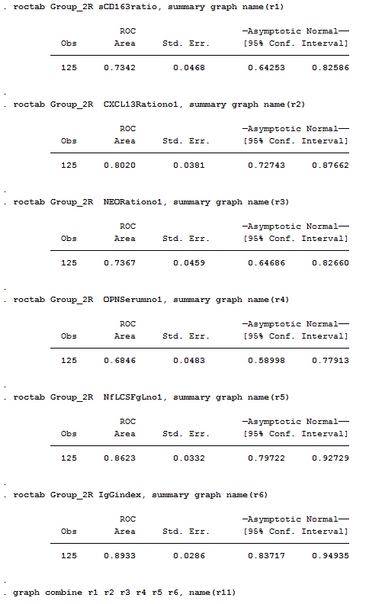

Do-file and output for the logistic regression analyses in STATA.

Table AD. Example of do-file and the final output from a logistic regression analysis

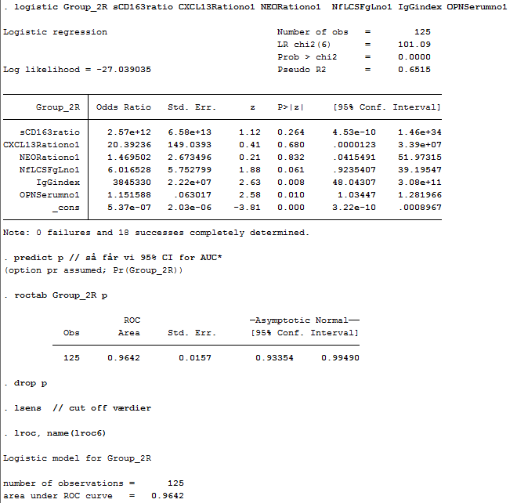

All references in S1_Dataset are given in the article.

Contact
For further information please contact mortenleifms@gmail.com

