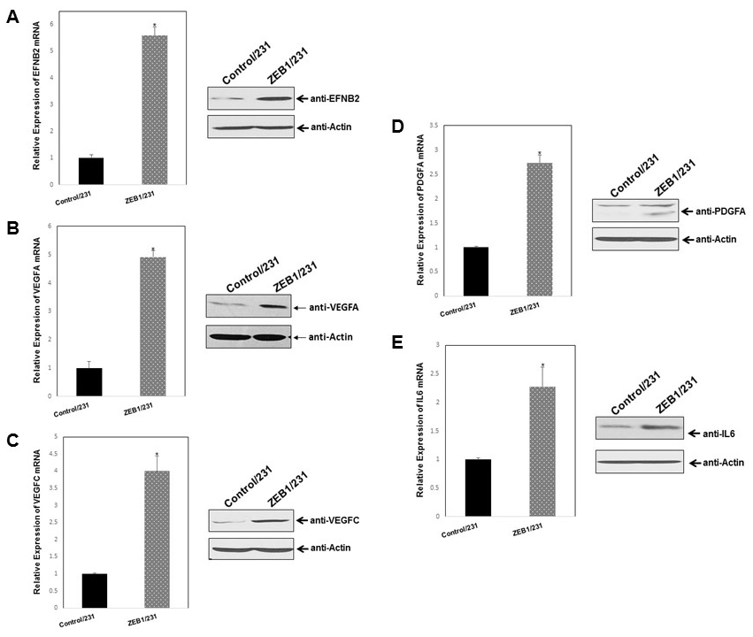
S1 Fig. ZEB1 induces tumor angiogenesis of breast cancer by altering the levels of angiogenic regulators. MDA-MB-231 cells were stably transfected with the human ZEB1 expression plasmid (ZEB1/231) or empty vector control (Control/231). Expression of EFNB2 (A), VEGFA (B) VEGFC (C), PDGFA (D), and IL6 (E) were examined by qPCR and Western blotting. GAPDH and actin were used to normalize the individual levels. *P < 0.05 vs respective control in Student’s t-test.

