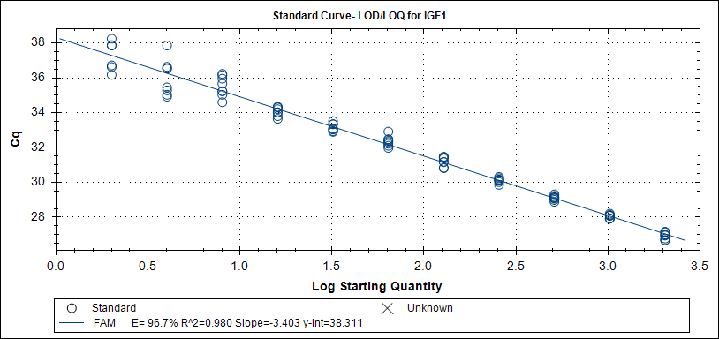
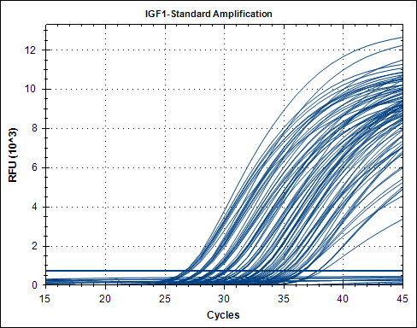
Supplemental Data Figure 1:

Supplemental Data Figure 1: Standard curve, amplification plot and calculation for experimental estimation of IGF1 LOD and LOQ.
IGF1 qPCR was optimized and tested for the limit of detection/limit of quantification (LOD/LOQ) as described by Burns et al. [25] using standard calibrators (n=8) in a background of 500ng hgDNA. Freshly quantified standard was serial 1:2 diluted from 2048 copies down to 1 copy/reaction. LOQ for IGF1 was determined as 16 copies with a limit of detection of 4 copies.

We defined the LOD as the lowest copy number that gives a detectable PCR amplification product at least 95% of the time. The LOQ was defined as the lowest concentration that could be quantified with >80% accuracy, and LOD was defined as the minimum copy number for which all replicates of the same dilution could be successfully detected. qPCR mixture contained 10µl SsoFast probes supermix (Bio-Rad) and primers and probes as indicated in Table 1. Two-step PCR protocol using CFX384 (Bio-Rad) started with 2 min at 98°C followed by 45 cycles at 95°C melting and 30sec annealing/extension at 64°C. We designed a new assay for IGF1 transgene detection with primers that resulted in an 83bp amplicon, in which the exon2/3 boundary was targeted by a -FAM™-labelled LNA-probe. As illustrated in Supplemental Data Figure 1, IGF1 qPCR efficiency was 96.7% with a linearity of r²= 0.99. The LOQ was defined as the lowest concentration that could be quantified with >80% accuracy, and set to 16 copies per reaction. LOD was found to be 4 copies.
IGF1 primers probe were chosen to target all IGF1 mRNA isoforms including mechano-growth factor (MGF) using UCSC Genome Browser (http://genome.ucsc.edu/) and Primer 3 [24].

