S1 File
Fig A Quarter of birth distributions of free-agents.
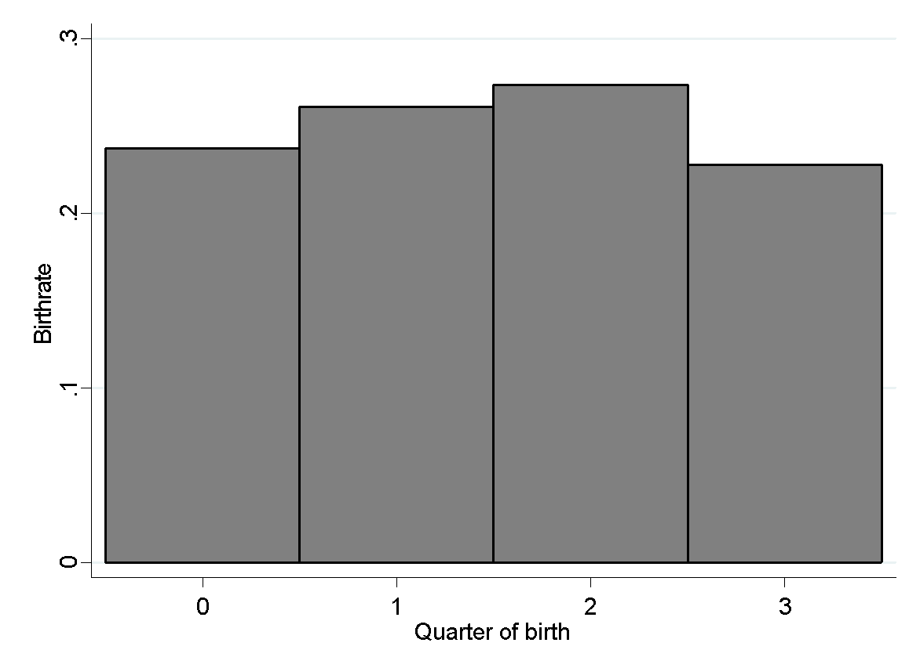
Fig B Quarter of birth distributions of non-NHL players.
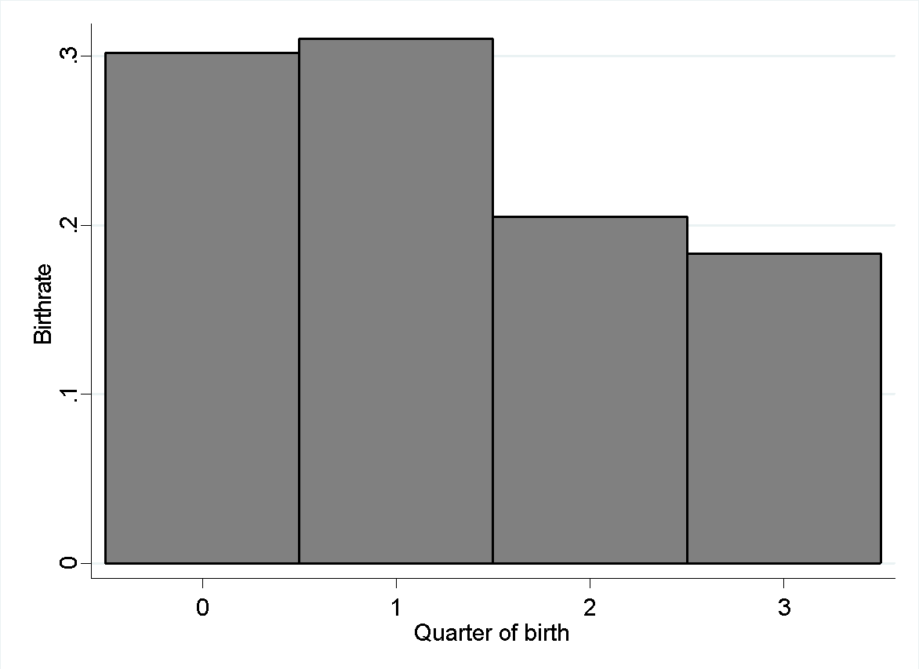

Table A. RAE by quarter, on points; OLS.
 | North.-Am.ª | North.-Am. | Canadians^{d}
Variables | Points | Points | Points
 | (1) | (2) | (3)
April-June | 2.480 | 2.176 | 3.215*
 | (1.549)^{c} | (1.438) | (1.704)
July-September | 5.093*** | 6.221*** | 6.905***
 | (1.786) | (1.666) | (1.981)
October-December | 4.574*** | 8.538*** | 7.414***
 | (1.745) | (1.795) | (2.090)
Control variables | N | Y | Y
Can. Jr. Hockey | N | N | Y
Observations | 4,447^{d} | 4,447 | 3,103
R-squared | 0.011 | 0.142 | 0.175
$$*** p<0.01, ** p<0.05, * p<0.1.$$
ª Only North American players are investigated.
^{b} Only Canadian players are investigated.
^{c} Standard errors in parenthesis are clustered on players.
^{d} Repeated observations per player are used.

Table B. RAE by quarter, on natural logarithm of salaries; OLS.
 | North.-Am.ª | North.-Am. | Canadians^{b}
Variables | Ln_Salary | Ln_Salary | Ln_Salary
 | (1) | (2) | (3)
April-June | 0.126 | 0.087 | 0.134
 | (0.087)^{c} | (0.076) | (0.088)
July-September | 0.199** | 0.260*** | 0.326***
 | (0.094) | (0.087) | (0.102)
October-December | 0.239** | 0.412*** | 0.390***
 | (0.093) | (0.099) | (0.122)
Control variables | N | Y | Y
Can. Jr. Hockey | N | N | Y
Observations | 4,447^{d} | 4,447 | 3,103
R-squared | 0.011 | 0.125 | 0.159
$$*** p<0.01, ** p<0.05, * p<0.1.$$
ª Only North American players are investigated.
^{b} Only Canadian players are investigated.
^{c} Standard errors in parenthesis are clustered on players.
^{d} Repeated observations per player are used.

